**VIETNAM NATIONAL UNIVERSITY**

**INTERNATIONAL SCHOOL**

-----🙣🕮🙡-----  


**FINAL TERM REPORT**

**COURSE: PROJECT**

**Professor Trần Thị Oanh**

**TOPIC: Stock Recommendation System**

**Presented by**

Group 2

Nguyễn Tuấn Minh 20070959

Trần Ngọc Thanh Bình 20070902

# **Table contents**

**1. Introduction** **2**

1.1 Why we should invest? What is the most effective investment channel in Vietnam? 2

1.2 The pressing issue for many investors nowadays 4

1.3 About the project 5

1.4 Project Goals/ Objectives 5

1.5 Project Scope/ Out-of-Scope 6

1.6 Project Risk/Issues 7

1.7 Project Deliverables 7

1.8 Project contributions of each member 8

**2. Methodology and Solution** **10**

2.1 Top-down analysis 10

2.2 Economic Rhythms and Investment Strategies: Navigating Business Cycles, Monetary Policy, and Market Trends 11

2.2.1 Business cycle definition and its phases 12

2.2.2 Monetary Policy 13

2.2.3 Conditions in the Market and How Investors Act 15

2.3 Analyzing the Impact and Limitations of Relative Strength in Industry Sector Investment 16

2.4 Essential Principles for Selecting Stocks: A Guide to Fundamental and Technical Analysis 18

2.4.1 High growth in current quarterly EPS and the last two quarters showing significant increases 18

2.4.2 EPS in each quarter of the last 12 months is at or near its peak 20

2.4.3 Year-Over-Year Revenue Surge with Accelerating Quarterly Growth 21

2.4.4 Accelerating profit growth over the last three quarters 23

2.4.5 Analyzing the Impact of High ROE on Stock Performance 24

2.4.6 Technical Approach to Identifying Strong Stocks 25

2.5 The Evolution and Impact of the Richard Donchian 5/20 System in Technical Trading 26

2.6 Essential of Portfolio Diversification 27

2.6.1 Advantages of Portfolio Diversification 27

2.6.2 Optimal Portfolio Size: How Many Stocks Should You Own? 28

2.7 Modern Portfolio Theory 30

2.7.1 Strategic Asset Allocation: The Modern Portfolio Theory Approach 30

2.7.2 Advantages of Modern Portfolio Theory 33

2.7.3 Disadvantages of Modern Portfolio Theory 34

2.8 Customer Segmentation analysis 35

2.8.1 Methodology 35

2.8.2 Key finding of Customer Segmentation 45

**3. Implementation and results** **45**

3.1 Economic analysis 45

3.1.1 Data collection 45

3.1.2 Navigating the Economic and Financial Landscape of Vietnam: 2017-2023 45

3.1.3 The relationship between VNINDEX and Economic Indicators 48

3.1.4 Key finding 55

3.2 Industry Sector Analysis 56

3.2.1 Data collection 56

3.2.2 Key finding 56

3.3 Comprehensive Stock Selection Strategy 58

3.3.1 Data collection 58

3.3.2 Key finding 58

3.4 Trading Bot 59

3.4.1 Data collection 59

3.4.2 5/20 Donchian Method Trading Bot: Revolutionizing Stock Market Strategy 60

3.4.3 Trading bot back-testing result 62

3.4.4 Limitations of trading bot 65

3.5 Portfolio allocation using Modern Portfolio Theory 65

3.6 Recommendations 65

3.7 Future works 65

**References** **66**

**Appendix** **70**

Appendix 1: Trading bot backtesting result on SSI 70

Appendix 2: Trading bot backtesting result on VND 71

Appendix 3: Trading bot backtesting result on HPG 72

Appendix 4: Trading bot backtesting result on MWG 73

# **1. Introduction**

## **1.1 Why we should invest? What is the most effective investment channel in Vietnam?**

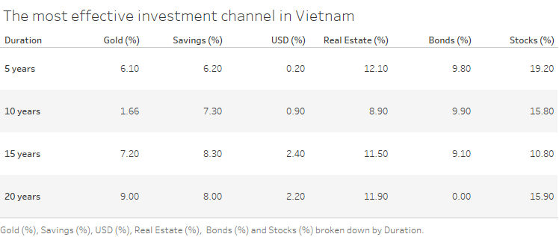

*Figure 1: The most effective investment channel in Vietnam (Dragon Capital, 2021)*

Given Vietnam's average inflation in the period 2010 - 2022 is 6.12%, investing becomes a strategic necessity rather than just a choice (DNSE, 2023). Firstly, through wealth accumulation, investing harnesses the power of compounding returns, which can significantly grow your wealth over time. This growth is not just about increasing numbers; it's about building a robust financial foundation that can support future needs and aspirations. Whether it's for retirement, educational expenses, or any other long-term goal, the compounded growth from investments can play a crucial role in realizing these objectives.

Secondly, and equally important, is the aspect of inflation hedging. With a steady inflation rate of 6.12% annually, the value of money doesn't remain static—it decreases. Therefore, keeping money idle or in low-yielding accounts means you're effectively losing purchasing power each year. By investing in assets that yield returns higher than the inflation rate, you not only preserve the real value of your wealth but potentially increase it. This approach ensures that your financial resources retain their effectiveness and purchasing power in the face of constant inflationary pressures, securing not just your present financial status but also safeguarding your future financial health.

In the landscape of investment in Vietnam, various channels exhibit differing performance metrics, particularly notable in the case of stocks and real estate. Stocks have consistently yielded the most impressive returns, marked by annualized returns of 19.2%, 15.8%, and 15.9% over the periods of 5, 10, and 20 years, respectively. This robust performance underscores the potential that equity investments hold for substantial growth and earnings in the long run, albeit accompanied by higher risks.

Real estate investments also stand out, especially when held over extended durations of 15 and 20 years, where the returns are recorded at 11.5% and 11.9%. This trend hints at the enduring value and upward trajectory of property investments, which are particularly appealing to those seeking stable investments over medium to long terms.

On the more conservative front, bonds present a less volatile investment route with moderate returns. The returns from bonds, fairly steady at 9.8%, 9.9%, and 9.1% for 5, 10, and 15-year terms, indicate a lower risk profile, which may be attractive to investors seeking consistent gains over time.

The performance of gold as an investment vehicle displays variability, with a mere 1.66% return over a decade but escalating to 9% over two decades. This pattern proposes that gold's value as an investment may shine over the long haul, serving as a safeguard against inflation, though its reliability over short-term spans may be questioned.

The avenue of savings accounts, while offering the security of liquidity and low risk, sits at the lower end of the return spectrum. This is an expected outcome for such secure investments.

Lastly, the returns from investments in the U.S. dollar have been relatively modest. This could be attributed to the stability or minimal inflation of the U.S. currency, or perhaps the Vietnamese dong's relative strength during the evaluated time frames.

In conclusion, while the stock market has been the most lucrative investment channel in Vietnam over the last two decades, the returns are especially noteworthy against Vietnam's government target inflation rate of 4% annually, suggesting that stocks have not only beaten inflation but also effectively preserved the purchasing power of capital.

## **1.2 The pressing issue for many investors nowadays**

Navigating the stock market successfully requires more than just a basic grasp of economic indicators, company financials, and price-affecting factors. It demands a substantial depth of knowledge and experience. This need for expertise is underscored by an AMFI survey, which shows an alarming 72% of people are uninformed about the investments necessary for financial independence, and 56% struggle with personal finance management (Times of India, 2023). In the U.S., a mere 14% of families invest directly in individual stocks, but a notable 52% have some level of market investment, suggesting widespread but potentially shallow market involvement (Investopedia, 2022). In Vietnam, the issue seems more pronounced, with a Yuanta Vietnam study indicating that 90% of investors there incur losses, hinting at a widespread lack of investment know-how among Vietnamese investors (Yuanta Vietnam, 2023).

Emotional decision-making presents a significant hurdle. Investor decisions, often swayed by greed and fear, lead to buying high and selling low. A survey disclosed that 58% of investors realize better outcomes when emotions are sidelined, yet nearly half find it challenging to keep these emotions in check (CNBC, 2021). The regret expressed by two-thirds of respondents over emotionally-driven decisions highlights the negative impact of emotions on investment strategies (MagnifyMoney, 2023).

The perils of insufficient diversification in investment portfolios are also critical. Overconcentration in a single stock or sector significantly ups the ante for substantial losses in market dips. Frank Reilly and Keith Brown’s research demonstrates that holding 12 to 18 stocks can capture about 90% of the benefits of diversification (Forbes, 2021). Yet, the risk of heavily investing in stocks is clear: a 10% market fall, not an infrequent event, can quickly wipe out a year’s growth, accentuating the importance of a well-balanced and diversified investment strategy.

## **1.3 About the project**

Our project is dedicated to addressing the pivotal challenges that investors face in the dynamic realm of stock market investment. By implementing a comprehensive top-down analysis approach, we aim to provide a multifaceted solution that empowers investors to navigate the complexities of the financial market with greater confidence and success. Our primary goal is to equip investors with the tools and knowledge necessary for proficient decision-making in the stock market. By offering a blend of insightful macroeconomic analysis, sector-specific guidance, tailored stock recommendations, innovative trading technology, and strategic portfolio management advice, we strive to enhance investors' abilities to successfully traverse and profit from the complexities of financial markets. Our project stands as a beacon for investors seeking to transform their investment journey into a more informed, strategic, and rewarding experience.

## **1.4 Project Goals/ Objectives**

1. **Macroeconomic Guidance:** We focus on educating investors about the optimal macroeconomic conditions for investment. Our service includes providing detailed insights into how various macroeconomic scenarios can influence investment strategies, enabling investors to align their decisions with the most favorable economic conditions.
2. **Sector Analysis:** A significant aspect of our project involves identifying and highlighting industry sectors that exhibit strong growth potential. Through thorough analysis, we assist investors in pinpointing the sectors most likely to offer high returns, thereby facilitating more informed and strategic investment choices.
3. **Stock Recommendations:** Our project is committed to offering investors data-driven insights into potential stock options. We analyze and recommend stocks that demonstrate promising growth prospects, aiding investors in building portfolios that are both robust and profitable.
4. **Automated Trading Bot:** To enhance the investment experience, we provide an automated Trading Bot that delivers precise buying and selling points. This tool is tailored to support various investment strategies, including short, medium, and long-term approaches, and is instrumental in helping investors capitalize on market opportunities while effectively managing risks.
5. **Portfolio Allocation Advice:** Understanding the importance of diversification, we offer guidance on the appropriate allocation of each stock within an investor's portfolio. This approach is crucial for effective risk management and in achieving optimal returns on investments.
6. **Real-Time Stock Market Price Board:** To ensure investors can monitor the market accurately and promptly, we offer a real-time stock market price board. This feature allows investors to stay updated with the latest market movements, helping them make timely and informed decisions in the ever-changing landscape of the stock market.

## **1.5 Project Scope/ Out-of-Scope**

The project focuses on an in-depth analysis of the Vietnamese stock market and its relationship with various economic indicators. Key areas of study include:

* Examination of Investment Channels in Vietnam: Analyzing different investment options such as stocks, real estate, bonds, gold, and savings accounts, with a particular emphasis on the stock market.
* Investment Strategies and Economic Indicators: Investigating the impact of macroeconomic conditions, business cycles, and monetary policies on investment decisions and market trends. This includes a detailed look at how interest rates, inflation, and other key economic metrics influence the stock market, particularly the VN-INDEX.
* Analytical Techniques and Tools: Utilizing a range of analytical methods, including top-down analysis, to guide investment decisions in the stock market. This will involve a comprehensive study of sector performance, stock recommendations, automated trading technology, and strategic portfolio management.
* Risk Analysis and Management: Identifying and addressing potential risks and issues associated with investing in the Vietnamese stock market.
* Empirical and Theoretical Research: Merging empirical data analysis with theoretical research to offer a rounded perspective on stock market dynamics and investment strategies.

The scope explicitly excludes areas outside the realms of the Vietnamese stock market and its directly related economic indicators. It does not cover global investment trends or markets outside of Vietnam. The aim is to provide targeted, actionable insights specific to the Vietnamese context.

## **1.6 Project Risk/Issues**

The "Project Risk" section in our report on Vietnamese investment channels, particularly the stock market, would cover the following aspects:

* Market Volatility and Economic Changes: The inherent instability of stock markets and the impact of fluctuating economic conditions on investment viability.
* Regulatory and Legal Changes: Risks associated with changes in government policies or legal frameworks that could impact investments.
* Liquidity Risks: Challenges related to the ease of entering and exiting market positions.
* Operational and Technological Risks: Potential issues with trading platforms or technical systems failures.
* Investment Knowledge and Decision Making: Risks stemming from investors' lack of knowledge or experience, leading to poor investment decisions.
* Global Market Influences: The impact of global economic events or trends on the Vietnamese market.

Each of these areas represents potential challenges that could affect the outcomes of investment strategies in the Vietnamese stock market.

## **1.7 Project Deliverables**

This project aims to produce a series of comprehensive deliverables that will contribute significantly to understanding and navigating the Vietnamese stock market. These deliverables include:

* Analytical Report on Investment Strategies: A detailed report assessing various investment strategies within the Vietnamese market, examining their viability and effectiveness.
* Economic Indicator Analysis: A comprehensive analysis of key economic indicators and their impact on the stock market, particularly the VN-INDEX.
* Investment Tools and Models: Development of tools or models to aid in investment analysis and decision-making, tailored to the specificities of the Vietnamese market.
* Strategic Recommendations: A set of strategic recommendations for investors, based on the findings from the analysis of market trends, economic indicators, and investment strategies.
* Educational Material for Investors: Creation of educational resources aimed at enhancing investor knowledge and understanding of the market dynamics in Vietnam.

These deliverables are designed to provide investors and stakeholders with valuable insights, tools, and strategies for effective participation in the Vietnamese stock market.

## **1.8 Project contributions of each member**

|  |  |  |
| --- | --- | --- |
| **Student’s name** | **Student’s ID** | **Tasks** |
| Nguyễn Tuấn Minh | 20070959 | * Perform analysis of Economic Conditions * Perform analysis of Industry Sectors * Perform analysis of stock ranking according to the set criteria * Implement a Trading Bot, providing specific buy-sell points suitable for short, medium, and long-term trading * Perform risk management and portfolio management to suggest appropriate portfolios for different investors * Write a report |
| Trần Ngọc Thanh Bình | 20070902 | * Setup a production-ready infrastructure on Kubernetes. * Developed automated pipelines that extract daily financial data. * Co-developed and packaged our Recommendation Service. * Develop real-time data pipelines and stream processing pipeline for trading board and Predictive Indicator. * Developed a LSTM model that becomes our Predictive Indicator. * Perform technical analysis of our project and proposed several future works. * Conducting research on Stream Processing, Real-time Machine Learning, Neural Network (LSTM, GRU), and providing help for team members. |

# **2. Methodology and Solution**

## **2.1 Top-down analysis**

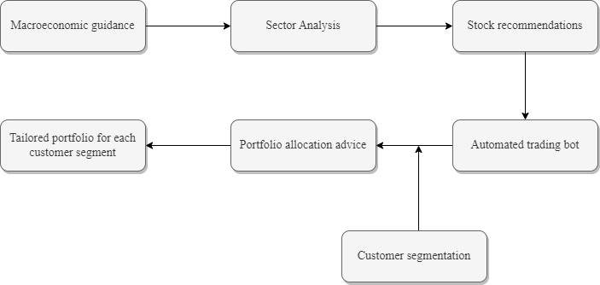

*Figure 2: Top-down analysis flowchart*

Top-down stock analysis in the context of investing represents a strategic and macroeconomic approach to portfolio construction and stock selection (Tamplin, 2023). This methodology begins with a broad assessment of the global economic landscape, where investors scrutinize key indicators such as GDP growth, inflation rates, and unemployment figures (Tamplin, 2023). This initial step is crucial as it sets the tone for understanding the overall health and direction of the global economy, which in turn influences market sectors differently (Tamplin, 2023). Following this, the analysis narrows down to employing technical analysis tools like charts and trend lines to discern macro trends in the stock market (Hanna, 2018). This step is pivotal in identifying the general direction of the market and spotting potential investment opportunities or risks (Hanna, 2018).

The third phase of top-down analysis involves a more granular examination of economic data and market performance, including consumer spending patterns, retail sales, and industrial production (Hanna, 2018). This detailed analysis helps in understanding the nuances of market dynamics and the potential impact of current events on stock performance (Hanna, 2018). The final step in this approach is the evaluation of key stock indices such as the S&P 500, Dow Jones, and Nasdaq (van Rensburg & van Vuuren, 2020). These indices serve as benchmarks for the overall market performance and can offer insights into sectoral strengths and weaknesses, guiding investors towards sectors that show promise based on current economic conditions (van Rensburg & van Vuuren, 2020).

One of the primary advantages of the top-down approach is its ability to identify the most promising sectors and industries for investment, based on overarching economic trends (Tamplin, 2023). This can be particularly beneficial in times of economic shifts or global events, such as the COVID-19 pandemic, where certain sectors like technology and healthcare might emerge as more favorable due to changes in consumer behavior and market needs (Tamplin, 2023). However, a potential drawback of this method is its tendency to overlook the fundamentals of individual stocks, especially those that may be performing well in sectors that are otherwise not favored in the current economic climate (Tamplin, 2023). This could lead to missed opportunities in stocks that are fundamentally strong but situated in underperforming sectors (Tamplin, 2023).

In conclusion, while the top-down approach offers a structured and macro-focused pathway for investment decision-making, it is most effective when complemented with bottom-up analysis that considers individual company performance (Tamplin, 2023). This combined strategy can lead to a more balanced and diversified investment portfolio, tailored to both capture broad market trends and capitalize on unique company strengths (Tamplin, 2023).

## **2.2 Economic Rhythms and Investment Strategies: Navigating Business Cycles, Monetary Policy, and Market Trends**

This parts provides a comprehensive overview of the intricate relationship between the economy's cyclical nature, central bank monetary policies, and the resulting market dynamics. It begins by delving into the business cycle's phases—Recovery, Expansion, Slowdown, and Contraction—each characterized by distinct economic indicators and investment implications. The narrative then shifts to the pivotal role of monetary policy, particularly central banks' interest rate decisions, and how these policies ripple through the economy, influencing lending rates, asset valuations, and investor behavior. Finally, the focus turns to market conditions, examining how investors respond to economic trends shaped by the business cycle and monetary policy. This holistic view underscores the importance of aligning investment strategies with economic indicators and market sentiments, enabling investors to navigate through the ebbs and flows of the financial landscape effectively.

### **2.2.1 Business cycle definition and its phases**

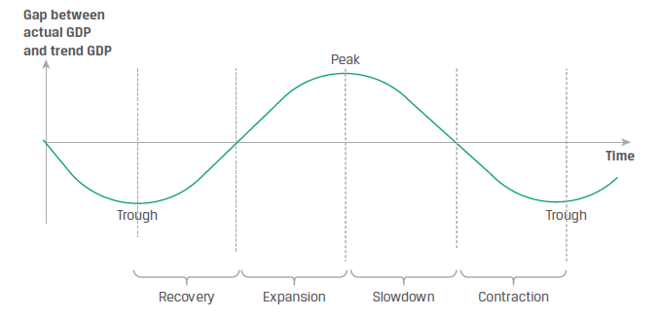

*Figure 3: Business Cycle Phase Characteristics (CFA Curriculum Volume 1 Level 1 2024)*

The business cycle is a fundamental concept in economics, marked by the perpetual ebb and flow of economic activity. It comprises four distinct stages, each with its own set of characteristics and implications for the economy.

The first stage, known as the "Recovery," occurs when the economy is at its lowest point, with actual output significantly trailing potential output (CFA Curriculum Volume 1 Level 1 2024). During this phase, economic activities such as consumer and business spending are below their capacity but are beginning to show signs of improvement (CFA Curriculum Volume 1 Level 1 2024). Key indicators include a shift in GDP growth from negative to positive, a high unemployment rate, and increased reliance on temporary and overtime workers (CFA Curriculum Volume 1 Level 1 2024). Additionally, there may be an uptick in spending on durable goods and housing, coupled with moderate or decreasing inflation rates (CFA Curriculum Volume 1 Level 1 2024).

Moving on to the "Expansion" phase, significant economic changes take place (Schweser Notes Level 1 Book 3 2024). The GDP growth rate surges, signaling a strengthening economy, and the unemployment rate declines as hiring accelerates (Schweser Notes Level 1 Book 3 2024). Investments, particularly in producers' equipment and housing, rise substantially, reflecting growing confidence in economic prospects (Schweser Notes Level 1 Book 3 2024). This phase may also witness an increase in the inflation rate and a surge in imports due to domestic income growth (Schweser Notes Level 1 Book 3 2024).

As the economy progresses, it eventually reaches the "Slowdown" phase. At this point, the economy attains its peak output relative to potential output, resulting in a significant positive output gap (CFA Curriculum Volume 1 Level 1 2024). However, the growth rate begins to decelerate in comparison to the growth of potential output, causing the positive output gap to narrow (CFA Curriculum Volume 1 Level 1 2024). While consumer confidence remains positive, companies may meet demand by relying on overtime rather than expanding their workforce. Inflation also tends to slow down, with the possibility of prices decreasing (CFA Curriculum Volume 1 Level 1 2024).

Lastly, the "Contraction" phase marks a downturn in the business cycle (CFA Curriculum Volume 1 Level 1 2024). Actual economic output falls below potential output, leading to a decline in consumer and business confidence (CFA Curriculum Volume 1 Level 1 2024). To cut costs, companies eliminate overtime and reduce their workforce (CFA Curriculum Volume 1 Level 1 2024). In more severe cases, this phase can result in a recession or even a depression, though it is typically shorter in duration than the expansion phase when the decline is moderate (CFA Curriculum Volume 1 Level 1 2024).

In conclusion, understanding the business cycle's four stages—Recovery, Expansion, Slowdown, and Contraction—provides valuable insights into the dynamics of economic activity and helps policymakers and investors make informed decisions in a constantly changing economic landscape. These stages reflect the inherent cyclicality of economic growth, with each phase bringing its unique challenges and opportunities.

### **2.2.2 Monetary Policy**

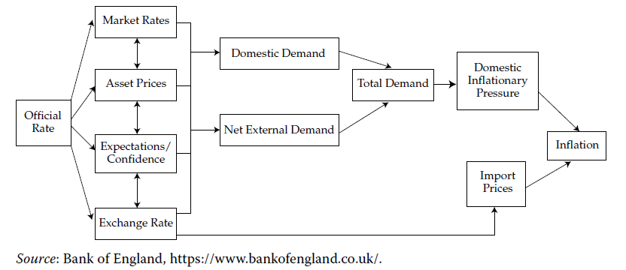

*Figure 4: The Transmission Mechanism*

Central banks have three primary tools at their disposal: open market operations, the refinancing rate, and reserve requirements (CFA Curriculum Volume 1 Level 1 2024). In our research, our main focus is on clarifying the impact of The Central Bank's Policy Rate on risky assets like the stock market (CFA Curriculum Volume 1 Level 1 2024). The primary objective of a central bank is to ensure price stability (CFA Curriculum Volume 1 Level 1 2024). Displayed in Figure 3 is a simplified illustration of the monetary transmission mechanism (CFA Curriculum Volume 1 Level 1 2024). This process describes how a central bank's interest rate is propagated throughout the economy and eventually influences the rate of price growth, i.e., inflation (CFA Curriculum Volume 1 Level 1 2024).

Figure 3: The Transmission Mechanism (CFA Curriculum Volume 1 Level 1 2024). To illustrate, when a central bank announces an increase in its official interest rate, the implementation of this policy can affect the economy through four interrelated channels: bank lending rates, asset prices, expectations of economic agents, and exchange rates (CFA Curriculum Volume 1 Level 1 2024). Firstly, commercial banks' base rates and interbank rates would typically rise in response to the official rate hike (CFA Curriculum Volume 1 Level 1 2024). As a result, banks would raise borrowing costs for both individuals and businesses across short- and long-term periods (CFA Curriculum Volume 1 Level 1 2024). Consequently, higher interest rates would lead businesses and consumers to reduce their borrowing since the cost of borrowing has gone up (CFA Curriculum Volume 1 Level 1 2024). Furthermore, an increase in short-term interest rates could lead to a decrease in the prices of assets like bonds or the valuation of capital projects, as the discount rate applied to future cash flows rises (CFA Curriculum Volume 1 Level 1 2024).

Market participants would then start to anticipate that higher interest rates may result in slower economic growth, reduced profits, and decreased borrowing for asset purchases (CFA Curriculum Volume 1 Level 1 2024). If the central bank's interest rate increase causes the country's exchange rate to appreciate, this could also lead to reduced profits for exporters, as it would make domestic exports more expensive for foreign buyers, thereby decreasing demand for them (CFA Curriculum Volume 1 Level 1 2024). The decline in asset prices, coupled with rising prices, would diminish household financial wealth, subsequently leading to a decline in consumption growth (CFA Curriculum Volume 1 Level 1 2024). Expectations about interest rates can significantly influence the economy (CFA Curriculum Volume 1 Level 1 2024). Often, businesses and individuals make investment and purchase decisions based on their expectations of interest rates, which are extrapolated from recent events (CFA Curriculum Volume 1 Level 1 2024). If the central bank's interest rate move is widely expected to be followed by further rate increases, investors and businesses will adjust their behavior accordingly (CFA Curriculum Volume 1 Level 1 2024). As a consequence, consumption, borrowing, and asset prices may all decrease due to these revised expectations (CFA Curriculum Volume 1 Level 1 2024).

An increase in the central bank's policy rate can have a broad impact on real domestic demand and net external demand (the difference between export and import consumption) through a complex web of interconnections (CFA Curriculum Volume 1 Level 1 2024). Weaker overall demand would exert downward pressure on domestic inflation rates, as would a stronger currency, which would lower the prices of imported goods (CFA Curriculum Volume 1 Level 1 2024). Taken together, these factors could begin to exert downward pressure on the overall measure of inflation (CFA Curriculum Volume 1 Level 1 2024).

### **2.2.3 Conditions in the Market and How Investors Act**

Numerous economic factors and sectors within the economy exhibit unique cyclic behaviors (CFA Curriculum Volume 1 Level 1 2024). Understanding these trends can provide valuable insights into the overall direction of economic cycles, or it can be especially relevant when implementing an investment strategy that demands precise, rather than broad, cyclical insights to achieve success (CFA Curriculum Volume 1 Level 1 2024).

During the recovery phase, as asset markets anticipate the end of a recession and the onset of an expansion, there is an upward repricing of risky assets (CFA Curriculum Volume 1 Level 1 2024). This is a critical period where monetary policy often plays a significant role. Central banks may adopt accommodative monetary policies, such as lowering interest rates and implementing quantitative easing, to stimulate economic growth (CFA Curriculum Volume 1 Level 1 2024). These policies aim to support businesses by reducing the cost of borrowing, which can drive the upward repricing of risky assets like corporate bonds and stocks (CFA Curriculum Volume 1 Level 1 2024). Equity markets typically hit their lowest point, known as a trough, approximately three to six months before the economy reaches its lowest point and well in advance of economic indicators showing signs of improvement (CFA Curriculum Volume 1 Level 1 2024).

Once an economy's expansion is firmly established, it often enters a "boom" stage (CFA Curriculum Volume 1 Level 1 2024). This phase is marked by robust economic growth, increased consumer and business confidence, higher corporate profits, and credit expansion (CFA Curriculum Volume 1 Level 1 2024). During the boom period, high-risk assets frequently experience significant price increases (CFA Curriculum Volume 1 Level 1 2024). Investors may be more inclined to invest in riskier assets like stocks and real estate, driven by the anticipation of further growth and increased profit potential (CFA Curriculum Volume 1 Level 1 2024). This is a period where central banks might consider tightening monetary policy by raising interest rates to prevent the economy from overheating and to curb inflationary pressures (CFA Curriculum Volume 1 Level 1 2024). The expectation of higher interest rates can lead to shifts in asset allocation, with some investors moving towards safer assets and away from riskier investments (CFA Curriculum Volume 1 Level 1 2024).

During economic contractions, investors tend to place greater importance on safer assets like government securities and stocks of companies with stable or growing positive cash flows, such as utility companies and producers of essential goods (CFA Curriculum Volume 1 Level 1 2024). These preferences are a result of the understanding that the value of a secure income stream becomes more significant during times when employment is uncertain or decreasing (CFA Curriculum Volume 1 Level 1 2024).

In conclusion, understanding the cyclic behaviors of various economic factors and sectors is crucial for making informed investment decisions. These insights can help investors navigate the different phases of economic cycles, from the recovery and expansion to the boom and contraction periods. Recognizing the repricing of risky assets during recovery, the anticipation of profit growth during expansion, and the dynamics of safe and high-risk assets during economic contractions is essential for success in the complex world of investment strategy. By staying attuned to these cyclical trends, investors can adapt their portfolios to capitalize on opportunities and manage risks effectively.

## **2.3 Analyzing the Impact and Limitations of Relative Strength in Industry Sector Investment**

Relative strength is a pivotal financial metric in industry sector analysis, serving as a comparative tool between a sector’s performance and the overall market (Investopedia, 2021). It is calculated by dividing the sector’s performance, often gauged through stock prices, by the performance of a broader market index (Investopedia, 2021). This computation offers a ratio that directly contrasts the sector against the market, highlighting whether a sector is outperforming or underperforming (Investopedia, 2021).

**Note:**

* Performance of Market Index: Measure the percentage change in the value of the market index over a specific period.
* Performance of Industry Sector: Similarly, calculate the percentage change in the value of a representative index or average of stocks within the sector over the same period, using the formula.

This metric is particularly valuable for identifying investment opportunities and deciphering market trends, providing investors with a clearer understanding of where momentum lies (Faber, 2010). In fact, research such as “Relative Strength Strategies for Investing” by Faber (2010) has found that a relative strength model can result in increased absolute returns with equity-like risk, outperforming the buy and hold benchmark in approximately 70% of all years. This suggests that relative strength can be a powerful tool in targeting growth areas or diversifying portfolios to reduce risk (Faber, 2010).

Relative strength is indeed a dynamic and valuable tool in industry sector analysis. It simplifies complex analyses, enabling a quick comparison of sectors against the market benchmark, which is crucial in a rapidly changing market (Investopedia, 2021). This capability allows for timely identification of investment opportunities (Faber, 2010). However, it’s essential to note that relative strength, while powerful, should not be the sole metric in investment decisions. It must be complemented with other analysis tools and used judiciously within a broader investment strategy (Investopedia, 2021).

Relative strength offers a lens through which market dynamics can be understood and navigated. Its ability to highlight sector momentum and trends underscores its significance in the financial world (Investing.com, 2022). Moreover, it plays a role in risk management and performance enhancement (McKinsey, 2019). However, the reliance on this metric must be balanced with other analytical methods to form a well-rounded investment strategy (Investopedia, 2021).

However, the reliance on past performance is a significant disadvantage, as historical data may not always be a reliable predictor of future trends (Investopedia, 2021). Additionally, relative strength can be sensitive to short-term market variances, potentially misrepresenting the long-term potential of a sector (Stivers and Sun, 2013). The paper “Market Cycles and the Performance of Relative Strength Strategies” by Stivers and Sun (2013) found that payoffs for relative strength strategies tend to be relatively higher within a market state (rising or falling markets), but substantially lower over transitions between states. This underscores the sensitivity of relative strength to market cycles and the potential risks of relying solely on this metric (Stivers and Sun, 2013).

In essence, while relative strength is a useful tool in gauging market dynamics and sector performance, investors must use it judiciously, considering its limitations and integrating it with other analytical methods for a well-rounded investment strategy (Investopedia, 2021).

## **2.4 Essential Principles for Selecting Stocks: A Guide to Fundamental and Technical Analysis**

### **2.4.1 High growth in current quarterly EPS and the last two quarters showing significant increases**

In exploring the intricacies of stock market dynamics, it becomes evident that certain patterns and indicators repeatedly signal the potential for significant gains in stock prices. One of the most notable indicators is the growth in Earnings Per Share (EPS). EPS serves as a critical metric for assessing a company's profitability, particularly for publicly traded companies. This metric is calculated by dividing the net income minus preferred dividends by the weighted average number of common shares outstanding. However, it's important to note that this calculation doesn't account for the effects of any dilutive securities:

A deep dive into the performance of various stocks over the years highlights a fascinating trend: stocks exhibiting substantial increases in EPS, especially in recent quarters, often correlate with a subsequent rise in stock prices ([William O'Neil](https://www.google.com/search?sca_esv=591244276&sxsrf=AM9HkKmSh1Y8vcglXfKce6gSXMcNN8kj6g:1702659065697&q=william+o%27neil&stick=H4sIAAAAAAAAAONgVuLUz9U3sDAwzzB4xGjCLfDyxz1hKe1Ja05eY1Tl4grOyC93zSvJLKkUEudig7J4pbi5ELp4FrHylWfm5GQm5irkq-elZuYAADWIBjRVAAAA&sa=X&ved=2ahUKEwil9KKm85GDAxX6lFYBHYzPBaEQ1i96BAgVEAM), 2010). This observation isn't just a one-off occurrence but a pattern witnessed in numerous high-performing stocks. This insight is pivotal, as seen in his analysis of the most successful stocks in the latter half of the 20th century, where companies like Dell and Cisco announced significant EPS increases in one or two quarters preceding major price surges ([William O'Neil](https://www.google.com/search?sca_esv=591244276&sxsrf=AM9HkKmSh1Y8vcglXfKce6gSXMcNN8kj6g:1702659065697&q=william+o%27neil&stick=H4sIAAAAAAAAAONgVuLUz9U3sDAwzzB4xGjCLfDyxz1hKe1Ja05eY1Tl4grOyC93zSvJLKkUEudig7J4pbi5ELp4FrHylWfm5GQm5irkq-elZuYAADWIBjRVAAAA&sa=X&ved=2ahUKEwil9KKm85GDAxX6lFYBHYzPBaEQ1i96BAgVEAM), 2010). This suggests that keeping an eye on EPS growth can be a valuable strategy for investors looking to identify potential high-growth stocks.

Further analysis of stock market trends, echoing some insights from stock market expert William O'Neil, indicates that stocks with over 70% EPS growth in their latest quarter often experience a substantial price surge shortly afterward ([William O'Neil](https://www.google.com/search?sca_esv=591244276&sxsrf=AM9HkKmSh1Y8vcglXfKce6gSXMcNN8kj6g:1702659065697&q=william+o%27neil&stick=H4sIAAAAAAAAAONgVuLUz9U3sDAwzzB4xGjCLfDyxz1hKe1Ja05eY1Tl4grOyC93zSvJLKkUEudig7J4pbi5ELp4FrHylWfm5GQm5irkq-elZuYAADWIBjRVAAAA&sa=X&ved=2ahUKEwil9KKm85GDAxX6lFYBHYzPBaEQ1i96BAgVEAM), 2010). Interestingly, even if a stock doesn't show high EPS growth in the current quarter, if it demonstrates this trend in the subsequent quarters, it often leads to an increase in stock value ([William O'Neil](https://www.google.com/search?sca_esv=591244276&sxsrf=AM9HkKmSh1Y8vcglXfKce6gSXMcNN8kj6g:1702659065697&q=william+o%27neil&stick=H4sIAAAAAAAAAONgVuLUz9U3sDAwzzB4xGjCLfDyxz1hKe1Ja05eY1Tl4grOyC93zSvJLKkUEudig7J4pbi5ELp4FrHylWfm5GQm5irkq-elZuYAADWIBjRVAAAA&sa=X&ved=2ahUKEwil9KKm85GDAxX6lFYBHYzPBaEQ1i96BAgVEAM), 2010). This pattern underscores the importance of not only looking at the current EPS growth but also considering the EPS trajectory over recent quarters ([William O'Neil](https://www.google.com/search?sca_esv=591244276&sxsrf=AM9HkKmSh1Y8vcglXfKce6gSXMcNN8kj6g:1702659065697&q=william+o%27neil&stick=H4sIAAAAAAAAAONgVuLUz9U3sDAwzzB4xGjCLfDyxz1hKe1Ja05eY1Tl4grOyC93zSvJLKkUEudig7J4pbi5ELp4FrHylWfm5GQm5irkq-elZuYAADWIBjRVAAAA&sa=X&ved=2ahUKEwil9KKm85GDAxX6lFYBHYzPBaEQ1i96BAgVEAM), 2010).

An effective approach for investors is to compare a company's current quarterly EPS with that of the same quarter in the previous year. This method helps in mitigating the impact of seasonal variations and provides a clearer picture of the company’s true performance ([William O'Neil](https://www.google.com/search?sca_esv=591244276&sxsrf=AM9HkKmSh1Y8vcglXfKce6gSXMcNN8kj6g:1702659065697&q=william+o%27neil&stick=H4sIAAAAAAAAAONgVuLUz9U3sDAwzzB4xGjCLfDyxz1hKe1Ja05eY1Tl4grOyC93zSvJLKkUEudig7J4pbi5ELp4FrHylWfm5GQm5irkq-elZuYAADWIBjRVAAAA&sa=X&ved=2ahUKEwil9KKm85GDAxX6lFYBHYzPBaEQ1i96BAgVEAM), 2010). Setting a minimum threshold for current quarterly EPS growth, such as a 15% increase compared to the same quarter in the previous year, can also be a prudent strategy. Such a threshold often serves as a precursor to a notable rise in stock prices ([William O'Neil](https://www.google.com/search?sca_esv=591244276&sxsrf=AM9HkKmSh1Y8vcglXfKce6gSXMcNN8kj6g:1702659065697&q=william+o%27neil&stick=H4sIAAAAAAAAAONgVuLUz9U3sDAwzzB4xGjCLfDyxz1hKe1Ja05eY1Tl4grOyC93zSvJLKkUEudig7J4pbi5ELp4FrHylWfm5GQm5irkq-elZuYAADWIBjRVAAAA&sa=X&ved=2ahUKEwil9KKm85GDAxX6lFYBHYzPBaEQ1i96BAgVEAM), 2010).

It's also crucial to recognize the value of a pattern where a stock not only shows high current quarterly EPS growth but also demonstrates strong EPS growth in the preceding two quarters ([William O'Neil](https://www.google.com/search?sca_esv=591244276&sxsrf=AM9HkKmSh1Y8vcglXfKce6gSXMcNN8kj6g:1702659065697&q=william+o%27neil&stick=H4sIAAAAAAAAAONgVuLUz9U3sDAwzzB4xGjCLfDyxz1hKe1Ja05eY1Tl4grOyC93zSvJLKkUEudig7J4pbi5ELp4FrHylWfm5GQm5irkq-elZuYAADWIBjRVAAAA&sa=X&ved=2ahUKEwil9KKm85GDAxX6lFYBHYzPBaEQ1i96BAgVEAM), 2010). This combination often earmarks a stock as a particularly strong candidate for substantial price increases ([William O'Neil](https://www.google.com/search?sca_esv=591244276&sxsrf=AM9HkKmSh1Y8vcglXfKce6gSXMcNN8kj6g:1702659065697&q=william+o%27neil&stick=H4sIAAAAAAAAAONgVuLUz9U3sDAwzzB4xGjCLfDyxz1hKe1Ja05eY1Tl4grOyC93zSvJLKkUEudig7J4pbi5ELp4FrHylWfm5GQm5irkq-elZuYAADWIBjRVAAAA&sa=X&ved=2ahUKEwil9KKm85GDAxX6lFYBHYzPBaEQ1i96BAgVEAM), 2010). The synergy of consistent and robust EPS growth across multiple quarters is a compelling indicator of a stock's potential ([William O'Neil](https://www.google.com/search?sca_esv=591244276&sxsrf=AM9HkKmSh1Y8vcglXfKce6gSXMcNN8kj6g:1702659065697&q=william+o%27neil&stick=H4sIAAAAAAAAAONgVuLUz9U3sDAwzzB4xGjCLfDyxz1hKe1Ja05eY1Tl4grOyC93zSvJLKkUEudig7J4pbi5ELp4FrHylWfm5GQm5irkq-elZuYAADWIBjRVAAAA&sa=X&ved=2ahUKEwil9KKm85GDAxX6lFYBHYzPBaEQ1i96BAgVEAM), 2010).

In light of these observations, it's somewhat surprising that many investors, including professionals, often opt for stocks with stagnant or declining EPS ([William O'Neil](https://www.google.com/search?sca_esv=591244276&sxsrf=AM9HkKmSh1Y8vcglXfKce6gSXMcNN8kj6g:1702659065697&q=william+o%27neil&stick=H4sIAAAAAAAAAONgVuLUz9U3sDAwzzB4xGjCLfDyxz1hKe1Ja05eY1Tl4grOyC93zSvJLKkUEudig7J4pbi5ELp4FrHylWfm5GQm5irkq-elZuYAADWIBjRVAAAA&sa=X&ved=2ahUKEwil9KKm85GDAxX6lFYBHYzPBaEQ1i96BAgVEAM), 2010).

O'Neil is often surprised at how many professional money managers and individual investors buy stocks with stagnant or declining current quarterly EPS ([William O'Neil](https://www.google.com/search?sca_esv=591244276&sxsrf=AM9HkKmSh1Y8vcglXfKce6gSXMcNN8kj6g:1702659065697&q=william+o%27neil&stick=H4sIAAAAAAAAAONgVuLUz9U3sDAwzzB4xGjCLfDyxz1hKe1Ja05eY1Tl4grOyC93zSvJLKkUEudig7J4pbi5ELp4FrHylWfm5GQm5irkq-elZuYAADWIBjRVAAAA&sa=X&ved=2ahUKEwil9KKm85GDAxX6lFYBHYzPBaEQ1i96BAgVEAM), 2010). He argues that there's no rational basis for expecting such stocks to maintain or increase in price ([William O'Neil](https://www.google.com/search?sca_esv=591244276&sxsrf=AM9HkKmSh1Y8vcglXfKce6gSXMcNN8kj6g:1702659065697&q=william+o%27neil&stick=H4sIAAAAAAAAAONgVuLUz9U3sDAwzzB4xGjCLfDyxz1hKe1Ja05eY1Tl4grOyC93zSvJLKkUEudig7J4pbi5ELp4FrHylWfm5GQm5irkq-elZuYAADWIBjRVAAAA&sa=X&ved=2ahUKEwil9KKm85GDAxX6lFYBHYzPBaEQ1i96BAgVEAM), 2010). Even modest EPS growth of 5%-10% is generally insufficient to trigger a significant price rise ([William O'Neil](https://www.google.com/search?sca_esv=591244276&sxsrf=AM9HkKmSh1Y8vcglXfKce6gSXMcNN8kj6g:1702659065697&q=william+o%27neil&stick=H4sIAAAAAAAAAONgVuLUz9U3sDAwzzB4xGjCLfDyxz1hKe1Ja05eY1Tl4grOyC93zSvJLKkUEudig7J4pbi5ELp4FrHylWfm5GQm5irkq-elZuYAADWIBjRVAAAA&sa=X&ved=2ahUKEwil9KKm85GDAxX6lFYBHYzPBaEQ1i96BAgVEAM), 2010). Companies with minimal EPS growth are also more likely to report lower profits in subsequent quarters ([William O'Neil](https://www.google.com/search?sca_esv=591244276&sxsrf=AM9HkKmSh1Y8vcglXfKce6gSXMcNN8kj6g:1702659065697&q=william+o%27neil&stick=H4sIAAAAAAAAAONgVuLUz9U3sDAwzzB4xGjCLfDyxz1hKe1Ja05eY1Tl4grOyC93zSvJLKkUEudig7J4pbi5ELp4FrHylWfm5GQm5irkq-elZuYAADWIBjRVAAAA&sa=X&ved=2ahUKEwil9KKm85GDAxX6lFYBHYzPBaEQ1i96BAgVEAM), 2010). Unlike institutional investors who face capital size limitations, individual investors have the advantage of waiting and investing in the best growth stocks in rising markets ([William O'Neil](https://www.google.com/search?sca_esv=591244276&sxsrf=AM9HkKmSh1Y8vcglXfKce6gSXMcNN8kj6g:1702659065697&q=william+o%27neil&stick=H4sIAAAAAAAAAONgVuLUz9U3sDAwzzB4xGjCLfDyxz1hKe1Ja05eY1Tl4grOyC93zSvJLKkUEudig7J4pbi5ELp4FrHylWfm5GQm5irkq-elZuYAADWIBjRVAAAA&sa=X&ved=2ahUKEwil9KKm85GDAxX6lFYBHYzPBaEQ1i96BAgVEAM), 2010).

### **2.4.2 EPS in each quarter of the last 12 months is at or near its peak**

In analyzing the dynamics of the stock market, it becomes evident that the acceleration in earnings per share (EPS) growth is a pivotal factor in forecasting the success of stocks. Drawing insights from the research and methodologies of William O'Neil and Mark Minervini, two notable figures in stock market analysis, it's clear that this trend holds significant weight in investment strategies. O'Neil's extensive analysis highlights that a majority of high-performing stocks demonstrate a notable increase in their EPS growth rate over a span of ten quarters before their stock prices see a marked rise. This phenomenon indicates that it's not merely high EPS that influences stock price ascents, but a combination of consistent high growth and noticeable acceleration or breakout in the EPS growth.

Expanding on this concept, Minervini focuses on the acceleration of the profit growth rate as a critical indicator. He suggests that the most promising stocks are those where each quarter's profit growth outpaces the previous one, leading to a compounding effect on the overall value. His research shows that more than 90% of the market's top-performing stocks exhibit this characteristic of escalating profit growth prior to or during their price surge. For example, a scenario where a company's quarterly EPS grows from a 10% increase in one quarter to a substantial 56% increase in the most recent quarter is a clear illustration of this trend. Such patterns of accelerated growth, as identified by both O'Neil and Minervini, are key to discerning potential stock market standouts, underscoring the importance of not just growth, but the momentum of growth in investment decision-making.

Supporting this perspective, recent empirical studies further validate the significance of EPS growth in stock market dynamics. For instance, research in the Indonesian banking sector, as explored by Muhammad Tufail (2013), emphasizes the role of EPS in evaluating company performance and forecasting future stock returns. Similarly, Julian Blake, Sonja Fourie, and Michael M. Goldman's (2019) analysis of South African companies with sports sponsorships reveals a direct correlation between EPS growth and corporate financial returns. These findings align with O'Neil and Minervini's assertions, illustrating that accelerated EPS growth is not just a theoretical concept but a practical indicator of stock performance. Additionally, studies on the Taiwan stock market, focusing on the use of EPS as a main variable in investment portfolios, corroborate the idea that consistent and accelerating EPS growth is a key indicator of potential stock success. This body of research collectively underscores the importance of not only recognizing growth but also understanding the momentum behind it in making informed investment decisions.

### **2.4.3 Year-Over-Year Revenue Surge with Accelerating Quarterly Growth**

The dynamics of the stock market are a tapestry woven with various financial indicators, each providing unique insights into the potential success of stocks. Among these, the role of earnings per share (EPS) growth stands out as a pivotal factor. This section delves into the intricacies of EPS growth and its impact on stock performance, guided by the methodologies and insights of William O'Neil and Mark Minervini, two acclaimed experts in stock market analysis. Their approach to understanding the nuances of EPS growth, particularly in relation to stock price movements, offers a valuable framework for investors.

In addition to exploring the strategies of O'Neil and Minervini, this discussion also considers contemporary research that complements and expands upon their theories. Insights from studies conducted by Zhaohui Li, Guangyun Deng, Hui-Chung Che, T. Agrawal, S. Sehgal, Vibhuti Vasishth, Olubunmi Omotayo Efuntade, Alani Olusegun Efuntade, Wei Zhou, Jin Chen, Shuai Lu, and Ningshan Chen shed light on the correlation between EPS growth, revenue growth, and overall stock market performance. These studies underscore the importance of considering a broad range of economic and corporate factors when evaluating stock performance.

This section aims to blend the seasoned perspectives of O'Neil and Minervini with the findings of contemporary empirical research. By doing so, it provides a nuanced view of the factors influencing stock market trends and investment strategies, offering valuable insights for investors navigating the complexities of the financial markets.

In analyzing the dynamics of the stock market, it becomes evident that the acceleration in earnings per share (EPS) growth is a pivotal factor in forecasting the success of stocks. Drawing insights from the research and methodologies of William O'Neil and Mark Minervini, two notable figures in stock market analysis, it's clear that this trend holds significant weight in investment strategies. O'Neil's extensive analysis highlights that a majority of high-performing stocks demonstrate a notable increase in their EPS growth rate over a span of ten quarters before their stock prices see a marked rise. This phenomenon indicates that it's not merely high EPS that influences stock price ascents, but a combination of consistent high growth and noticeable acceleration or breakout in the EPS growth.

Expanding on this concept, Minervini focuses on the acceleration of the profit growth rate as a critical indicator. He suggests that the most promising stocks are those where each quarter's profit growth outpaces the previous one, leading to a compounding effect on the overall value. His research shows that more than 90% of the market's top-performing stocks exhibit this characteristic of escalating profit growth prior to or during their price surge. For example, a scenario where a company's quarterly EPS grows from a 10% increase in one quarter to a substantial 56% increase in the most recent quarter is a clear illustration of this trend. Such patterns of accelerated growth, as identified by both O'Neil and Minervini, are key to discerning potential stock market standouts, underscoring the importance of not just growth, but the momentum of growth in investment decision-making.

Contemporary research in the field echoes and expands upon these sentiments. The study by Zhaohui Li, Guangyun Deng, and Hui-Chung Che (2021) on the predictive ability of patent indicators for EPS in Chinese listed companies underscores the significance of underlying factors in forecasting EPS growth. This aligns with O'Neil's principle that robust EPS growth should be rooted in solid business performance, including revenue growth. Similarly, T. Agrawal, S. Sehgal, and Vibhuti Vasishth's (2020) research on the Indian stock market highlights the impact of corporate fundamentals on investment strategies, echoing Minervini's emphasis on revenue growth as a foundation for profit growth. These studies reinforce the concept that sustainable profit growth, as advocated by both O'Neil and Minervini, is closely tied to a company's fundamental financial health.

Furthermore, the research by Olubunmi Omotayo Efuntade and Alani Olusegun Efuntade (2022) on the influence of economic fundamentals on stock prices further validates the importance of solid revenue and EPS growth in stock valuation. This research highlights the broader economic context within which individual company performance, as measured by EPS and revenue growth, impacts stock prices. Additionally, the study on investment strategies for Chinese listed military enterprises by Wei Zhou, Jin Chen, Shuai Lu, and Ningshan Chen (2021) offers insights into efficient investment strategies based on network efficiency values. This approach to identifying potential investment opportunities mirrors the analytical rigor advocated by O'Neil and Minervini in assessing EPS and revenue growth trends.

In essence, while O'Neil and Minervini's strategies focus on the critical role of EPS and revenue growth in evaluating stock performance, contemporary research provides empirical support to these investment philosophies. The importance of these metrics in guiding investment decisions is underscored by a broader understanding of market dynamics and the impact of various economic and corporate factors. This comprehensive approach to stock market analysis, blending the insights of seasoned analysts with contemporary empirical research, offers invaluable guidance for discerning investors looking to navigate the complexities of the financial markets.

### **2.4.4 Accelerating profit growth over the last three quarters**

Navigating the stock market can often feel like deciphering a complex puzzle, where each piece represents a different financial indicator. Among these, the growth in earnings per share (EPS) emerges as a particularly telling piece, offering insights into a stock's potential trajectory. This perspective is heavily influenced by the teachings of Mark Minervini, a master in stock market strategy, whose insights have shaped my understanding of stock performance.

Minervini's approach is rooted in the observation that a significant proportion of high-performing stocks, approximately 75%, exhibit not just profit growth, but impressively high growth when compared year-over-year. This isn't a mere coincidence but a pattern that savvy investors can leverage. Minervini suggests a proactive approach, advocating for a focus on stocks that show not just a one-time spike in profits but a consistent upward trend over several quarters. The ideal scenario, as per his analysis, is a sequential increase in profit growth quarter over quarter. This pattern aligns closely with stock price movements, making it a crucial factor in investment decision-making.

The current quarter's profit growth, in particular, holds a special significance. Minervini points out that this metric often has the strongest correlation with a stock's price movement, making it a key focus for investors. For a stock to truly stand out, especially to institutional investors, it should not only report attractive profits for the current quarter but also demonstrate a minimum net profit growth of 20% in recent quarters. However, the higher the growth, the better the prospects. Minervini's research indicates that 'super stocks', or those that achieve exceptional success, typically report profit increases of 30%-40% or more during their growth phase.

This strategy is exemplified by several notable stocks that have followed this trajectory. Cisco Systems, for instance, reported over 100% profit growth in 15 out of 17 quarters from March 1989 to May 1993, with its stock price increasing more than thirteenfold. Home Depot and Microsoft also followed similar patterns of sustained profit growth, leading to significant increases in their stock prices.

In essence, Minervini's teachings underscore the importance of looking beyond surface-level financial metrics. By focusing on sustained and escalating profit growth, investors can identify stocks with the potential for remarkable performance. This approach, while methodical, requires a keen eye for detail and a deep understanding of market trends, something that I have come to appreciate deeply in my analysis of stock market dynamics.

### **2.4.5 Analyzing the Impact of High ROE on Stock Performance**

The return on equity (ROE), also referred to as return on total equity, represents the relationship between net income and the average total equity, including preferred stock (Schweser Notes Level 1 Book 3 2024). Analysts should raise concerns if this ratio appears excessively low (Schweser Notes Level 1 Book 3 2024).

Merging the original insights with the additional research findings creates a comprehensive narrative that underscores the critical importance of Return on Equity (ROE) in stock market investing, a concept strongly advocated by William O'Neil. O'Neil's approach, which emphasizes ROE as a key measure of a company's profitability and efficiency in using shareholders' equity, is further validated by recent empirical studies (Aduroh & Paramu; Cheffins; Bai et al.; Nur’ainy et al.). His assertion that high-performing stocks typically exhibit an ROE of at least 15%, and often much higher, is echoed in research across various markets. This high ROE, as O'Neil suggests, is not just a number but a testament to a company's effective management and operational efficiency.

For instance, the study by M. S. Aduroh and H. Paramu on Indonesian public companies highlights the positive impact of high ROE on firm value (Aduroh & Paramu). This aligns with O'Neil's perspective, indicating that companies with higher ROE are often more efficiently managed, making them more attractive to investors. The research also points to good corporate governance as a key factor in achieving high ROE, suggesting that well-governed companies are more likely to maximize shareholder value.

Similarly, B. Cheffins' comprehensive analysis of U.S. corporate governance practices and their impact on firm performance complements O'Neil's views (Cheffins). This research shows that effective governance mechanisms, which often lead to higher ROE, are crucial for a company's long-term success and sustainability.

Furthermore, the study by C. Bai and colleagues on corporate governance in China reveals a direct correlation between better governance and higher profitability and stock market valuation, as reflected in higher ROE (Bai et al.). This supports O'Neil's argument that high ROE is a reflection of a company's overall health and management quality.

Lastly, research by Renny Nur’ainy and team on the implementation of good corporate governance in Indonesia suggests that companies with effective governance, as indicated by higher ROE, tend to perform better (Nur’ainy et al.). This finding supports O'Neil's strategy of focusing on stocks with high ROE for potential investment opportunities.

In summary, these studies provide robust empirical support to O'Neil's emphasis on ROE as a key indicator of a stock's potential (Aduroh & Paramu; Cheffins; Bai et al.; Nur’ainy et al.). They illustrate that high ROE, often a result of effective corporate governance and efficient management, is a critical factor in identifying stocks likely to deliver superior performance. This comprehensive understanding of corporate fundamentals offers a strategic roadmap for investors seeking to navigate the complexities of the stock market, highlighting the importance of looking beyond surface-level financial metrics to understand a company's true potential.

### **2.4.6 Technical Approach to Identifying Strong Stocks**

In the world of stock market investment, the strategies and insights provided by William O'Neil and Mark Minervini are crucial for pinpointing stocks with exceptional growth potential. Their approaches, which are firmly based on historical data and technical chart patterns, present a distinctive perspective for evaluating the performance of stocks.

O'Neil and Minervini have consistently emphasized the importance of clear trend patterns preceding significant price increases in stocks. Their research has shown that nearly all super stocks were trading above their 200-day moving average before experiencing major price surges, with a staggering 96% trading above their 50-day moving average. This pattern is not just a coincidence but a critical indicator of a stock's potential for explosive growth.

Adopting what I refer to as the 'Trend Template' approach, I apply this methodology to each stock I consider for investment. The Trend Template acts as a filter, helping to sift through the myriad of stocks to identify those that meet specific trend criteria. If a stock fails to meet these criteria, it is promptly removed from consideration. This approach is stringent but necessary; even if a stock's fundamentals appear strong, I only consider purchasing if it aligns with a long-term upward trend, as defined by the Trend Template.

The Trend Template is defined by specific moving average patterns. For instance, one pattern might be where a stock's 50-day moving average is above its 150-day moving average, and the 150-day moving average is, in turn, above the 200-day moving average. Another pattern could involve exponential moving averages, such as the EMA34 being greater than the EMA89 for a particular stock. These technical indicators are not just arbitrary markers but are deeply rooted in the stock's performance history and market psychology.

O'Neil and Minervini's approach underscores the importance of trend confirmation in stock trading. Without this confirmation, investors risk buying into a declining stock or short selling in a strong upward trend, or even attempting to trade a stock that is stagnant in its first phase. Their methodologies teach that understanding and respecting the trend is crucial in minimizing risk and maximizing potential gains in the stock market. This disciplined approach to trend analysis, while methodical, requires a keen eye for detail and a deep understanding of market trends, something that I have come to appreciate deeply in my analysis of stock market dynamics.

## **2.5 The Evolution and Impact of the Richard Donchian 5/20 System in Technical Trading**

The Richard Donchian 5/20 system stands as a significant milestone in the evolution of technical analysis, skillfully blending the foundational principles of Dow Theory with innovative trading strategies suitable for contemporary markets. This system, developed by Richard Donchian, widely recognized as the "father of trend following," has its roots deeply embedded in the classical technical analysis principles formulated by Charles Dow, co-founder of The Wall Street Journal, in the late 19th and early 20th centuries.

Dow Theory laid the groundwork for what would eventually evolve into modern technical analysis. Charles Dow's pioneering work focused on understanding the movements of stock market prices, emphasizing the importance of identifying long-term, intermediate, and short-term trends through various market indicators. Central to Dow's theory was the concept that stock markets moved in predictable patterns or trends, which, if correctly identified, could be leveraged for successful trading decisions.

Building upon Dow's foundational work, Robert Rhea, a renowned journalist and technical analyst, further advanced these concepts in the 1920s and 1930s. Rhea meticulously studied the writings of Charles Dow and his colleague William Peter Hamilton, systematically organizing and interpreting their theories. His efforts provided a more structured and accessible framework for Dow Theory, solidifying its relevance and applicability in the trading community.

In 1961, Richard Donchian introduced the 5/20 system, a revolutionary development in applying and adapting the principles of Dow Theory to practical trading. The system utilizes two primary moving averages – the 5-day and the 20-day – as its core components. These averages play a crucial role in generating actionable trading signals. When the price moves above the 5-day average, it suggests a buying opportunity, and conversely, a dip below the 20-day average indicates a potential selling point.

The system's most notable features are its simplicity and effectiveness in following market trends. It harnesses the specific moving averages to reflect an intuitive understanding of market dynamics, recognizing that markets often maintain trends over considerable periods. This insight is in line with the principles of Dow Theory, which emphasizes the significance of identifying and following market trends.

Additionally, the system incorporates the concept that markets typically retract to their moving averages before resuming their trend. This feature allows traders to follow ongoing trends and to anticipate and act upon potential trend reversals. The versatility of the 5/20 system is further underscored by its adaptability across various asset classes and timeframes, including stocks, commodities, currencies, and cryptocurrencies. It functions effectively across different chart timescales, from minutes to weeks, making it an invaluable tool for a wide range of traders.

Despite its strengths, the Donchian 5/20 system is not without limitations. In markets that lack clear trends or exhibit high price volatility, the system may generate false signals, leading to suboptimal trading decisions. The reliance on moving averages can also introduce a delay in responding to market changes, potentially resulting in missed trading opportunities or diminished profits when the market direction reverses. External factors such as unexpected news events can also impact the system's effectiveness, causing substantial price fluctuations.

In summary, the Richard Donchian 5/20 system stands as a testament to the enduring influence of Dow Theory in the realm of technical trading. It demonstrates a harmonious blend of historical market analysis concepts with modern trading techniques, offering a robust and comprehensive strategy for traders seeking to exploit market trends. This system not only pays homage to the analytical insights of pioneers like Charles Dow and Robert Rhea but also exemplifies Donchian's innovative application of these time-honored concepts in the fluid and ever-changing landscape of financial markets.

## **2.6 Essential of Portfolio Diversification**

### **2.6.1 Advantages of Portfolio Diversification**

Diversification of a portfolio is a strategic approach in investment management that involves spreading investments across a variety of different assets, sectors, industries. The primary goal of diversification is to minimize the risk associated with the portfolio by reducing the impact of volatility in any single asset or sector. This technique effectively spreads out the potential risk and return across different investments, rather than concentrating them in a single area.

One of the key advantages of portfolio diversification is risk management. By investing across different assets and markets, an investor can mitigate the losses in one area with gains in another. This approach is especially beneficial in unpredictable markets, as it helps to stabilize the overall performance of the portfolio. Diversification also has the potential to improve returns for a given level of risk, as it combines investments that have historically not moved in the same direction or to the same degree. This way, even if part of the portfolio is declining, other parts are more likely to be growing, or at least not declining as much.

Recent studies have further refined our understanding of diversification. For instance, Fragkiskos (2014) shows that the benefits of diversification may vary with different risk thresholds and market conditions. In extreme risk scenarios, portfolio allocations may need to be more concentrated to mitigate catastrophic risks. Additionally, Raju and Agarwalla (2021) highlight that the effectiveness of diversification can be influenced by the correlations between assets. When correlations increase, particularly during market downturns, the benefits of diversification may be reduced. Moreover, their study suggests that more stocks may be needed to achieve a higher confidence level in risk reduction, with around 40-50 stocks needed to substantially diversify away idiosyncratic risk.

In conclusion, diversification is a dynamic and evolving strategy in investment management. It is important to continuously monitor and adjust the diversification strategy based on changing market conditions and emerging research findings, as emphasized by Gilles Boevi Koumou in his work on the topic.

### **2.6.2 Optimal Portfolio Size: How Many Stocks Should You Own?**

The investment strategy championed here challenges the conventional wisdom of over-diversification. While acknowledging the merits of diversification, it warns against the pitfalls of spreading investments too thinly. The argument hinges on the idea that excessive diversification leads to complexity, a loss of focus, and diminished returns, negating the potential benefits.

This philosophy underscores the importance of simplification in investment strategies ([William O'Neil](https://www.google.com/search?sca_esv=591244276&sxsrf=AM9HkKmSh1Y8vcglXfKce6gSXMcNN8kj6g:1702659065697&q=william+o%27neil&stick=H4sIAAAAAAAAAONgVuLUz9U3sDAwzzB4xGjCLfDyxz1hKe1Ja05eY1Tl4grOyC93zSvJLKkUEudig7J4pbi5ELp4FrHylWfm5GQm5irkq-elZuYAADWIBjRVAAAA&sa=X&ved=2ahUKEwil9KKm85GDAxX6lFYBHYzPBaEQ1i96BAgVEAM), 2010). It suggests that knowing what not to do is as crucial as knowing what to do ([William O'Neil](https://www.google.com/search?sca_esv=591244276&sxsrf=AM9HkKmSh1Y8vcglXfKce6gSXMcNN8kj6g:1702659065697&q=william+o%27neil&stick=H4sIAAAAAAAAAONgVuLUz9U3sDAwzzB4xGjCLfDyxz1hKe1Ja05eY1Tl4grOyC93zSvJLKkUEudig7J4pbi5ELp4FrHylWfm5GQm5irkq-elZuYAADWIBjRVAAAA&sa=X&ved=2ahUKEwil9KKm85GDAxX6lFYBHYzPBaEQ1i96BAgVEAM), 2010). The common advice of not putting all your eggs in one basket is critically examined ([William O'Neil](https://www.google.com/search?sca_esv=591244276&sxsrf=AM9HkKmSh1Y8vcglXfKce6gSXMcNN8kj6g:1702659065697&q=william+o%27neil&stick=H4sIAAAAAAAAAONgVuLUz9U3sDAwzzB4xGjCLfDyxz1hKe1Ja05eY1Tl4grOyC93zSvJLKkUEudig7J4pbi5ELp4FrHylWfm5GQm5irkq-elZuYAADWIBjRVAAAA&sa=X&ved=2ahUKEwil9KKm85GDAxX6lFYBHYzPBaEQ1i96BAgVEAM), 2010). The experience suggests that most people excel when focusing on a few tasks rather than many ([William O'Neil](https://www.google.com/search?sca_esv=591244276&sxsrf=AM9HkKmSh1Y8vcglXfKce6gSXMcNN8kj6g:1702659065697&q=william+o%27neil&stick=H4sIAAAAAAAAAONgVuLUz9U3sDAwzzB4xGjCLfDyxz1hKe1Ja05eY1Tl4grOyC93zSvJLKkUEudig7J4pbi5ELp4FrHylWfm5GQm5irkq-elZuYAADWIBjRVAAAA&sa=X&ved=2ahUKEwil9KKm85GDAxX6lFYBHYzPBaEQ1i96BAgVEAM), 2010). In investing, as in other fields, success often stems from deep knowledge in a few areas rather than a superficial understanding of many. Hence, over-diversification might lead to a shallow grasp in each area of investment ([William O'Neil](https://www.google.com/search?sca_esv=591244276&sxsrf=AM9HkKmSh1Y8vcglXfKce6gSXMcNN8kj6g:1702659065697&q=william+o%27neil&stick=H4sIAAAAAAAAAONgVuLUz9U3sDAwzzB4xGjCLfDyxz1hKe1Ja05eY1Tl4grOyC93zSvJLKkUEudig7J4pbi5ELp4FrHylWfm5GQm5irkq-elZuYAADWIBjRVAAAA&sa=X&ved=2ahUKEwil9KKm85GDAxX6lFYBHYzPBaEQ1i96BAgVEAM), 2010).

The strategy points to the financial crises of 2000 and 2008-2009, where over-diversification did not protect portfolios ([William O'Neil](https://www.google.com/search?sca_esv=591244276&sxsrf=AM9HkKmSh1Y8vcglXfKce6gSXMcNN8kj6g:1702659065697&q=william+o%27neil&stick=H4sIAAAAAAAAAONgVuLUz9U3sDAwzzB4xGjCLfDyxz1hKe1Ja05eY1Tl4grOyC93zSvJLKkUEudig7J4pbi5ELp4FrHylWfm5GQm5irkq-elZuYAADWIBjRVAAAA&sa=X&ved=2ahUKEwil9KKm85GDAxX6lFYBHYzPBaEQ1i96BAgVEAM), 2010). During these downturns, about 75% of stocks declined with the market, illustrating the limitations of diversification in bear markets ([William O'Neil](https://www.google.com/search?sca_esv=591244276&sxsrf=AM9HkKmSh1Y8vcglXfKce6gSXMcNN8kj6g:1702659065697&q=william+o%27neil&stick=H4sIAAAAAAAAAONgVuLUz9U3sDAwzzB4xGjCLfDyxz1hKe1Ja05eY1Tl4grOyC93zSvJLKkUEudig7J4pbi5ELp4FrHylWfm5GQm5irkq-elZuYAADWIBjRVAAAA&sa=X&ved=2ahUKEwil9KKm85GDAxX6lFYBHYzPBaEQ1i96BAgVEAM), 2010). This leads to the notion that holding too many stocks can create a false sense of security and impede prompt decision-making, like shifting to cash holdings or cutting losses ([William O'Neil](https://www.google.com/search?sca_esv=591244276&sxsrf=AM9HkKmSh1Y8vcglXfKce6gSXMcNN8kj6g:1702659065697&q=william+o%27neil&stick=H4sIAAAAAAAAAONgVuLUz9U3sDAwzzB4xGjCLfDyxz1hKe1Ja05eY1Tl4grOyC93zSvJLKkUEudig7J4pbi5ELp4FrHylWfm5GQm5irkq-elZuYAADWIBjRVAAAA&sa=X&ved=2ahUKEwil9KKm85GDAxX6lFYBHYzPBaEQ1i96BAgVEAM), 2010).

The report by Sodini and Viceira provides insights that complement the argument against over-diversification in investment strategies (Sodini & Viceira, 2020). While the report acknowledges the benefits of diversification in reducing idiosyncratic risks and enhancing predictability in large populations, it also highlights that some risks are more diversifiable than others (Sodini & Viceira, 2020). This notion aligns with the caution against over-diversification, which can lead to complexity and a loss of focus.

The goal for successful investors, according to this strategy, is to achieve large gains from a small number of stocks ([William O'Neil](https://www.google.com/search?sca_esv=591244276&sxsrf=AM9HkKmSh1Y8vcglXfKce6gSXMcNN8kj6g:1702659065697&q=william+o%27neil&stick=H4sIAAAAAAAAAONgVuLUz9U3sDAwzzB4xGjCLfDyxz1hKe1Ja05eY1Tl4grOyC93zSvJLKkUEudig7J4pbi5ELp4FrHylWfm5GQm5irkq-elZuYAADWIBjRVAAAA&sa=X&ved=2ahUKEwil9KKm85GDAxX6lFYBHYzPBaEQ1i96BAgVEAM), 2010). It echoes Warren Buffett's sentiment that excessive diversification is essentially a guard against ignorance and arrogance. Specific guidance is offered for investors based on their capital size. Those with $20,000 to $200,000 in capital should limit their portfolios to four or five well-understood stocks ([William O'Neil](https://www.google.com/search?sca_esv=591244276&sxsrf=AM9HkKmSh1Y8vcglXfKce6gSXMcNN8kj6g:1702659065697&q=william+o%27neil&stick=H4sIAAAAAAAAAONgVuLUz9U3sDAwzzB4xGjCLfDyxz1hKe1Ja05eY1Tl4grOyC93zSvJLKkUEudig7J4pbi5ELp4FrHylWfm5GQm5irkq-elZuYAADWIBjRVAAAA&sa=X&ved=2ahUKEwil9KKm85GDAxX6lFYBHYzPBaEQ1i96BAgVEAM), 2010). For capital between $5,000 and $20,000, a maximum of three stocks is advised ([William O'Neil](https://www.google.com/search?sca_esv=591244276&sxsrf=AM9HkKmSh1Y8vcglXfKce6gSXMcNN8kj6g:1702659065697&q=william+o%27neil&stick=H4sIAAAAAAAAAONgVuLUz9U3sDAwzzB4xGjCLfDyxz1hKe1Ja05eY1Tl4grOyC93zSvJLKkUEudig7J4pbi5ELp4FrHylWfm5GQm5irkq-elZuYAADWIBjRVAAAA&sa=X&ved=2ahUKEwil9KKm85GDAxX6lFYBHYzPBaEQ1i96BAgVEAM), 2010). Even large portfolios of up to a million dollars should not exceed six to seven carefully chosen stocks ([William O'Neil](https://www.google.com/search?sca_esv=591244276&sxsrf=AM9HkKmSh1Y8vcglXfKce6gSXMcNN8kj6g:1702659065697&q=william+o%27neil&stick=H4sIAAAAAAAAAONgVuLUz9U3sDAwzzB4xGjCLfDyxz1hKe1Ja05eY1Tl4grOyC93zSvJLKkUEudig7J4pbi5ELp4FrHylWfm5GQm5irkq-elZuYAADWIBjRVAAAA&sa=X&ved=2ahUKEwil9KKm85GDAxX6lFYBHYzPBaEQ1i96BAgVEAM), 2010). This approach ensures ease of monitoring and managing investments.

In conclusion, this investment approach advocates for a focused strategy, where depth of understanding and active management of a few selected investments are prioritized over a diversified portfolio. It emphasizes discipline in buying and selling, along with an accurate assessment of market trends, to become a successful investor. The philosophy challenges the assumption that a portfolio with a large number of stocks is inherently safer, proposing instead a more concentrated and well-informed investment method.

## **2.7 Modern Portfolio Theory**

### **2.7.1 Strategic Asset Allocation: The Modern Portfolio Theory Approach**

Modern Portfolio Theory (MPT) is a financial and mathematical methodology for assembling an investment portfolio that aims to maximize expected return for a given level of risk, or conversely, minimize risk for a given level of expected return (Muller, 2014). Invented by Harry Markowitz in the 1950s, MPT introduced a revolutionary approach to investment strategy, emphasizing the importance of diversification across various asset classes (Muller, 2014). Markowitz's theory is built on the concept that combining assets with different risk profiles and correlations can lead to an overall more efficient portfolio (Muller, 2014). The essence of MPT lies in its creation of the Efficient Frontier, a graphical representation of optimal portfolios that offer the highest expected return for each level of risk (Elton & Gruber, 1998). This methodology uses mathematical formulas to calculate portfolio variance, standard deviation, and expected returns, fundamentally changing the way investors and financial analysts evaluate and construct investment portfolios (Elton & Gruber, 1998). Markowitz's groundbreaking work on MPT not only earned him a Nobel Prize in Economics but also permanently transformed investment strategy, embedding a rigorous quantitative approach into the fabric of financial decision-making (Elton & Gruber, 1998).

Modern Portfolio Theory (MPT) methodology is built upon several key components, primarily focusing on diversification, risk-return trade-off, and portfolio optimization (Elton & Gruber, 1998). The methodology works by combining various asset classes in a portfolio to minimize risk (volatility) while maximizing expected return (Elton & Gruber, 1998). Diversification is central to this theory, predicated on the idea that different asset types often move independently of each other (Elton & Gruber, 1998).

The application of MPT involves specific mathematical formulas:

1. **Expected Return of a Portfolio**

is the expected return of each asset.

is the weight of the asset in the portfolio.

This formula aggregates the weighted returns of all assets, providing a comprehensive expectation of portfolio performance. It's foundational in determining how different combinations of assets can contribute to the overall expected gain or loss.

1. **Portfolio Variance**

is the covariance between the returns of assets and.

is the weight of asset .

is the weight of asset .

This formula measures the overall risk of the portfolio by considering not just the individual risk of assets (as indicated by their variance) but also how each asset's returns relate to every other asset (covariance). The double summation accounts for all possible pairs of assets, emphasizing that risk in a portfolio is not just the sum of individual risks but also includes the relationships between assets.

1. **Portfolio Standard Deviation**

This is the square root of the portfolio variance, it quantifies the overall risk in terms of volatility (Muller, 2014). The standard deviation is a critical measure because it provides a digestible, singular figure representing the portfolio's total risk, facilitating comparisons between different portfolio compositions (Muller, 2014).

Investors apply these calculations to identify the Efficient Frontier, which is the set of optimal portfolios offering the highest expected return for a given level of risk (CFA Curriculum Volume 2 Level 1 2024). For each level of expected portfolio return, we can vary the portfolio weights on the individual assets to determine the portfolio that has the least risk (CFA Curriculum Volume 2 Level 1 2024). These portfolios that have the lowest standard deviation of all portfolios with a given expected return are known as minimum-variance portfolios (CFA Curriculum Volume 2 Level 1 2024). Together they make up the minimum-variance frontier (CFA Curriculum Volume 2 Level 1 2024).

Assuming that investors are risk averse, investors prefer the portfolio that has the greatest expected return when choosing among portfolios that have the same standard deviation of returns (CFA Curriculum Volume 2 Level 1 2024). Those portfolios that have the greatest expected return for each level of risk (standard deviation) make up the efficient frontier (CFA Curriculum Volume 2 Level 1 2024). The efficient frontier coincides with the top portion of the minimum-variance frontier (CFA Curriculum Volume 2 Level 1 2024). A risk-averse investor would only choose portfolios that are on the efficient frontier because all available portfolios that are not on the efficient frontier have lower expected returns than an efficient portfolio with the same risk (CFA Curriculum Volume 2 Level 1 2024). The portfolio on the efficient frontier that has the least risk is the global minimum-variance portfolio (CFA Curriculum Volume 2 Level 1 2024).

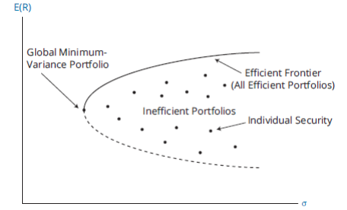

*Figure 5: Minimum-variance and efficient frontier*

MPT also uses the Sharpe Ratio:

is the expected return of the portfolio.

is the risk-free rate

is the standard deviation of the portfolio's return, representing the risk or volatility of the portfolio.

The Sharpe Ratio is used to measure the performance of an investment compared to a risk-free asset, after adjusting for its risk (Muller, 2014). The Sharpe Ratio thus provides a way to quantify how much excess return is being received for the extra risk taken when holding a risky asset, as opposed to a risk-free asset (Muller, 2014). A higher Sharpe Ratio indicates a more favorable risk-adjusted return, suggesting that the investment's returns are more than compensating for the additional risk (Muller, 2014).

### **2.7.2 Advantages of Modern Portfolio Theory**

Modern Portfolio Theory (MPT), a groundbreaking framework in investment strategy and risk management, offers several compelling advantages. Firstly, it emphasizes the importance of diversification, advocating for a portfolio that combines a variety of assets to reduce risk while maximizing returns (Pan, 2019). This diversification principle is rooted in the theory's core idea that the risk and return of a portfolio are more important than the performance of individual securities. Secondly, MPT introduces the concept of an efficient frontier, providing investors with a quantitative means to identify the most efficient portfolios based on desired risk levels (Tasche & Zentrum Mathematik). This approach allows for strategic asset allocation, balancing risk against expected returns. Additionally, MPT has evolved with advancements in computational power and financial modeling. For instance, the Intelligent Portfolio Theory, an extension of MPT, integrates dynamic asset allocation and trading strategies, offering a more adaptive and comprehensive investment framework (Pan, 2019). This evolution also includes the incorporation of sophisticated risk measures like Value-at-Risk (VaR), moving beyond traditional variance-based risk assessments (Tasche & Zentrum Mathematik). Furthermore, when combined with behavioral finance, MPT offers a more holistic view of the market, acknowledging the impact of investor psychology on financial decisions (Curtis, 2004). This synergy enhances the practical application of MPT, making it a more effective tool in contemporary investment management. Lastly, the adaptability of MPT to technological innovations, such as automatic trading systems, makes it accessible and relevant in the modern financial landscape, particularly in managing risks and optimizing returns in diverse market conditions (Snarska & Krzych, 2006). Overall, Modern Portfolio Theory's blend of theoretical rigor, practical adaptability, and its continuous evolution with emerging financial insights and technologies, solidify its standing as a cornerstone in investment strategy and portfolio management.

### **2.7.3 Disadvantages of Modern Portfolio Theory**

Modern Portfolio Theory (MPT), while influential in the field of investment management, is not without its disadvantages. One significant limitation is its reliance on assumptions that may not always hold true in real-world scenarios. For instance, MPT assumes that markets are efficient and investors are rational, which often isn't the case (Curtis, 2004). Behavioral finance, which focuses on how psychological factors affect financial decisions, highlights these discrepancies, suggesting that investor behavior often deviates from the rationality assumed by MPT.

Another critique of MPT is its reliance on historical data to predict future returns and risks. This backward-looking approach can be problematic, especially in volatile or rapidly changing markets (Grujić, Mekinjić, & Vujičić-Stefanović). The theory also tends to overlook transaction costs and foreign exchange differences, which can significantly impact portfolio performance (Grujić, Mekinjić, & Vujičić-Stefanović).

Moreover, MPT's standard risk measures, such as variance and standard deviation, may not adequately capture the true risks involved in investment scenarios, especially in markets characterized by asymmetric information and non-normal return distributions (Zhang et al. 2022). This can lead to suboptimal portfolio construction and risk management.

In summary, while MPT provides a foundational framework for portfolio construction and risk management, its limitations, including questionable assumptions about market efficiency and investor rationality, reliance on historical data, and potential underestimation of risks, suggest the need for a more nuanced approach that incorporates behavioral insights and more sophisticated risk assessment tools.

## **2.8 Customer Segmentation analysis**

### **Methodology and solution**

We employed K-Means clustering, a statistical technique that groups customers based on the similarity of their financial characteristics. We selected three key features: 'Monthly Income', 'Accumulated Assets', and 'Age', for their insightful representation of customer behavior.

1. **Data Standardization**

To ensure a fair comparison, we normalized the data to give equal weight to the three features despite their differing scales and ranges.

1. **Optimal Number of Clusters**

The Elbow Method indicated that three is the optimal number of customer segments. This was supported by the Silhouette Score, which suggested that three clusters provide a good balance between having distinct customer segments and manageability.

1. **Cluster Analysis**

***Cluster 0***

* Features: Highest average monthly income and accumulated assets with a wide age range.
* Appears to be the most affluent group, possibly consisting of established or retired individuals with significant financial resources. Ideal candidates for premium products and services.

***Cluster 1***

* Features: Moderate average monthly income and accumulated assets. Age distribution suggests a mid-career group.
* Represents middle-income customers likely in the midst of their careers. They might be managing financial responsibilities such as mortgages and education for children.

***Cluster 2***

* Features: Lowest average monthly income and accumulated assets. Younger age demographic.
* Likely consists of younger or early-career individuals beginning to accumulate wealth. Open to financial products for long-term growth.

# **3. Implementation and results**

## **3.1 Economic analysis**

### **3.1.1 Data collection**

We have undertaken a comprehensive data collection initiative, focusing on key macroeconomic indicators from 2017 to 2023. This includes gathering data on the FED Interest Rate and the SBV Interest Rate, which are crucial for understanding monetary policy impacts. Additionally, we have compiled information on the 10-Year Bond Yield, a significant indicator of long-term interest rates and economic expectations. The VND/USD exchange rate data has also been collected, providing insights into currency market dynamics and international trade implications. Furthermore, the Consumer Price Index (CPI) data has been gathered to analyze inflation trends. Lastly, we have included the VN-Index in our dataset, offering a comprehensive view of the Vietnamese stock market's performance over this period. This extensive collection of macroeconomic data is instrumental in providing a holistic understanding of the economic environment and financial markets.

### **3.1.2 Navigating the Economic and Financial Landscape of Vietnam: 2017-2023**

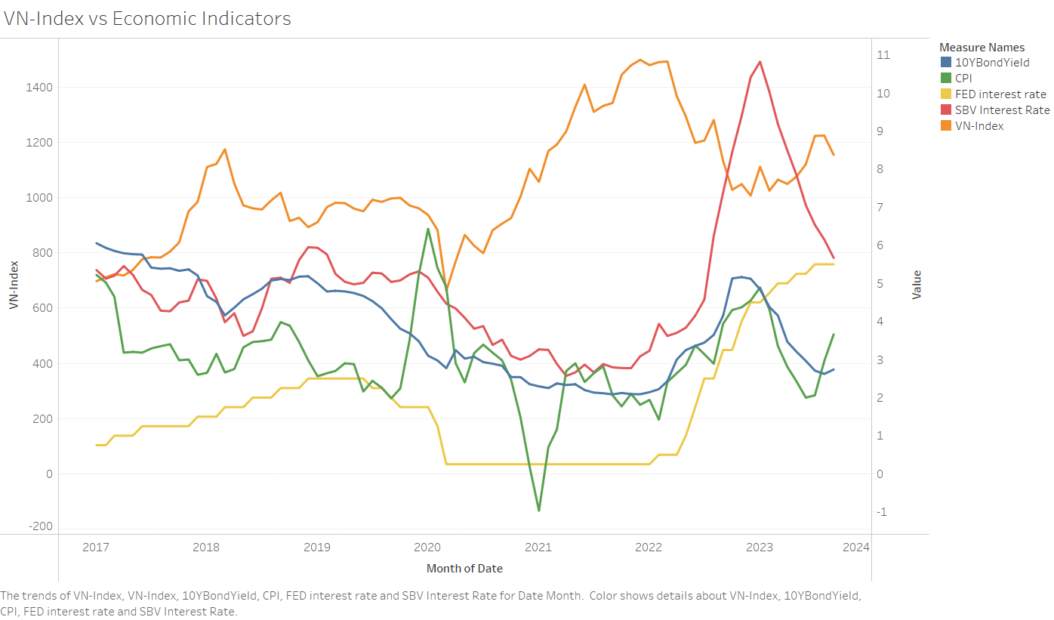

*Figure 12: Monetary Policy and the VN-Index 2017-2023*

During the period spanning 2016-2020, the global economic landscape navigated through a series of complex vicissitudes, marked by heightened protectionism and trade tensions between major economic entities such as the U.S.-China, South Korea-Japan, Australia-China, and U.S.-EU. These geopolitical frictions adversely influenced investor confidence, curtailed trade, decelerated investments, and further destabilized an already precarious global economic recovery. The emergence of the Covid-19 pandemic in early 2020 amplified these challenges, leading to a global recession, with a contraction of -4.4% as indicated by IMF's 2020 estimates (Zulfahmi & Sishadiyati, 2023).

In response, international financial and currency markets experienced considerable instability. Leading economies, including the U.S. Federal Reserve and the State Bank of Vietnam (SBV), shifted their monetary policies from "normalization" to aggressive monetary easing. These adjustments aimed to stimulate borrowing, investments, and consumption to bolster economic activity during the downturn (Queyranne, Baksa, Abdulkarim, & Bazinas, 2021).

The impact of these monetary policy actions was tangible in the financial markets. Central bank rate reductions traditionally invigorate investments and bolster financial asset valuations, as empirically validated by the appreciation of the VN-Index from 670 in January 2020 to 1498 by December 2021 (Rao & Kumar, 2023). However, in February 2022, with rising inflationary pressures and geopolitical events, central banks increased rates, prompting capital reallocation towards more resilient assets like government bonds, driving up their yields.

Between February and July 2023, the VN-Index embarked on a recovery trajectory, buoyed by a moderation in inflation rates and central bank rate recalibrations (Zulfahmi & Sishadiyati, 2023). This period underscored the responsive approach central banks employ in using rates to target inflation and economic stability.

Despite accommodative monetary stances, challenges persist. The prevailing environment, influenced by central bank rate decisions and broader monetary policy objectives, suggests caution for investments in high-risk assets, particularly equities. Central banks' monetary decisions, especially those concerning interest rates, have a profound impact on borrowing, consumption, and subsequently, economic growth. When central banks lean towards rate reductions, the environment typically becomes conducive for increased borrowing and consumption, potentially leading to economic expansion. This positive trajectory often translates into augmented corporate profitability, subsequently buoying stock prices. Additionally, stable inflation metrics, or aggressive steps by central banks to mitigate excessive inflation, further signal a stable environment favorable for stock market performance.

Yet, the investment landscape is not without its set of cautionary markers. A hike in interest rates by central banks can dampen borrowing and expenditure, potentially heralding an economic slowdown. Such a turn of events can adversely affect corporate bottom lines, leading to subdued stock valuations. External variables, too, play a pivotal role. Even in the face of seemingly favorable monetary dynamics, geopolitical disturbances or political unrest can introduce market volatility. Such uncertainties often precipitate a shift in capital from equities to more stable assets.

Drilling down further, there are nuanced factors that investors should heed. The strength of the domestic currency, which can be influenced by interest rate decisions, directly impacts sectors with a pronounced export inclination. A potent domestic currency might erode the global competitiveness of these sectors, potentially denting their stock valuations. Moreover, the forward-looking statements and guidance from central banks shape market sentiment, often influencing investment decisions even before actual policy adjustments come into play.

Complementing these considerations is the yield on the 10-year government bond (10Y bond yield), an invaluable metric for stock market participants. A rising yield often signifies market expectations of imminent central bank rate augmentations, making bonds a more attractive proposition vis-à-vis equities. Such scenarios can be particularly challenging for interest rate-sensitive sectors like real estate, while sectors like banking might benefit from an expanded interest rate differential. Conversely, a receding 10Y bond yield could be indicative of looming economic challenges or anticipated monetary easing, making growth-centric stocks or dividend-yielding sectors more appealing. The broader yield curve, especially its shape, offers additional insights, with an inverted curve historically signaling potential economic contractions. Additionally, in our globally intertwined financial architecture, 10Y bond yield movements in major economies can redirect global capital flows, influencing markets across the spectrum. An uptick in bond yields, propelled by surging inflation expectations, might also redirect investor attention towards tangible assets or sectors positioned to thrive in inflationary contexts.

In essence, while central bank policies and metrics like the 10Y bond yield provide invaluable guidance, a comprehensive investment strategy necessitates a holistic perspective, blending these insights with a broader understanding of global economic trends, geopolitical shifts, and industry-specific dynamics.

### **3.1.3 The relationship between VNINDEX and Economic Indicators**

This part aims to establish the relationship between VNINDEX and several key economic indicators. We seek to ascertain whether there is a relationship between stock market performance and specific economic variables, such as interest rates, inflation etc. By analyzing these relationships, we can provide valuable insights for investors.

**Select the independent variables**

(a) FED Interest Rate

The central interest rate set by the U.S. Federal Reserve to influence economic activity. Higher FED interest rates can lead to a stronger U.S. dollar, which may attract foreign investments away from emerging markets like Vietnam. It can increase the cost of borrowing for businesses and impact corporate earnings, potentially leading to lower stock prices.

(b) SBV Interest Rate

The official interbank interest rate set by the State Bank of Vietnam, impacting financial and economic activities in Vietnam. The State Bank of Vietnam's interest rate influences the cost of borrowing and lending in the Vietnamese financial system. A higher SBV interest rate may reduce investor appetite for equities, as fixed-income assets become more attractive.

(c) 10-Year Bond Yield

The interest rate on 10-year government bonds, a key indicator for long-term interest rates. Rising bond yields can signal higher returns on fixed-income investments, potentially diverting funds away from stocks. It may also indicate concerns about inflation and affect investors' risk appetite for equities.

(d) VND/USD

The exchange rate between the Vietnamese Dong (VND) and the United States Dollar (USD). A weaker Vietnamese Dong (VND) relative to the U.S. Dollar (USD) can benefit export-oriented companies but may increase import costs and inflation. Exchange rate fluctuations can affect the competitiveness of Vietnamese businesses, impacting stock prices.

(e) CPI (Consumer Price Index)

Measures changes in consumer goods and services prices, a common indicator for inflation and cost of living. A rising CPI can erode purchasing power and reduce real returns on investments. It may influence investor sentiment, as high inflation can be perceived as a risk factor for the stock market.

**Multiple regression model**

where:

**Estimation**

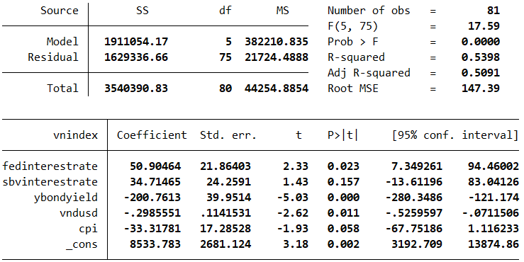

Figure 13: Linear Regression Coefficients and Relationships

**Assessing the fitness of the model**

The coefficient of determination is 0.5398, this means that 53.98% of the variation in operating margins is explained by the six independent variables, while 46.02% remains unexplained. The adjusted coefficient of determination is 0.5091, that is, the adjusted coefficient of determination is 50.91%, indicating that, no matter how we measure the

coefficient of determination, the model’s fit is moderately good.

**Diagnose violations of required conditions**

1. No perfect multicollinearity

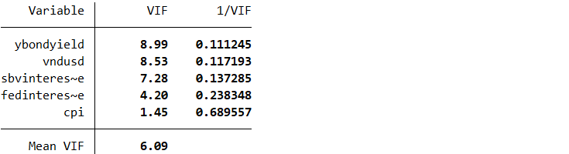

Figure 14: Checking for assumption “No perfect multicollinearity”

The VIF values for all the independent variables are below 10, indicating that there is no significant issue of multicollinearity in the regression model. The assumption of no perfect multicollinearity is not violated.

2. The errors are homoscedastic (standard deviation of ε, σε, is a constant)

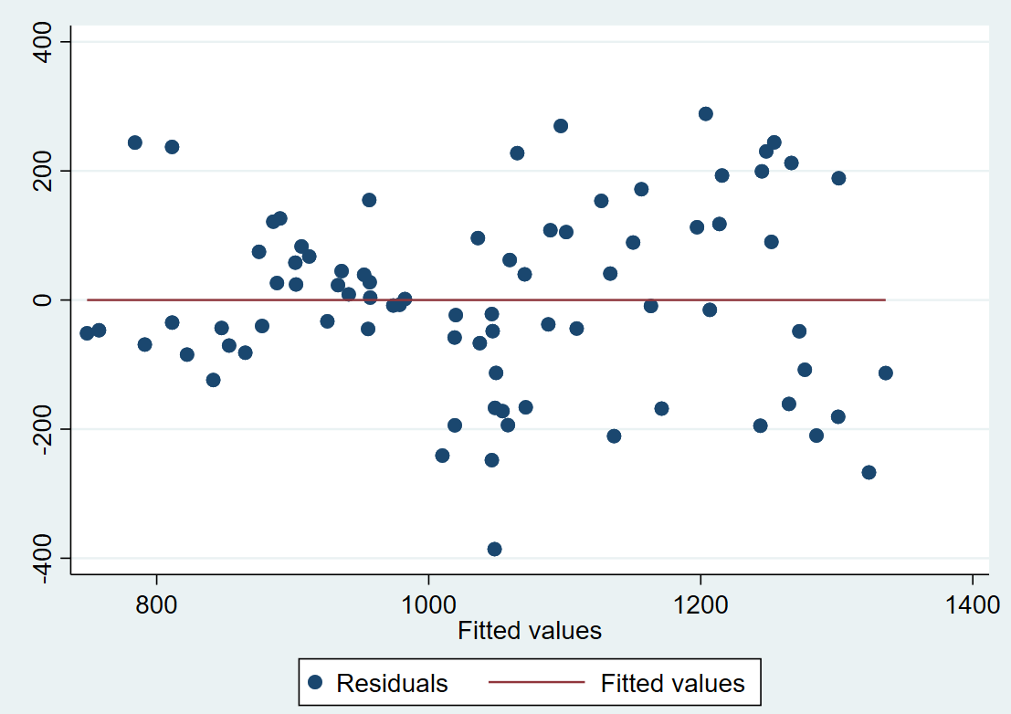

Figure 15: Checking for assumption “The errors are homoscedastic”

As can be seen from Figure 24, there is no evidence of heteroscedasticity.

3. Zero conditional mean

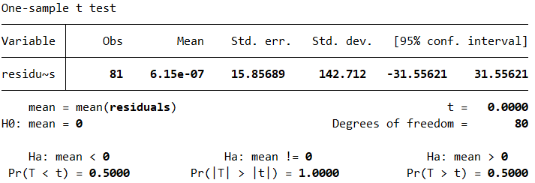

Figure 16: Checking for assumption “Zero conditional mean”

The one-sample t-test indicates that there is no significant difference between the mean of the residuals and zero. This suggests that the assumption of a zero conditional mean is not violated, meaning that, on average, the errors in the regression model do not exhibit a systematic bias or pattern

4. The errors are independent

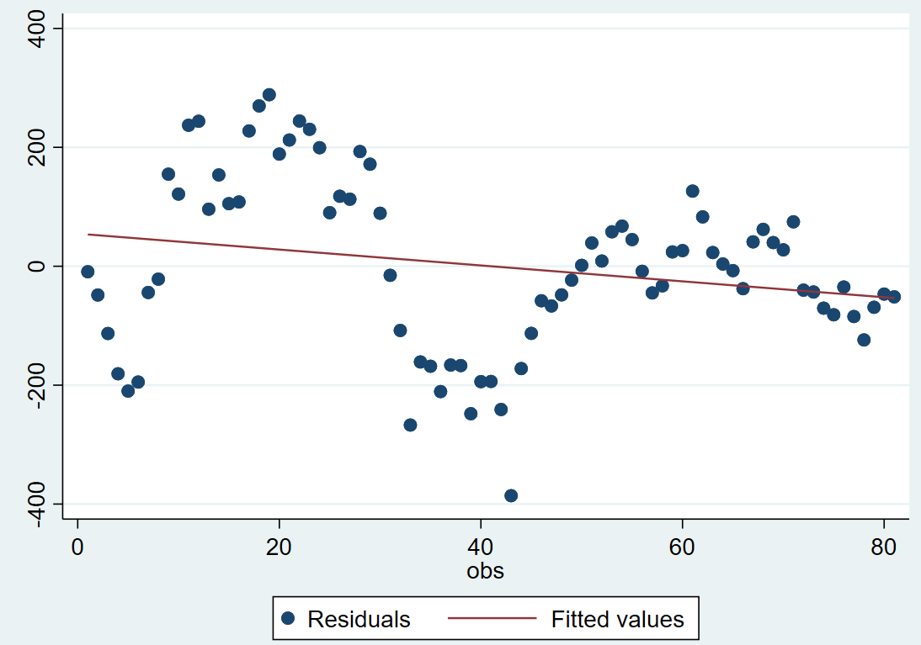

Figure 17: Checking for assumption “The errors are independent”

As can be seen from Figure 26, there is evidence of autocorrelation

**Testing the significance of the individual coefficient estimates**

For each independent variable, we test (i = 1, 2, 3, 4, 5)

* Test of β1 (Coefficient of the FED Interest Rate)

Value of the test statistic: t = 2.33; p-value = 0.023 < 0.05 = α; reject . There is evidence to infer that the FED Interest Rate and VN-Index are linearly related.

* Test of β2 (Coefficient of the SBV Interest Rate)

Value of the test statistic: t = 1.46; p-value = 0.157 > 0.05 = α; do not reject . There is no evidence to conclude that SBV Interest Rate is linearly related to VN-Index.

* Test of β3 (Coefficient of the 10-Year Bond Yield )

Value of the test statistic: t = -5.03; p-value = 0 < 0.05 = α; reject . There is strong evidence to infer that the 10-Year Bond Yield and VN-Index are linearly related.

* Test of β4 (Coefficient of the VND/USD )

Value of the test statistic: t = -2.62; p-value = 0.011 < 0.05 = α; reject . There is evidence to infer that the VND/USD and VN-Index are linearly related.

* Test of β5 (Coefficient of the CPI)

Value of the test statistic: t = -1.93; p-value = 0.058 > 0.05 = α; do not reject . There is evidence to infer that the CPI and VN-Index are linearly related.

Overall, there is sufficient evidence at the 5% significance level to infer that each of the following variables is linearly related to VN-Index:

**Interpreting the coefficient estimates**

* The intercept (8533.78): This is the expected value of the VN-Index when all other variables are 0. However, in this context, a value of 0 for these variables may not make practical sense.
* FED Interest Rate coefficient (50.9): For each unit increase in the FED Interest Rate, the VN-Index is expected to increase by 50.9 units, assuming all other variables are held constant.
* SBV Interest Rate coefficient (34.71): For each unit increase in the SBV Interest Rate, the VN-Index is expected to increase by 34.71 units, assuming all other variables are held constant.
* 10Y Bond Yield coefficient (-200.76): For each unit increase in the 10Y Bond Yield, the VN-Index is expected to decrease by 200.76 units. This is because of the negative coefficient, indicating an inverse relationship with the VN-Index.
* VND/USD exchange rate coefficient (-0.29): For each unit increase in the VND/USD exchange rate, the VN-Index is expected to decrease by 0.29 units. Again, this negative coefficient indicates an inverse relationship.
* CPI coefficient (-33.31): For each unit increase in the CPI, the VN-Index is expected to decrease by 33.31 units, indicating an inverse relationship.

### **3.1.4 Key finding**

In the evaluation of the regression model analyzing the relationship between the VN-Index and various economic indicators, the findings reveal a complex interplay of factors. The model aligns with traditional monetary policy theories in some aspects while presenting notable deviations in others. A key insight is the model's negative coefficient for the 10-Year Bond Yield and the Consumer Price Index (CPI). This aligns with the conventional wisdom that rising bond yields make equities less attractive and that high inflation erodes consumer purchasing power, both negatively impacting stock market performance.

Contrastingly, the positive coefficients for the FED and SBV interest rates challenge standard expectations. Typically, higher interest rates are thought to deter equity investments by increasing borrowing costs and potentially slowing economic activity. However, the model suggests that the VN-Index actually rises with increasing interest rates, hinting at unique market dynamics that could be influenced by factors such as external capital inflows or specific domestic economic conditions not directly included in the model.

Additionally, the inverse relationship between the VN-Index and the VND/USD exchange rate suggests that a weaker Vietnamese Dong relative to the U.S. Dollar might negatively impact the stock market, possibly due to concerns over economic stability or the effects of higher import costs on domestic industries.

The most significant finding of the model is the dominant influence of the 10-Year Bond Yield on the VN-Index. The large absolute value of its coefficient indicates a strong negative relationship: a one-unit increase in the 10-Year Bond Yield is associated with a substantial decrease of 200.76 units in the VN-Index, assuming other variables remain constant. This finding underscores the sensitivity of the VN-Index to long-term interest rates and reflects the broader economic sentiment and expectations about future financial conditions.

In summary, while the model provides valuable insights into the factors influencing the VN-Index, it also highlights the complexity of stock market dynamics. These dynamics are shaped not only by domestic monetary policies but also by a blend of global economic events and investor perceptions, making the financial market a multifaceted and intricate system.

## **3.2 Industry Sector Analysis**

### **3.2.1 Data collection**

We have undertaken a comprehensive data collection effort, focusing on the prices of 95 different stocks, along with the specific Industry Sector of each stock, over the period from June 9, 2022, to August 31, 2023. This extensive dataset serves as the foundation for our analysis, where we aim to calculate the relative strength of each industry sector in comparison to the VN-Index. By meticulously tracking and analyzing these stock prices over the specified timeframe, we can gain valuable insights into the performance of various sectors within the Vietnamese market. This analysis will enable us to understand how different industry sectors have fared relative to the overall market trends as represented by the VN-Index, providing a nuanced view of sectoral strengths and weaknesses.

### **3.2.2 Implementation**

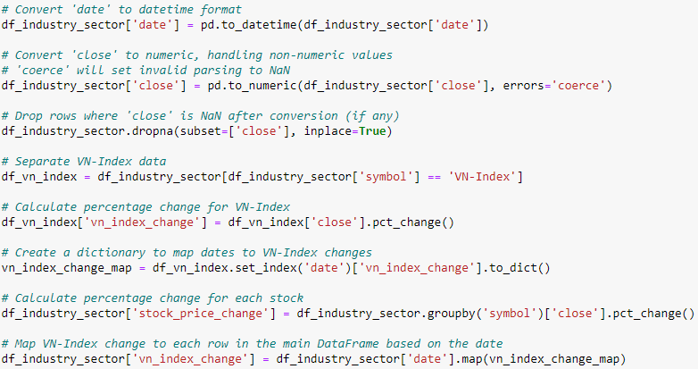

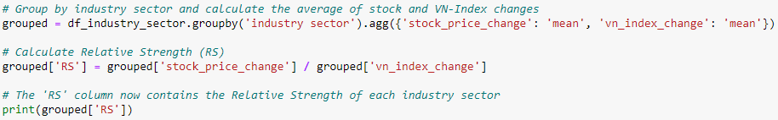

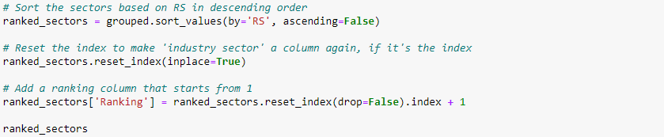

*Figure 18: Relative strength implementation*

A detailed process is outlined for calculating the Relative Strength (RS) of various industry sectors relative to a market index, exemplified here by the VN-Index. Initially, the dataset is prepared by converting the 'date' column to datetime format and transforming the 'close' column into numeric values, with non-numeric values turned into NaNs. Following this, any rows with NaN in the 'close' column are discarded. The dataset is then filtered to separate the data specifically for the VN-Index. Subsequently, the percentage change in the closing prices is calculated for both the VN-Index and the stocks in the dataset. This step is crucial for assessing the performance dynamics over time. A dictionary is created to map the percentage changes of the VN-Index to corresponding dates, facilitating a direct comparison with stock performance on the same dates. The main DataFrame is then grouped by industry sector, where average percentage changes for both stock prices and the VN-Index are calculated. The RS for each sector is derived by dividing the average stock price change by the average VN-Index change, offering a measure of each sector's performance relative to the overall market. Finally, the sectors are ranked based on their RS values in descending order, and a ranking column is added to the dataset, starting from 1. This process results in a structured and insightful analysis of the relative strength of each industry sector, providing a valuable tool for market analysis and investment decision-making.

### **3.2.3 Key finding**

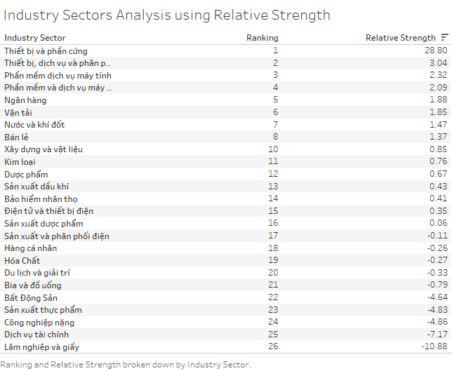

*Figure 19: Industry Sectors Analysis using Relative Strength*

The analysis of industry sectors in the Vietnamese market, based on stock price changes, VN Index changes, and Relative Strength (RS), reveals a diverse landscape of performance and market dynamics. At the forefront is the "Thiết bị và phần cứng" (Equipment and Hardware) sector, which, despite a negative stock price change, achieves the highest RS of 28.795372. This exceptional RS score indicates a robust performance relative to the market, suggesting resilience or sector-specific strengths that outweigh broader market trends.

Close behind, the "Thiết bị, dịch vụ và phân phối dầu khí" (Oil & Gas Equipment, Services, and Distribution) sector shows a positive trajectory in both stock price and VN Index change, reflected in its healthy RS of 3.039476. This performance points to a sector that is thriving in line with, or slightly better than, overall market movements.

The sectors of "Phần mềm dịch vụ máy tính" (Computer Services Software) and "Phần mềm và dịch vụ máy tính" (Software and Computer Services) also demonstrate positive growth, with RS values indicating that they are outperforming the market, albeit not as dramatically as the leading sector. This suggests a solid and growing demand for technology and software services.

In the banking sector ("Ngân hàng"), there is evidence of positive growth, mirrored in both stock price and VN Index change. Its RS indicates a performance slightly above the market average, suggesting stability and steady growth, a positive sign for investors looking for reliable sectors.

The "Vận tải" (Transportation) sector, similar to banking, shows healthy growth, although its RS is slightly lower, indicating good but not exceptional performance compared to the market.

Conversely, sectors like "Nước và khí đốt" (Water and Gas), "Bán lẻ" (Retail), and "Chỉ số thị trường chung" (General Market Index) present a mixed picture. While the Water and Gas sector shows slight resilience despite a negative stock price change, the Retail sector, despite challenges, performs better than the market average. The General Market Index serves as a baseline for market comparison.

The remaining sectors, ranging from "Xây dựng và vật liệu" (Construction and Materials) to "Lâm nghiệp và giấy" (Forestry and Paper), display varying degrees of market alignment. Some, like Construction and Materials, Metals, and Pharmaceuticals, indicate moderate positive growth, while others, notably Real Estate, Food Production, Heavy Industry, Financial Services, and Forestry and Paper, are marked by negative stock price changes and RS values below 1, signaling underperformance relative to the broader market.

In essence, this analysis paints a picture of a market with distinct sectoral strengths and weaknesses. Sectors like Equipment and Hardware, and Oil & Gas Equipment, Services, and Distribution are outperforming the market significantly, while sectors like Banking and Transportation show steady growth. On the other hand, sectors like Real Estate, Food Production, Heavy Industry, and Financial Services face notable challenges, as evidenced by their negative RS values and lower rankings. This sectoral analysis is crucial for investors seeking to navigate the complexities of the Vietnamese market, highlighting areas of potential opportunity and risk.

## **3.3 Comprehensive Stock Selection Strategy**

### **3.3.1 Data collection**

In this section, we have meticulously gathered financial report data and price information for 95 stocks spanning from 2017 to 2023. This extensive data collection is pivotal for our stock selection process, which is based on a blend of fundamental and technical analysis criteria as outlined in our methodology section. By analyzing the financial reports, we gain deep insights into each company's financial health, performance trends, and overall stability. Simultaneously, the price data of these stocks provide us with valuable information on stock performance over time.

### **3.3.2 Implementation**

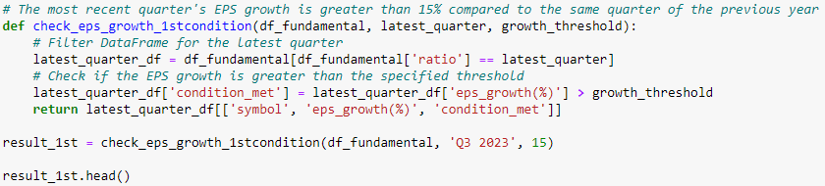

*Figure 20: First condition*

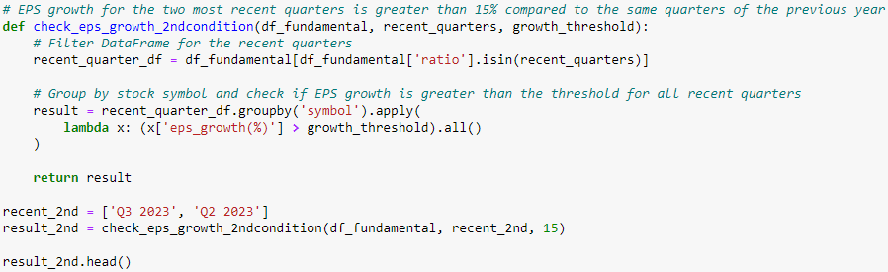

*Figure 21: Second condition*

In your sophisticated stock evaluation strategy, the code meticulously implements and combines nine distinct conditions to analyze and rank stocks, each examining different facets of a company's financial and technical performance. The first two conditions focus on Earnings Per Share (EPS) growth. The *check_eps_growth_1stcondition* function verifies if the most recent quarter's EPS growth, specifically 'Q3 2023', surpasses a 15% threshold compared to the same quarter of the previous year. Meanwhile, *check_eps_growth_2ndcondition* extends this scrutiny to two recent quarters ('Q3 2023' and 'Q2 2023'), ensuring EPS growth in both exceeds 15% relative to the corresponding quarters of the prior year. This layered EPS analysis emphasizes both immediate performance and short-term consistency in growth.

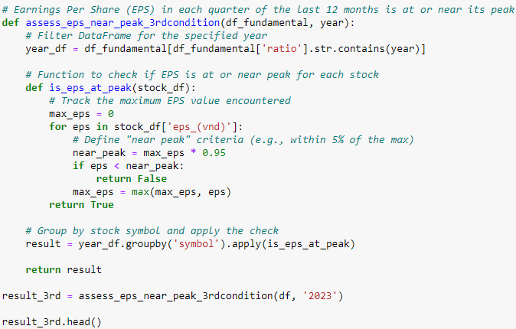

*Figure 22: Third conditions*

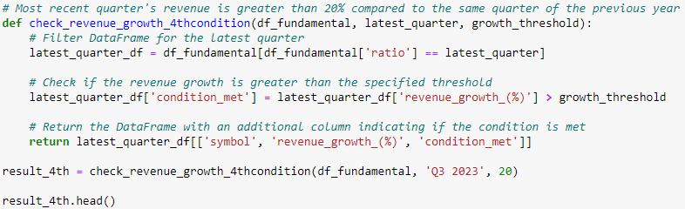

*Figure 23: Fourth condition*

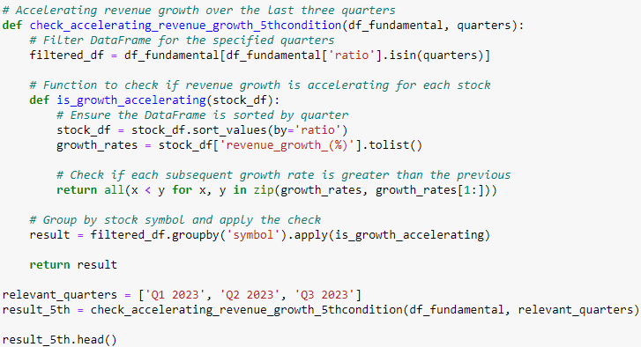

*Figure 24: Fifth condition*

The third condition, implemented in *assess_eps_near_peak_3rdcondition*, delves into EPS stability and strength across the last year, 2023 in this case. It assesses if EPS in each quarter is at or near its peak, signaling consistent operational efficiency and profitability. The fourth and fifth conditions, encapsulated in *check_revenue_growth_4thcondition* and *check_accelerating_revenue_growth_5th* condition, shift focus to revenue growth. The former examines if the most recent quarter's revenue growth (again 'Q3 2023') exceeds 20% year-over-year, while the latter assesses accelerating revenue growth over the last three quarters, indicating robust market demand and business expansion.

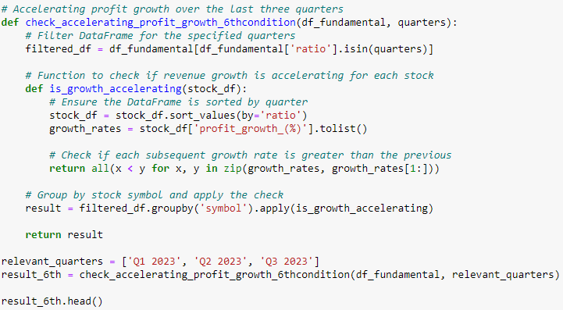

*Figure 25: Sixth condition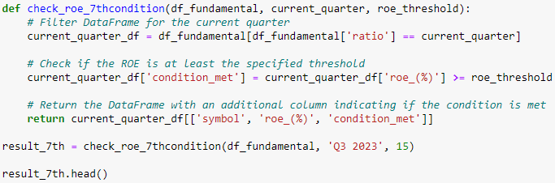*

*Figure 26: Seventh condition*

Profit growth is scrutinized in the sixth condition through *check_accelerating_profit_growth_6thcondition*, ensuring profit gains are accelerating over the most recent three quarters, mirroring the revenue growth analysis. The seventh condition, *check_roe_7thcondition*, introduces ROE analysis for 'Q3 2023', checking if it meets or surpasses 15%, a metric of financial efficiency.

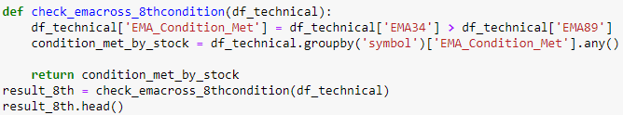

*Figure 27: Eighth condition*

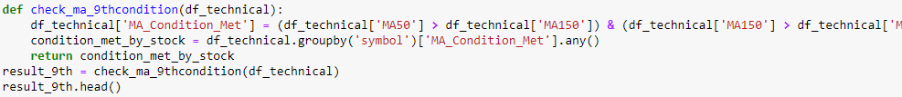

*Figure 28: Nineth condition*

Technical analysis is integrated via the eighth and ninth conditions with *check_emacross_8thcondition* and *check_ma_9thcondition*. The former examines EMA crossovers for bullish trends, while the latter analyzes MA patterns to ensure a strong upward trend.

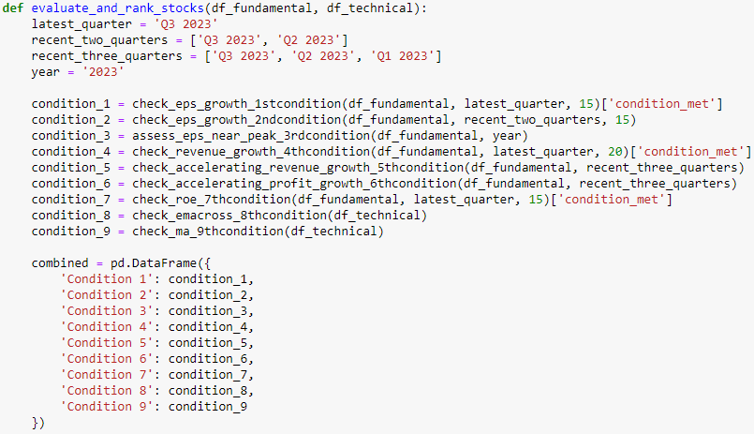

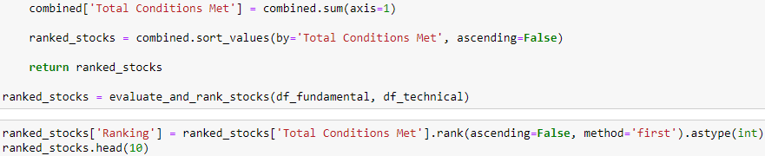

*Figure 29: Combination of 9 conditions to evaluate stocks*

Finally, this robust methodology culminates in a comprehensive ranking system. Each stock is assessed against all nine conditions, and the results are aggregated. Stocks meeting a higher number of these criteria are ranked higher, under the premise that fulfilling multiple conditions indicates a strong, well-rounded company. This intricate approach, weaving together multiple strands of fundamental and technical analysis, offers investors a nuanced and thorough framework for identifying high-potential stocks. The resulting ranked list is more than just a set of recommendations; it's a strategic tool, crafted to guide investors towards stocks that not only show promising individual metrics but also exhibit a holistic pattern of strength and growth potential.

### **3.3.3 Key finding**

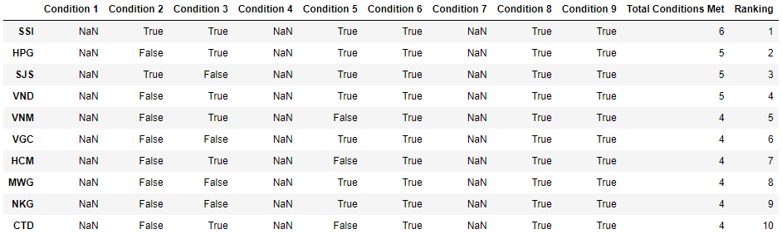

*Figure 30: Assessing Criteria for Stock Selection Strategy*

In the analysis of stock performance based on nine key criteria, SSI emerges as the frontrunner, satisfying 6 out of the 9 conditions. This top ranking underscores SSI's strong alignment with the majority of the evaluated fundamental and technical criteria, despite falling short in three areas. Its position at the apex of the ranking highlights its status as the most favorable stock in the assessment, particularly in terms of meeting the specified criteria that gauge both fundamental and technical health.

In a closely contested tier, HPG, SJS, and VND are in a three-way tie, each complying with 5 out of the 9 conditions. This result points to a relatively robust alignment with the criteria, though it stops short of being comprehensive. The specific conditions that these stocks fail to meet could be pivotal, especially for investors who prioritize certain aspects of stock performance over others. This tie suggests that while these stocks show promise, they also have distinct areas that require careful consideration by investors.

Further down the ranking, VNM, VGC, HCM, MWG, NKG, and CTD each meet 4 of the 9 conditions. Their lower positioning in the ranking reflects a moderate level of compliance with the selected criteria. The fact that these stocks satisfy less than half of the conditions indicates notable gaps in aligning with the desired investment parameters. This suggests that while they exhibit some positive attributes, there are significant aspects in which they do not meet the investment criteria, warranting a cautious approach from investors.

Overall, this analysis provides a clear hierarchy of stock performance based on specific, quantifiable criteria. It offers valuable insights for investors, highlighting not only the strengths but also the potential shortcomings of each stock within the context of the selected fundamental and technical parameters.

## **3.4 Trading Bot**

### **3.4.1 Data collection**

In this segment of our analysis, we have strategically gathered price data for 10 select stocks over the period from 2017 to 2023. These stocks – SSI, VND, HPG, SJS, VNM, VGC, HCM, MWG, NKG, and CTD – represent the top performers that most closely align with the criteria established in our stock selection process. The choice of this specific six-year timeframe is intentional and critical to our evaluation. This period encapsulates the full spectrum of market conditions, including Uptrend, Downtrend, and Sideways movements. By analyzing data across these varied market states, our objective is to rigorously assess the effectiveness of our stock trading strategy. We aim to determine whether our approach remains robust and yields favorable outcomes regardless of the prevailing market conditions. This comprehensive evaluation is designed to test the adaptability and resilience of our trading methods, ensuring they are equipped to navigate the complexities and dynamics of the stock market effectively.

### **3.4.2 5/20 Donchian Method Trading Bot: Revolutionizing Stock Market Strategy**

This Trading Bot, crafted on the foundation of the 5/20 Donchian technical analysis method as outlined in our methodology section, is a sophisticated tool designed to enhance the trading experience. It automates the process of identifying precise buying and selling points based on the 5/20 strategy The integration of a Trading Bot, particularly one tailored to the 5/20 Donchian method, revolutionizes the approach to stock trading with its array of advantages. Firstly, the bot significantly enhances time efficiency by automating market analysis and trade execution, liberating investors from the need for constant market vigilance. This automation allows them to allocate their time more effectively towards strategic planning or other pursuits.

A key benefit of the Trading Bot is its ability to facilitate emotionless trading. By relying on predefined rules and algorithms, the bot circumvents the emotional biases that often lead to poor trading decisions. This objectivity is crucial, especially in a market where emotional reactions can lead to hasty or ill-advised trades. Consistency is another hallmark of the Trading Bot. Adhering to the disciplined parameters of the 5/20 Donchian method, it ensures a steady and methodical approach to trading, which is particularly valuable in the often volatile stock market.

The bot's ability to rapidly respond to market changes is a significant advantage. It processes extensive data at a speed unattainable by human traders, thus capitalizing on quick market shifts and minimizing risks associated with delayed reactions. Backtesting and optimization are further enhanced with the Trading Bot. It allows for thorough testing against historical data, refining the trading strategy to ensure robust performance under various market conditions. This feature is invaluable for developing a resilient trading approach.

Scalability is another key benefit. The bot can manage multiple trades across various stocks and sectors simultaneously, a feat challenging to replicate through manual trading. This scalability is crucial for expanding trading operations without compromising efficiency or accuracy. For new or part-time traders, the Trading Bot offers accessibility and convenience. It simplifies complex trading decisions, making the stock market more approachable for those who may lack the time or expertise for in-depth market analysis.

Lastly, the bot's reliance on data-driven decisions ensures a high level of accuracy and reliability in trades, grounding each action in thorough analysis and sophisticated algorithms.

In essence, the Trading Bot stands as a transformative tool in the stock market, aligning with the evolving needs of modern investors who seek to leverage technology for more informed, efficient, and effective trading outcomes.

### **3.4.3 Implementation**

Central to this strategy is the analysis of the 5-day and 20-day moving averages (MA5 and MA20) of a stock's price. Thetrading_strategyfunction systematically iterates through the stock data, captured in the DataFramedf, to identify pivotal crossover points between these two moving averages, which serve as indicators for trading decisions.

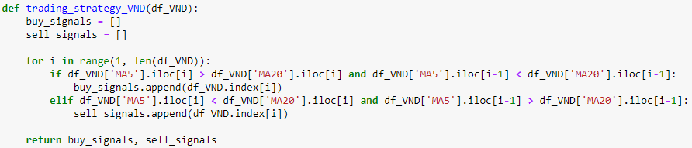

*Figure 31: Rule-based for trading bot*

The core of the strategy lies in recognizing buy and sell signals:

* **Buy Signals:** The algorithm determines a buy signal when the shorter-term MA5 crosses above the longer-term MA20. This crossover is identified in the code through the conditiondf['MA5'].iloc[i] > df['MA20'].iloc[i] coupled with df['MA5'].iloc[i-1] < df['MA20'].iloc[i-1]. This specific scenario suggests an emerging upward trend in the stock's price, indicating a potential opportunity for investors to purchase the stock, expecting further price increases.
* **Sell Signals:** Conversely, the sell signal is flagged when the MA5 dips below the MA20, implying a bearish trend. The code captures this through the conditional check df['MA5'].iloc[i] < df['MA20'].iloc[i] anddf['MA5'].iloc[i-1] > df['MA20'].iloc[i-1]. This pattern typically signifies a downward trajectory in the stock's price, potentially signaling traders to sell off their holdings to avoid further losses or to capitalize on short-selling opportunities.

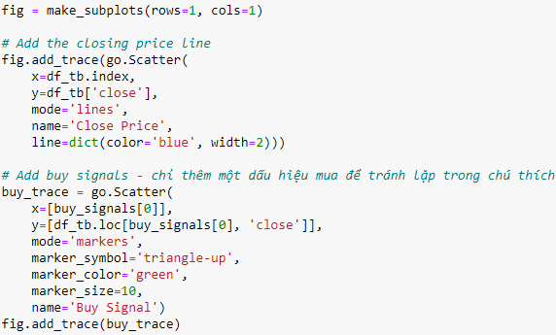

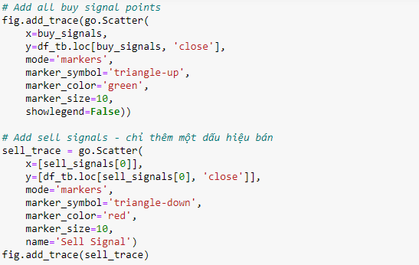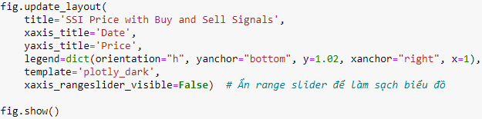

*Figure 32: Visualize the buy and sell signal of trading bot*

What sets this implementation apart is not just the logical detection of these signals but also their visual representation. Utilizing Plotly's make_subplotsandgo.Scatter, the code elegantly plots the stock's closing price against time and overlays the buy and sell signals on this plot. Buy signals are marked with green upward-pointing triangles, and sell signals with red downward-pointing triangles. This visual aid is crucial in providing a clear, intuitive understanding of the market trends and the effectiveness of the signals generated by the moving average crossovers.

Furthermore, the strategy's implementation is meticulously designed to handle real-world stock data, considering each trading day's data point to ensure no opportunity for a buy or sell signal is missed. This diligent approach, combined with the interactive and informative visual representation of the stock's performance and the signals, makes the 5/20 Donchian strategy not just a theoretical concept but a practical tool for traders. It exemplifies how technical analysis can be efficiently utilized to make informed trading decisions, thereby serving as an invaluable asset in a trader's arsenal, especially in volatile or fast-moving markets.

This demonstration highlights the bot's ability to adeptly navigate and respond to the market's dynamics, showcasing its utility as an essential asset for investors aiming to refine and expedite their trading decisions in the ever-evolving landscape of the stock market.

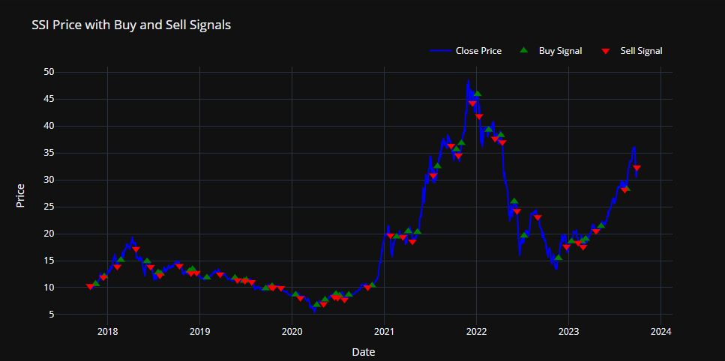

*Figure 33: Trading bot demonstration on SSI from 2017-2023*

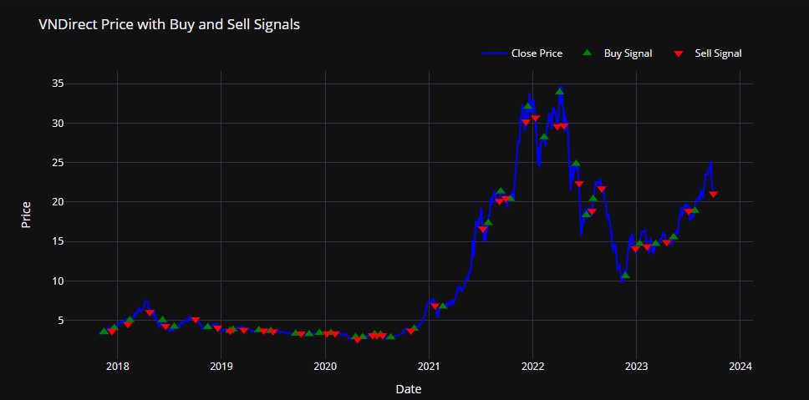

*Figure 34: Trading bot demonstration on VND from 2017-2023*

### **3.4.4 Trading bot back-testing result**

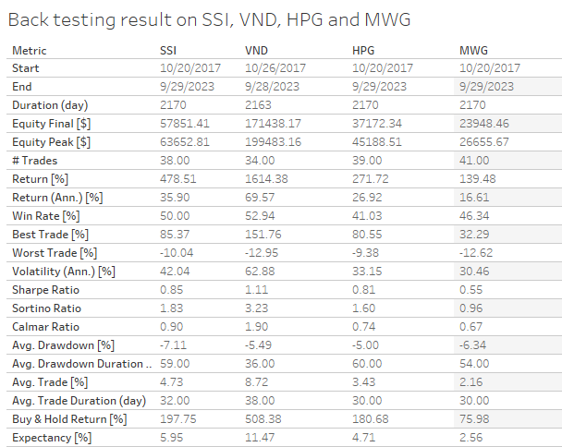

*Figure 35: Trading bot back-testing result on SSI, VND, HPG and MWG*

Focusing solely on the duration and exposure time of the trading bot across the four stocks, we observe a strategic approach characterized by a long-term perspective and varying degrees of market engagement. The duration of the trades, spanning approximately six years, indicates a commitment to a long-term trading strategy. This extended period allows for the capture of a wide range of market conditions, from short-term fluctuations to longer-term trends, providing a comprehensive test of the bot's effectiveness over time. The exposure time, ranging from 55% to 60% across different stocks, reveals the proportion of this duration when the bot was actively invested in the market. Notably, this level of exposure suggests a moderately aggressive trading strategy. It implies that the bot was invested more than half of the time, seizing market opportunities as they arose, yet it also allowed for periods of non-exposure, potentially to avoid risk during unfavorable market conditions or to reassess its strategy. This blend of consistent market participation with periods of strategic withdrawal underscores a balanced approach, aiming to capitalize on market opportunities while mitigating risk through calculated non-exposure.

In examining the Equity Final and Equity Peak values from your trading bot's performance, a clear narrative of growth and peak performance emerges. The Equity Final values reflect significant growth for all stocks, with VND standing out due to its exceptional rise. Specifically, VND's Equity Final value reached an impressive $171,438.17, dwarfing the final equity figures of SSI ($57,851.41), HPG ($37,172.34), and MWG ($23,948.46). This indicates not just a successful strategy but a standout performance in the case of VND, where the bot's approach capitalized most effectively on the market opportunities. The Equity Peak values further reinforce this story. VND again leads with a staggering peak equity of $199,483.16, signaling a period during the trading span where its performance reached its zenith. This peak is markedly higher than those achieved by SSI ($63,652.81), HPG ($45,188.51), and MWG ($26,655.67). The notable difference between VND's final and peak equity values might also suggest a significant retraction from its highest point, indicating a period of exceptional gains followed by a downturn. These figures collectively underscore a highly effective strategy for VND, while also illustrating substantial growth achieved across all the other stocks, albeit to a lesser extent.

The performance of the trading bot, particularly in the context of returns, highlights its superiority over a traditional buy & hold strategy. When we analyze the Return [%], it's evident that the bot's strategy yielded substantial gains across all stocks, significantly outstripping the returns one would have achieved with a simple long-term hold approach. For example, VND delivered a staggering return of 1614.38%, far exceeding its buy & hold return of 508.38%. This trend is consistent across the other stocks as well; SSI's return at 478.51% against a buy & hold return of 197.75%, HPG with 271.72% compared to its 180.68% buy & hold return, and MWG at 139.48% over a buy & hold return of 75.98%.

These figures not only demonstrate the efficacy of the bot's active trading strategy but also underscore its ability to significantly amplify returns compared to a passive investment strategy. Additionally, when we look at the Annualized Returns (Return (Ann.) [%]), the data further reinforces this narrative of impressive performance. VND, in particular, showcases extraordinary annualized returns of 69.57%, indicating that not only did the bot capture substantial gains, it did so consistently over the trading period. This consistent high performance over time, especially in comparison to the more conservative annual gains from a buy & hold strategy, speaks volumes about the bot's strategic acumen and its ability to navigate and capitalize on market dynamics effectively.

The analysis of risk metrics for the trading bot across the four stocks provides a comprehensive view of how risk was managed in relation to the returns generated. Beginning with Volatility (Ann.) [%], we observe that VND and SSI exhibited higher annual volatility, suggesting they were subjected to greater market risk compared to HPG and MWG. Specifically, VND's higher volatility indicates it was exposed to more significant price fluctuations, a factor that could typically increase the risk of substantial losses.

However, when we assess the Sharpe Ratio, which adjusts returns for this volatility, both SSI and VND stand out with ratios above 1. This is particularly noteworthy for VND, which, despite its higher volatility, achieved the highest Sharpe Ratio, indicating that it managed to generate substantial risk-adjusted returns. A Sharpe Ratio above 1 is generally considered excellent, suggesting that the returns provided by the bot for these stocks were more than compensating for the taken risks.

Further into the risk analysis, the Sortino Ratio, which focuses on downside risk, shows higher values across all stocks, with VND again being the most notable. This implies that the bot's strategy was particularly effective in managing and mitigating downside risks in volatile markets, a key aspect of any successful trading strategy.

The Calmar Ratio, which relates returns to the maximum drawdown, also tells a positive story for VND and SSI. Their high ratios suggest that these stocks had better risk-adjusted performance relative to their respective maximum drawdowns. Speaking of which, the Max Drawdown [%] metric indicates the largest drop from a peak to a trough. VND's maximum drawdown being the least severe among the stocks is a testament to more effective risk management, despite its higher volatility and substantial gains.

Analyzing the trading bot's performance across the four stocks (VND, SSI, HPG, and MWG) reveals a well-calibrated approach in its trading frequency and effectiveness. The number of trades executed presents a picture of moderation, with 34 trades for VND, 38 for SSI, 39 for HPG, and 41 for MWG. This indicates a slightly higher activity with MWG and HPG, yet the numbers are not excessively high, suggesting a strategic and balanced trading approach across all stocks.

In terms of win rates, VND leads with the highest, highlighting its efficiency in executing winning trades. In comparison, HPG, with the lowest win rate at 41.03%, seems to have encountered more challenges in consistently securing wins, though it remained profitable. SSI and MWG recorded win rates of 50% and 46.34% respectively, suggesting a more evenly balanced win-loss ratio.

The variability in trade outcomes is further illustrated by the best and worst trade percentages. VND not only had the highest win rate but also excelled in its best trade, reinforcing its superior performance. Conversely, MWG's worst trade showed a decline of 12.62%, possibly indicating higher risks or challenges in mitigating losses in certain situations. The range of outcomes for SSI and HPG aligns with the inherent variability in trading.

When assessing average trade profitability, VND consistently outperforms, suggesting that its trades were generally more lucrative. In contrast, despite having the highest number of trades, MWG's average trade percentage was the lowest, indicating that its trades were less profitable on average. SSI and HPG occupy a middle ground, reflecting moderate success in this metric.

Lastly, the trade duration, averaging around one month for all stocks, points to a strategy focused on short to medium-term market movements. This consistent duration across stocks suggests a deliberate approach in not veering towards extremely short or long-term trades, instead capitalizing on intermediate market trends.

The efficiency and quality metrics of the trading bot across the four stocks - VND, SSI, HPG, and MWG - provide a clear picture of its effectiveness and reliability. The Profit Factor for all stocks was greater than 1, which is a strong indicator of profitability. Particularly notable is VND, which achieved the highest Profit Factor, underscoring the exceptional profitability of the strategy employed for this stock. The Expectancy [%] metric, representing the average expected return per trade, was positive across the board, with VND again leading the way. This higher expectancy in VND suggests that each trade, on average, was more likely to yield a higher return compared to the other stocks.

Further examining the System Quality Number (SQN), which assesses the strength and reliability of the trading system, we find that VND and SSI scored higher values. This indicates that the trading systems for these stocks were more robust and consistent in performance. The higher SQN for VND and SSI suggests a higher degree of reliability and effectiveness in the trading strategies implemented for these stocks, reinforcing the notion that the bot was particularly adept at navigating the market conditions and opportunities associated with VND and SSI. Overall, these efficiency and quality metrics collectively demonstrate that the trading bot was not only profitable but also reliable and consistent in its performance, particularly in the case of VND.

## **3.5 Portfolio allocation using Modern Portfolio Theory**

### **3.5.1 Data Collection**

To accurately calculate the weight of each stock in our investment portfolio, we diligently collected data on the prices of the top 10 stocks identified in Section 3.3. This comprehensive dataset spans from 2017 to 2023, providing a substantial historical perspective on the performance of these selected stocks. The primary purpose of this extensive data collection is to apply the Modern Portfolio Theory (MPT) in our investment strategy. MPT, a key concept in investment management, emphasizes the importance of diversification and risk-return trade-off in portfolio construction. By analyzing the historical price data of these stocks, we can assess their volatility and correlation with each other. This analysis is crucial for determining the optimal allocation of each stock in the portfolio, aiming to maximize returns while minimizing risk. This methodical approach, grounded in the principles of MPT, enables us to create a well-balanced and efficient portfolio tailored to meet our investment objectives and risk tolerance levels. The use of historical data over a significant period allows for a more accurate and robust analysis, factoring in different market cycles and conditions, thereby enhancing the potential for achieving better risk-adjusted returns.

### **3.5.2 Implementation**

The provided code represents an exemplary application of Modern Portfolio Theory (MPT), skillfully adapted for practical portfolio management. This adaptation begins with the calculation of lognormal returns for each stock, a crucial step in MPT. Log returns are favored in this context for their ability to accurately reflect compounded returns over time, making them ideal for a comparative analysis across various time periods. This lays the groundwork for assessing each stock's performance and its impact on the portfolio's overall risk and return dynamics.



*Figure 36: Calculate the Lognormal Returns for each stock*

Continuing this MPT-aligned approach, the code calculates the covariance matrix of these log returns, annualizing it by multiplying by 252 to reflect the standard number of trading days in a year. This step is vital in MPT for understanding how different stocks' returns move in relation to each other, which is instrumental in devising effective diversification strategies. Diversification, a central tenet of MPT, aims to create a portfolio with assets that have varying correlations, thereby mitigating unsystematic risk.

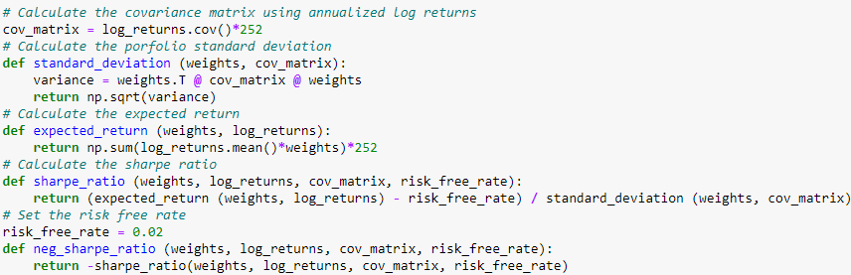

*Figure 37: Essential calculations of MPT*

The code's next advancement is the computation of the portfolio's standard deviation using the standard_deviation function. This metric is integral to MPT, as it helps in evaluating the viability of different asset combinations in striking the right balance between risk and return. The expected_return function then calculates the portfolio's expected annual return, based on the weighted average of the stocks' mean log returns, aligning perfectly with the MPT's objective of maximizing returns for a given level of risk.

The Sharpe Ratio, derived via the sharpe_ratio function, captures the essence of MPT. It measures the risk-adjusted return, providing a gauge of the excess return generated per unit of risk compared to a risk-free investment. A high Sharpe Ratio indicates an attractive risk-adjusted return.

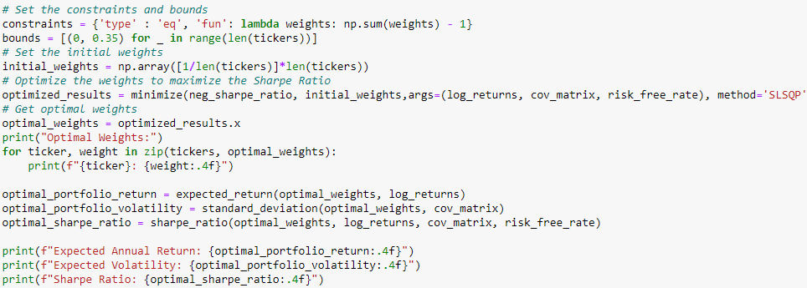

*Figure 38: Essential calculations of MPT*

A key enhancement in the code is the optimization process, which employs SciPy's minimize function to maximize the Sharpe Ratio. This optimization process is subjected to constraints and bounds that ensure the sum of the weights equals 1, in line with MPT's full capital allocation requirement, while also capping individual stock weights at 50%. This constraint is a significant improvement over traditional MPT, mitigating the risk of over-concentration in any single asset and fostering a more balanced, diversified portfolio.

The code concludes by outputting the optimal weights for each stock, along with the portfolio’s expected annual return, volatility, and Sharpe Ratio. These results not only underscore the practical utility of MPT in portfolio construction but also emphasize the additional risk management layer introduced through the weight constraints.

In essence, this implementation stays true to the principles of MPT while incorporating pragmatic enhancements to ensure its applicability in real-world investment scenarios. It represents a comprehensive approach that harmonizes theoretical optimization with practical risk management, aiming to construct a diversified portfolio that maximizes risk-adjusted returns within specific constraints. The introduction of individual asset weight caps, in particular, represents a notable advancement, addressing the real-world need for balanced investment strategies that consider market volatility and the risks of over-concentration.

### **3.5.3 Key finding**

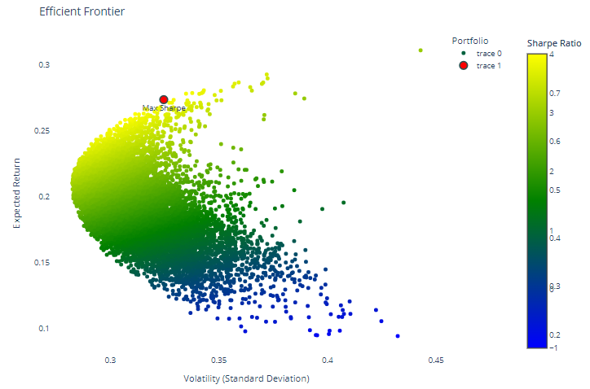

*Figure 39: Efficient frontier of portfolio of 5 stocks with high risk*

The efficient frontier illustrated in the graph is an embodiment of Modern Portfolio Theory (MPT), meticulously applied to a select portfolio composed of five key stocks: SSI, VND, HPG, NKG, and MWG. These stocks were chosen based on predetermined criteria to construct a diversified investment portfolio, aiming to optimize the balance between risk and return as prescribed by MPT. The graph portrays a scatter plot of numerous potential portfolios, with each point representing a unique combination of weights across the chosen stocks. The color gradient across these points, ranging from blue to yellow, denotes the Sharpe Ratio—a critical measure of risk-adjusted returns.

The efficient frontier itself is the envelope formed by the upper boundary of this point cloud, signifying the set of 'efficient' portfolios that offer the maximum expected return for a given level of risk. Within this context, risk is quantified by the standard deviation of portfolio returns, and the expected return is the mean of the portfolio's historical log returns, annualized for comparability.

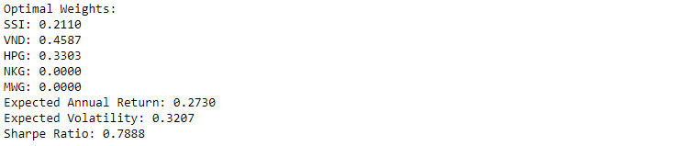

*Figure 40: Portfolio allocation for each stock*

In this detailed analysis, the portfolio labeled 'Max Sharpe' is highlighted in red, signaling its optimal status as per MPT guidelines. The optimal weights for this portfolio are 21.10% for SSI, 45.87% for VND, and 33.03% for HPG, with NKG and MWG being excluded from the allocation, suggesting that under the constraints and historical performance, these stocks do not contribute positively to the optimal risk-return profile. The allocation implies a focused investment strategy that concentrates on a subset of the analyzed securities, which, based on past performance, are expected to synergize to maximize the portfolio's Sharpe Ratio.

The optimal portfolio's expected annual return is projected at a robust 27.37%, juxtaposed with an anticipated volatility of 32.46%. This level of expected return is quite substantial and indicates the strong performance of the selected stocks in the analyzed period. However, the associated volatility also denotes a moderate to high risk profile, highlighting the inherent trade-off in investment decisions between potential returns and the level of acceptable risk.

The Sharpe Ratio for this optimal portfolio is calculated to be 0.7888, which, while not exceeding the threshold of 1, is still indicative of a respectable excess return over the risk-free rate when each unit of risk is considered. This ratio serves as a guiding metric for investors, depicting how well the investment's return compensates for its taken risk.

From the standpoint of diversification, the absence of investment in NKG and MWG could be a reflection of their lower contribution to the portfolio's efficiency or perhaps a higher correlation with the included stocks that does not reduce overall risk. The concept of diversification is foundational to MPT and is displayed through the shape of the efficient frontier—illustrating that combining various assets often results in a portfolio that can achieve higher returns for a given level of risk compared to individual assets.

Investors can leverage this efficient frontier graph to align their risk appetite with their investment choices. For conservative investors, portfolios plotted towards the bottom left offer a safer haven with lower returns and reduced volatility. In contrast, more aggressive investors might gravitate towards the top right segment, where higher returns are potentially achievable at the expense of increased risk exposure.

In summary, the graph not only validates the application of MPT in the practical scenario of portfolio optimization but also acts as a strategic guide for investment selection. It provides investors with a visual tool to compare different portfolio combinations and choose one that aligns with their individual risk tolerance, financial goals, and investment horizon. The 'Max Sharpe' portfolio stands out as the most efficient portfolio, having been rigorously calculated to deliver the best possible risk-adjusted returns given historical performance and reflecting a judicious blend of theoretical financial principles with pragmatic investment strategies.

## **3.6 Technical Analysis**

### **3.6.1 System Design and Tooling Choices**

For this project, we wanted to challenge ourselves and build an underlying **production-ready system.** For this reason, we had to find a way of incorporating industry best practices. How they deploy systems at scale, and the answer was quite obvious, a fully containerized system would be our choice, as containerizations bring many benefits, such as[1]:

* **Portability**: Containers are platform-independent, allowing applications to run on any machine without worrying about dependencies.
* **Efficiency**: Containers are lightweight and use fewer resources than virtual machines, leading to higher utilization of computing resources.
* **Agility**: Containers integrate well with existing DevOps environments, enabling faster delivery of enhancements.
* **Isolation**: Each container runs in isolation, improving the security by isolating applications from the host system and each other.
* **Easier Management**: Install, upgrade and rollback processes are built into platforms like Kubernetes.

With the pros that we listed above, explain why there are more than 50 percent of firms in the US’s Top 100 Fortune companies use a container orchestration platform[2], mainly Kubernetes.

As a result, we chose Kubernetes as our platform to build our system and applications on top of it.

With a solid choice of the base platform, we continue to consider our needs, specifically what this project needs, its requirements, how the components would interact with each other, and how the system should work as a whole. With the nature of this project, which is **data-intensive** and also comes with specific requirements for the stock market, which are:

* **Real-time Timeliness**: A common trait of the stock market, requiring realtime-updates based on current market data, this is by far the most crucial, as stock prices can change rapidly, and having the most updated information is essential for making informed trading decisions.
* **Low latency**: The system should have low latency to ensure that the recommendation and inference service can give the most up-to-date recommendations, the stock market is where a second can make a significant difference.

These above requirements play a crucial role in how we design the system and choose our tools and frameworks, and we come up with a high-level design of the system as below:

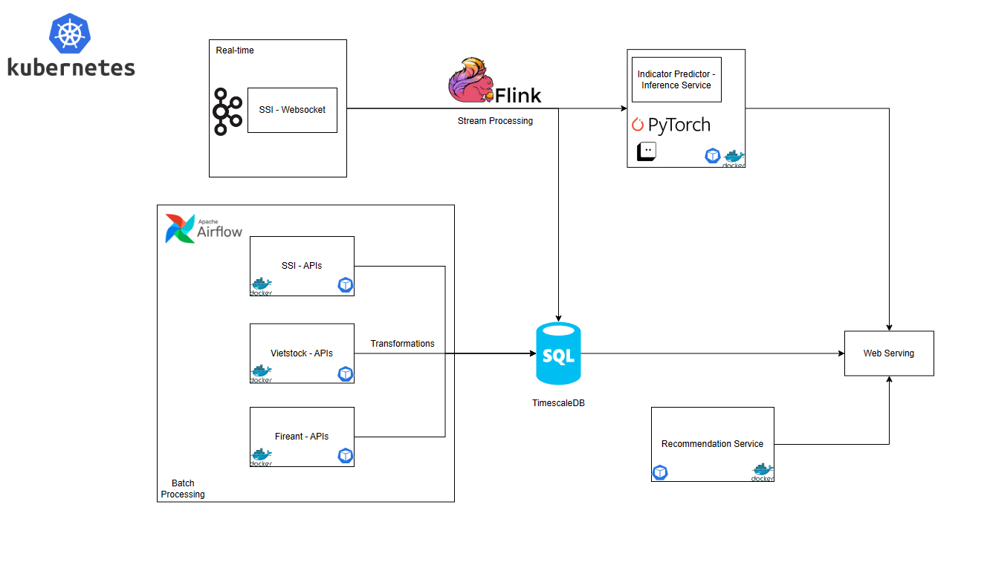

*Figure 6: System Design*

To clearly explain the system design diagram above, we first need to identify the requirements of this project, to its technical aspects, we need:

1. **Realtime and stream processing** would enable us to serve a real-time stock data feed and a stream processing that would allow us to have a real-time price indicator, a service that performs real-time inference from our ML model.
2. To enable our recommendation service to function properly, we would also need additional data that does not need to be real-time, so **batch processing** is a natural choice. Based on that, we need an orchestration tool that can enable us to perform batching automatically.
3. For our database, since the stock-market data is time series in nature, we need to choose a database that is tailored to this purpose, which is a **time series database**.
4. For our machine learning model, we wanted to pick a machine learning framework that is **easy to work with** and **has good community support**. We also wanted the framework to be somewhat **Pythonic** (i.e. it aligns with the philosophy of the Python language, thus making it more readable, follow conventions, easier to maintain, and more efficient).
5. To serve our model, we also need to pick a framework that would make **the process of deploying a model into an inference service as easy as possible**, and **not sacrificing too much on its functionalities**, also, if that framework comes with some **built-in MLOps toolings**, that would be great.

After some research, we came up with a tech stack that is suitable, powerful, and widely adopted. This is extremely important, as widely adopted technologies would have big user bases, and large communities, thus making it easier to tackle problems that may arise in the development process. The frameworks and toolings that were chosen are

1. We chose Apache Kafka and Apache Flink for event streaming and stream processing, respectively. Kafka is a widely adopted event streaming platform offering **high throughput** and **availability**[3]. Apache Flink is a unified stream and batch-processing framework, that offers **correctness** (with exactly-once-state consistency), **layered APIs** (with SQL and DataStream API to allow us to seamlessly work with data processing in SQL, Python, Java, etc), it also offers **scalability**, **low latency**, and **high throughput**[4]. Together with Kafka, this would be the backbone of our real-time system.
2. For batch processing, the choice would be **Apache Airflow**, a very popular workflow management platform that allows us to schedule our tasks, offers many other toolings to **handle complex workflows** (such as tasks branching and Xcom), and also offers a lot of different operators to handle different type of workloads[5].
3. The database of choice would be TimescaleDB, an extension of the most popular and widely used relational database PostgreSQL, Timescale is designed **specifically to improve the handling of time series data[6]**. This is a sweet spot, as we do not need to re-learn a new type of database, instead, this is just PostgreSQL, making it easier to use and maintain.
4. The machine learning framework of choice would be **PyTorch**, as it is quite a bit **easier to work with**, **more Pythonic**, and as such, making the code more **readable**, and **reuseable**.
5. For serving our model, we chose **BentoML[7]**, this is a framework that enables **packaging and serving our model extremely easily**, and it also has **a set of MLOps toolings** that is great when it comes to basic tasks like logging and serving multiple models.

### **3.6.2 Methodology and solution**

#### **3.6.2.1 Batch Data**

1. Getting the necessary data

Most of the batching data - the data that does not need to be real-time, is crawled using various APIs from multiple finance data providers, this is a popular practice in data crawling, in our development, the workflow is typically composed of steps below:

* **Identify the data needs** -i.e. What are they? Where can they be viewed on the web?
* Getting into providers’ websites to watch and identify the APIs, in this step, we use **Chrome’s developer tools** to **watch** the **networks** and **inspect** the network activities to find our desired APIs[8].
* After that, a tool for testing APIs is used, in our case, we use **Postman,** a platform to build and test APIs. In our use case, Postman allows us to customize the parameters and headers of an API request easily, we can also inspect the response and even get a piece of code generated to call the API[9].
* After we have identified the data, and the needed APIs, and tested those APIs, we write **Python codes to get the data**, **transform the data** to our desired outputs, and **put the data into the database**. These are basic **ETL** tasks.

2. Scheduling

Most of our batch data only require daily refresh, so we set our Airflow DAGs (A DAG (Directed Acyclic Graph) is the core concept of Airflow, collecting Tasks together, organized with dependencies and relationships to say how they should run[10].) with our desired schedule and task flows to create ETL pipelines for our data crawling tasks. The workflow is again, typically as follows:

* What is our desired Interval for this data? Does it need to run daily, weekly, or hourly, or how often does it need to run?
* What tasks does this DAG have? **Extract (calling the API)**, **Transform (performing transformations on the data)**, and **Load (loading it to a database)**. But, for this project, in particular, we adopted an **Integrated ELT Process.** Unlike the usual method where Extract, Transform, and Load are defined and executed separately in an Airflow DAG, our approach **encapsulated ETL tasks within a single Python module**. This module, designed following the **Object-Oriented principles**, consists of a class with methods, that in sequence, would perform the ETL process. This was done to maximize efficiency and minimize complexity, as it allows for the execution of all ETL tasks in a single run, thereby reducing the overhead associated with multiple task executions in Airflow.
* Deploy the DAG.

#### **3.6.2.2 Real-time Data**

1. Define the sources of real-time data for our use case

For our use case, we opted to connect to **SSI’s iBoard WebSocket[11]** (which is the trading board of SSI - the biggest securities company in Vietnam), before that, we also considered the WebSocket source of VNDirect (which is the second biggest securities company in Vietnam), but ultimately we chose SSI because in our humble opinion, we have used both systems, and we see that SSI seems to be more reliable.

2. After that, we connect the WebSocket to our Kafka cluster, and we use the following components to define our data:

* Schema Registry[12]: this is a registry to provide schema information for Kafka Producers and Consumers. It allows producers and consumers to communicate through a well-defined data contract[13] (we did not explicitly apply data contract in this project, so this is just a term) in the form of a schema.
* A Python code, to connect to the WebSocket and facilitate its messages through Kafka.
* Our web UI would be connected to Kafka and consume from the topic that our producer produces the messages to, and serve the real-time data on a dashboard for customers.

#### **3.6.2.3 Stream Processing**

1. For this part of the project, we use Flink to apply a **window function** on a **five-minute interval** and send the average close value to our **inference service,** to get a **Predictive Trading Signal.**

2. When Flink is subscribed to the topic, it runs a **Windowing function[14]** to calculate the average close value of that window and then sends the data to our inference service.

*Figure 7: Stream Processing*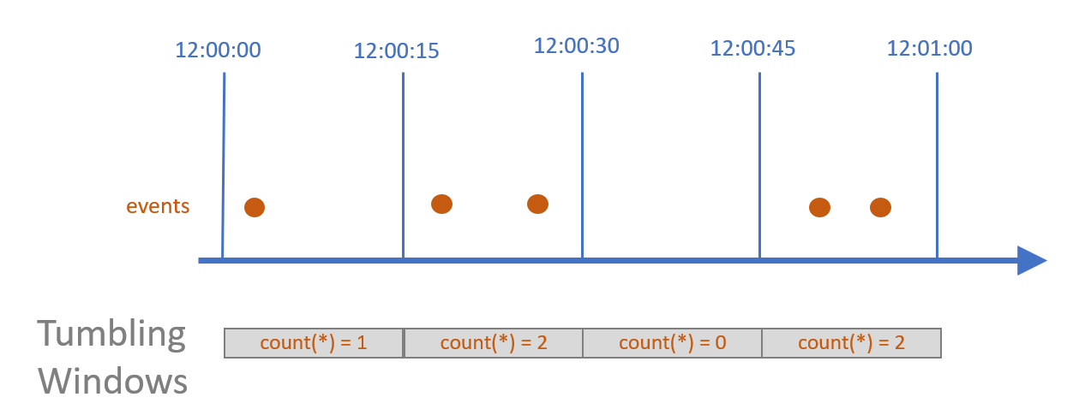

* For this windowing function, we went with a concept named: **Tumbling Window.** This is essentially performing a **GroupBy** function on a stream of data (or **unbounded data**), this function would perform GroupBy on **Event Time[15]** (which is the time that the event actually occurred, as opposed to **Processing Time[16]**).
* Flink would also ingest data into our database.
* Our inference service - which is an **LSTM model**, will predict the price based on that windowed average value, and based on that price, we produce a **Trading Signal**, that indicates **the direction of the stock value**, **up or down**.

#### **3.6.2.4 Inference Service**

Our inference service is an LSTM mode, packaged and deployed with BentoML on Kubernetes as a Kubernetes Deployment. The service will have API endpoints that allow the streaming process to send the data, and receive the prediction.

#### **3.6.2.5 Our Prediction Model**

##### **a. LSTM - Long Short-Term Memory**

For this project, our model would only have to produce a Trading Signal, so we opted for one of the most well-known models for **Timeseries Analysis - The LSTM - Long Short-Term Memory network.**

First of all, what is a Long Short Term Memory network? The LSTM network is a type of Recurrent Neural Network, created to resolve the **vanishing gradient problem[17]** that is present in traditional RNNs.

*Figure 8: LSTM - Long Short-Term Memory*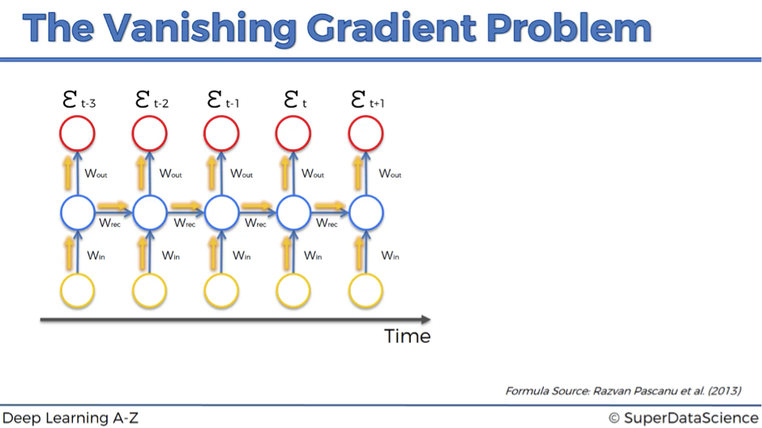

So what is the **vanishing gradient problem** in the first place? In RNNs, information travels through time, which means that information from previous points is used as input for the next time points. During training, the cost function compares your outcomes to your desired output at each time point, the error is then calculated and propagated back through the network to update the weights, this process is known as **backpropagation**[18].

The **vanishing gradient problem** arises here, during backpropagation, if the weights of the network are small (less than 1), the gradients of the loss function can approach zero as they are propagated back through the network. This is because the gradient of each layer is multiplied by the weight of the previous layer during backpropagation, as a result, the contribution of information (gradients) from earlier layers or time steps in the sequence can shrink to a point where it does not affect the update of the current weights. This is problematic in sequences where the data needs to be propagated over a long period. In the context of time series data, this means that the RNN may not be able to learn from important events that happened many time steps ago, this can affect the network’s ability to capture important patterns of the data.

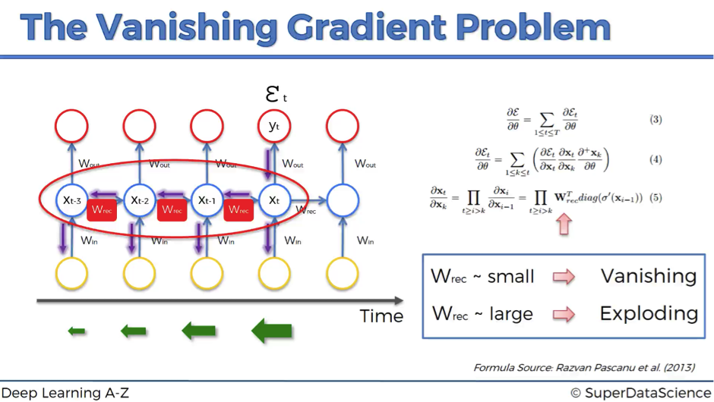[19]

*Figure 9: Vanishing gradient problem*

To combat this problem, several strategies were created, namely LSTM (Long Short Term Memory), or GRUs (Gated Recurrent Units), they are designed to allow gradients to flow unchanged throughout the backpropagation process. Let's take a look at the architecture of an LSTM network

* A common LSTM unit is made up of 4 components[20]: a **cell**, an **input gate**, an **output gate,** and a **forget gate.**
* **Forget Gate (f):** This gate decides what information should be kept or removed from the cell state, it uses the current input and the previous hidden state to make the decision. It uses a sigmoid function, which outputs a value between 0 (completely forget) and 1 (keep) for each number in the cell state.
* **Input Gate**: This gate updates the cell state with new information, it has two parts: a sigmoid layer, which devices which values to update, and a tanh layer, which creates new candidate values.
* **Cell State**: This is updated by forgetting the decided information and then adding the new candidate values.
* **Output Gate**: This decides the next hidden state. A sigmoid layer decides which parts of the cell state to output and then the cell state is put through tanh (to normalize values to between -1 and 1) and multiplied by the output of the sigmoid gate.

##### **b. How we create our LSTM model**

With the idea of which model to use, our machine learning framework of choice, we now present our data: a dataset of daily Open, High, Low, Close, and Volume data, for 100 stocks in the VN100 Index, spanning from 2017 to 2023.

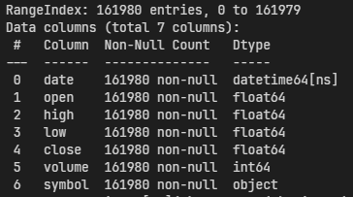

*Figure 11: Framework of choice*

As for coding up the model, we follow fairly traditional steps of training and validating a model, including:

* Clean up the data
* Splitting the data
* Scale the data
* Train the data
* Perform validation

More specifically, here are the steps, provided with code snippets in PyTorch

1. Scale the data using MinMaxScaler:

for num, i in enumerate(symbol_lts):

sc = MinMaxScaler(feature_range=(0, 1))

a0 = np.array(df_new[i]["Train"])

a1 = np.array(df_new[i]["Test"])

a0 = a0.reshape(a0.shape[0], 1)

a1 = a1.reshape(a1.shape[0], 1)

transform_train[i] = sc.fit_transform(a0)

transform_test[i] = sc.fit_transform(a1)

scaler[i] = sc

* Loops over a list of symbols (symbol_lts).
* For each symbol:
* Creates a MinMaxScaler instance to scale data between 0 and 1.
* Retrieves the 'Train' and 'Test' data for the current symbol from a DataFrame.
* Converts the 'Train' and 'Test' data to NumPy arrays and reshapes them to have a single column.
* Uses the MinMaxScaler to scale the 'Train' and 'Test' data.
* Stores the scaled data in the transform_train and transform_test dictionaries, using the symbols as keys.
* Stores the MinMaxScaler instance in the scaler dictionary, using the symbol as the key

1. Define the LSTM network

class LSTM(nn.Module):

def __init__(self, input_size, hidden_size, num_stacked_layers):

super().__init__()

self.hidden_size = hidden_size

self.num_stacked_layers = num_stacked_layers

self.lstm = nn.LSTM(

input_size, hidden_size, num_stacked_layers, batch_first=True

)

self.fc = nn.Linear(hidden_size, 1)

def forward(self, x):

batch_size = x.size(0)

h0 = torch.zeros(self.num_stacked_layers, batch_size, self.hidden_size).to(

device

)

c0 = torch.zeros(self.num_stacked_layers, batch_size, self.hidden_size).to(

device

)

# We need to detach as we are doing truncated backpropagation through time (BPTT)

out, (hn, cn) = self.lstm(x, (h0.detach(), c0.detach()))

out = self.fc(out[:, -1, :])

return out

* The class LSTM is defined, which inherits from nn.Module, the base class for all neural network modules in PyTorch.
* The __init__ method is defined, which is the constructor of the class. It takes three parameters:
* input_size: The number of input features.
* hidden_size: The number of hidden units in the LSTM layer.
* num_stacked_layers: The number of stacked LSTM layers.
* Inside the __init__ method:
* An LSTM layer (self.lstm) is defined, which takes input_size features, outputs hidden_size hidden states, and consists of num_stacked_layers stacked layers.
* A fully connected layer (self.fc) is defined, which maps the hidden_size LSTM output to a single output value.
* The forward method is defined, which takes an input tensor x and computes the output of the model. Inside the forward method:
* Two tensors h0 and c0 are initialized with zeros. These tensors represent the initial hidden state and the initial cell state of the LSTM layer, respectively.
* The detach method is called on h0 and c0 to prevent backpropagation through them, as the model uses truncated backpropagation through time (BPTT).
* The LSTM layer is applied to the input data and the initial states, resulting in an output tensor and the final hidden and cell states.
* The output tensor is passed through the fully connected layer, but only the last time step is considered (out[:, -1, :]). This is because in many tasks, only the output of the LSTM at the last time step is used for prediction.
* The output of the fully connected layer is returned.

1. Define a train function, to train each epoch of the process

def train_one_epoch():

model.train(True)

for i in symbol_lst_filtered:

logging("Fitting to", i)

running_loss = 0.0

for epoch in range(num_epochs):

logging.info(f"Epoch: {epoch + 1}")

for batch_index, batch in enumerate(train_loaders[i]):

x_batch, y_batch = batch[0].to(device), batch[1].to(device)

output = model(x_batch).squeeze()

loss = loss_function(output, y_batch)

running_loss += loss.item()

optimizer.zero_grad()

loss.backward()

optimizer.step()

if batch_index % 100 == 99: # logging.info every 100 batches

avg_loss_across_batches = running_loss / 100

logging.info(

"Batch {0}, Loss: {1:.3f}".format(

batch_index + 1, avg_loss_across_batches

)

)

running_loss = 0.0

logging.info()

* The function iterates over each symbol in symbol_lst_filtered.
* For each symbol, it iterates over a number of epochs defined by num_epochs.
* In each epoch, it iterates over each batch in the corresponding train loader.
* For each batch, it performs a forward pass with the model, computes the loss, and adds it to running_loss.
* It then resets the gradients, performs backpropagation with loss.backward(), and updates the model parameters with optimizer.step().
* Every 100 batches, it logs the average loss across the last 100 batches and resets running_loss.

1. Define a Validation function to validate each epoch:

def validate_one_epoch():

model.train(False)

running_loss = 0.0

for stock in symbol_lst_filtered:

for batch_index, batch in enumerate(test_loaders[stock]):

x_batch, y_batch = batch[0].to(device), batch[1].to(device)

with torch.no_grad():

output = model(x_batch).squeeze()

loss = loss_function(output, y_batch)

running_loss += loss.item()

avg_loss_across_batches = running_loss / len(test_loaders)

logging.info("Val Loss: {0:.3f}".format(avg_loss_across_batches))

* The model is set to evaluation mode with model.train(False).
* A variable running_loss is initialized to 0.0.
* The function iterates over each stock in symbol_lst_filtered.
* For each stock, it iterates over each batch in the corresponding test loader.
* For each batch, it moves the input data (x_batch) and target values (y_batch) to the device where the model is running.
* It performs a forward pass with the model without computing gradients (with torch.no_grad():), and computes the loss between the model output and the target values.
* The loss is added to running_loss.
* After iterating over all batches and stocks, it computes the average loss across all batches and logs it.

1. Run the training process

if __name__ == "__main__":

setup_logging()

model = LSTM(1, 6, 1)

model.to(device)

learning_rate = 0.001

num_epochs = 10

loss_function = nn.MSELoss()

optimizer = torch.optim.Adam(model.parameters(), lr=learning_rate)

for epoch in range(num_epochs):

train_one_epoch()

validate_one_epoch()

* An instance of the LSTM class is created with 1 input feature, 6 hidden units, and 1 stacked layer.
* The model is moved to the device specified by the device variable.
* The learning rate and number of epochs for training are set to 0.001 and 10, respectively.
* The loss function is set to mean squared error (nn.MSELoss()).
* The optimizer is set to Adam, with the learning rate passed as a parameter.
* The script enters a loop that runs for num_epochs iterations.
* In each iteration, the train_one_epoch function is called to train the model, and the validate_one_epoch function is called to validate the model.

#### **3.6.2.6 Recommendation Service**

Our recommendation service (as mentioned in the previous part) is packaged as a service and is running as a Kubernetes Deployment, provided with API endpoints that would be called by the web service for giving recommendations.

### **3.6.3 Implementation and Results Analysis**

#### **3.6.3.1 Implementation**

##### **a. Infrastructure and Code Quality**

With our previous statement of wanting this project to be **production-ready**, we believe that we have **achieved about 80%** of what we set out to do in terms of **production readiness.** These criteria are based on my **personal, real-world experience of working in a tech company, and also through research[21]:**

* **Code Quality & Sufficient Testing:** Code quality had been controlled, we follow the **SOLID[22]** principle and the **PEP8[23]** style guide of the Python language. The system had undergone rigorous testing to ensure it functions as expected under various conditions.
* We included logging to easily trace and fix bugs.
* We have included Unit Testing to ensure that our code base functions as expected.
* As for a full Integration Test, it is difficult to simulate under a group project environment, but because each component has been thoroughly unit-tested, we expect a full Integration Test should not be too hard to pass.
* In conclusion, we achieved 2 criteria over the 3 that we set out, so we would give ourselves a **finish percentage of 70%**
* **Reliability**: As this is running on a personal computer, it would be hard to measure this, as it heavily relies on the Infrastructure. But as stated above, we used a standard Kubernetes cluster, a technology that has been thoroughly developed tested, and widely used, we believe this would be sufficient if we count this point, but we decided not to grade this measurement because the evidence is not sufficient.
* **Scalability:** With Kubernetes, this should be simple in practice, because Kubernetes itself and its ecosystem provide a lot of auto-scaling options, most notably with **KEDA**[24]. As for us, we have not implemented any auto-scaling because we have not needed to, but if implemented, this should be simple enough to achieve. For this, we grade ourselves a **percentage point of 70%**, as we have chosen the best framework there is, and it has auto-scalable solutions.
* **Fault-tolerance:** In Kubernetes, if a pod fails or becomes unhealthy, the system can automatically restart it, this is part of Kubernetes’s self-healing mechanism, which is designed to handle certain types of faults and make the system healthy again. Kubernetes can also self-heal at the cluster level, if a node in the cluster fails, Kubernetes can automatically reschedule the pods from the failed node to a healthy node.[25]

##### **b. Serving and User Experience**

We have implemented our Recommendation Service, Real-time Price Board (with a predictive indicator) through a Web-UI.

Our Recommendation service can offer users recommended stocks and portfolio allocations based on their investment taste.

Our predictive indicator will produce a real-time predictor of stocks, and based on that, users can make more informed investment decisions.

#### **3.6.3.2 Results Analysis**

##### **a. Infrastructure and Code Quality**

For this part, as we have informed above, we did a solid job of choosing and using the industry's best tools and also applying the industry's best practices to our infrastructure and code. However, there are still parts where we can further enhance to make this project 100% production-ready, they are:

* Implementing CI/CD - Continuous Integration/Continuous Deployment, which is essentially automating the process of Coding, Testing, and Deploying applications, with little time and expertise, we could not deliver on this.
* A more robust infrastructure would be better if we installed proper VMs and Kubernetes with some production-grade distributions (for example RKE2), right now the Kubernetes Cluster is running locally with Docker Desktop on our machine, this is only suitable for development purposes.
* Full system integration testing: as mentioned above, we did not conduct full system tests, in real life, this would be extremely important, as the cohesion and correctness of the system as a whole would be vital to decide whether or not the system is production-ready.

##### **b. Serving and User Experience**

Our serving and User Experience could be deemed enough for an entry-level project, but with the goal of production-ready, we have much to do in terms of identifying customers’ needs and optimizing the experience.

##### **c. Our Machine Learning Model of Choice**

Generally speaking, we evaluate that our model performs relatively well, with respect to being an indicator. We did not use this model as a “price” predictor to get the exact price, rather, we used it as a Predictive Indicator, so our customers can make more informed trading decisions based on real-time fluctuations of the market. However, there are still a few things that we should have done, but could not:

1. Using Gated Recurrent Units (GRU) instead of LSTM, because:
   1. GRU is simpler, as they only have two gates (reset gates and update gates), whereas LSTM has three gates (input, output and forget gates). This makes GRU in general, more computationally efficient and faster to train[26]. This is especially true in our case, where we chose to train everything locally.
   2. GRU is also proven to perform as well as LSTM for certain tasks, and they are particularly effective when having less training data, which is true for our case, we only have about 170 thousand rows of data[27].
   3. GRU also generally uses less memory than LSTM, which would also come in handy for us when we are training the model locally[28].

There are a few more reasons, but the main point is GRU can give a similar result while being more efficient

1. Try different deep learning approaches

When we started developing this model, we had the idea of performing a transfer learning approach with this model, where we would have a machine learning model for each industry sector, and based on the model’s knowledge, continue to let it learn from the stocks prices to get the best output with respect to that sector and its stocks.

## **3.7 Customer segmentation**

* **Visual Analysis**
* **Elbow Method Graph**

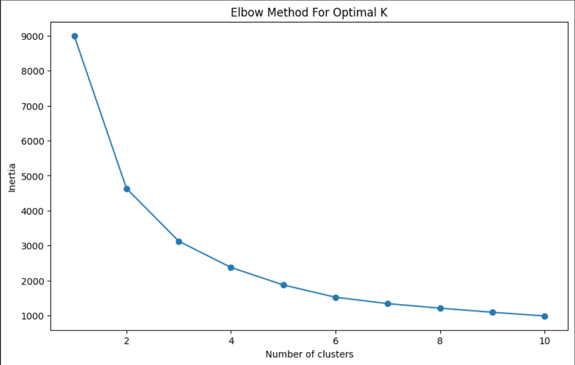

*Figure 41: Elbow method*

This graph shows the inertia (sum of squared distances from each point to its assigned center) for different numbers of clusters. The 'elbow' is the point after which the inertia starts to decrease at a slower rate. It suggests the number of clusters is a good trade-off between the complexity of the model and the accuracy of the segmentation. In this graph, there appears to be an elbow at 3 clusters, which is why you might choose to segment the customer base into 3 distinct groups.

* **Silhouette Score Graph**

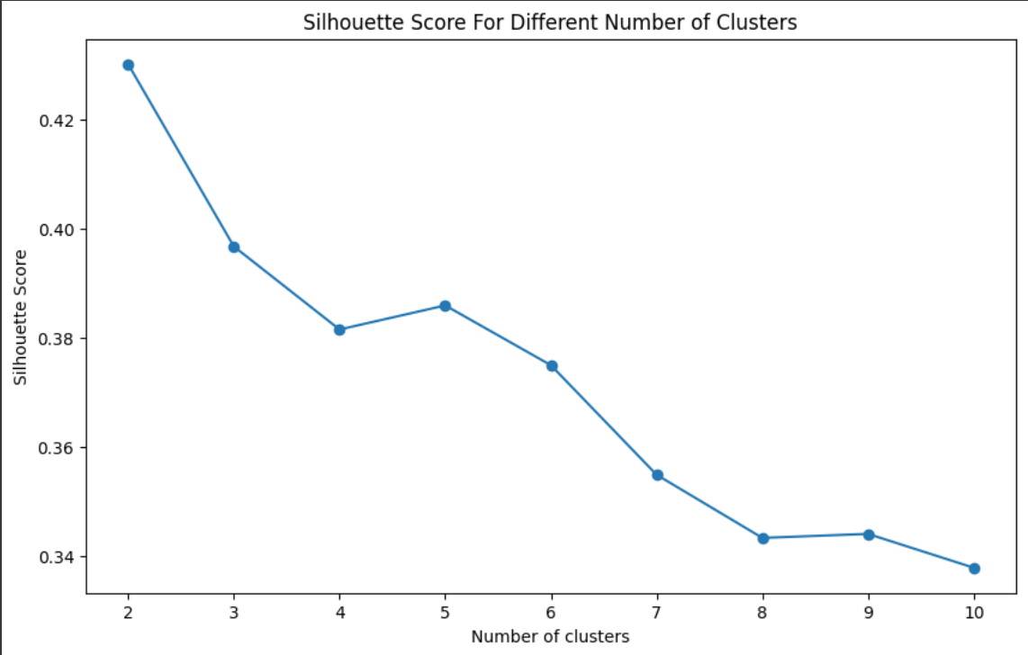

*Figure 42: Silhouette Score Graph*

The silhouette score measures how similar an object is to its own cluster compared to other clusters. A high value indicates that the object is well-matched to its own cluster and poorly matched to neighboring clusters. The graph shows the silhouette score for different numbers of clusters. You typically look for the highest score to choose the optimal number of clusters. In this case, the highest score occurs at 2 clusters, which suggests that two clusters might actually be the best segmentation of the data. However, for the purposes of your analysis, you've chosen 3 clusters, which might have been due to business considerations or other factors in the data.

* **Distribution of Monthly Income by Cluster**

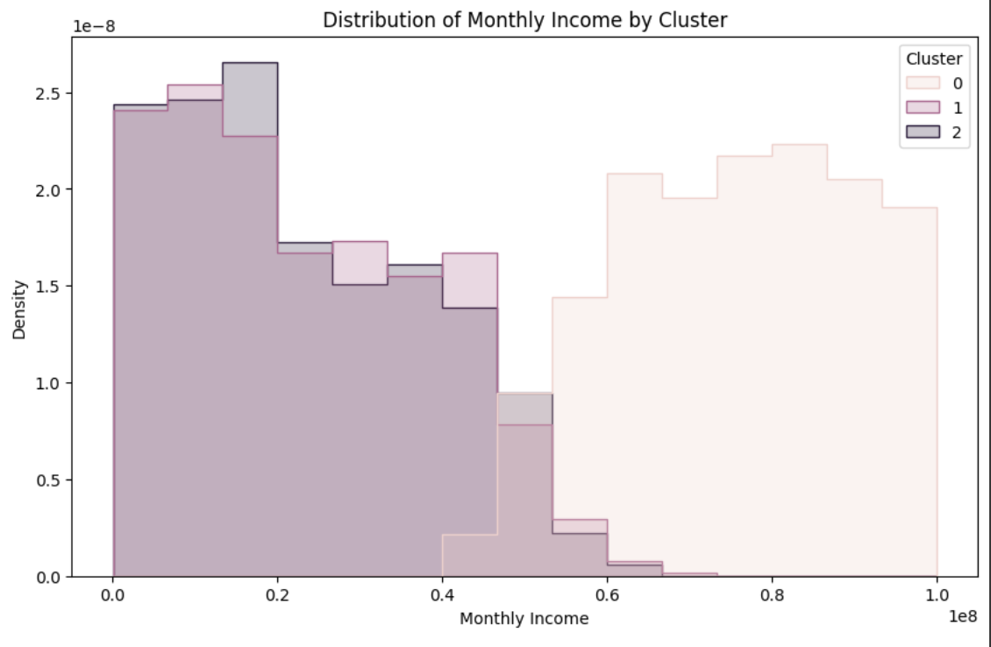

*Figure 43: Distribution of Monthly Income by Cluster*

This histogram shows the distribution of 'Monthly Income' across the three clusters. It helps you understand how monthly income is spread out within each cluster. For example, you might see that one cluster has a higher concentration of individuals with larger monthly incomes, while another has lower incomes.

* **Distribution of Accumulated Assets by Cluster**

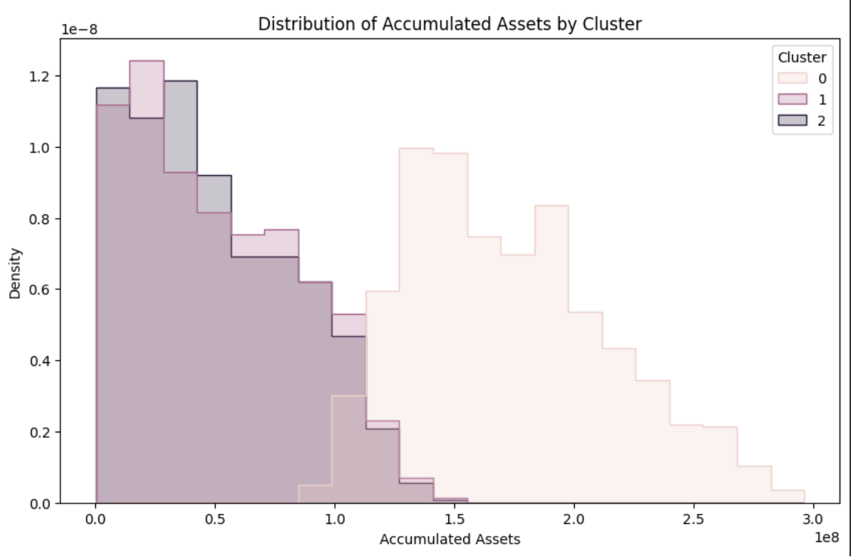

*Figure 44: Distribution of Accumulated Assets by Cluster*

This histogram shows the distribution of 'Accumulated Assets' across the three clusters. It helps you understand the financial asset base of customers in each cluster, such as which cluster represents the most affluent customers.

* **Distribution of Age by Cluster**

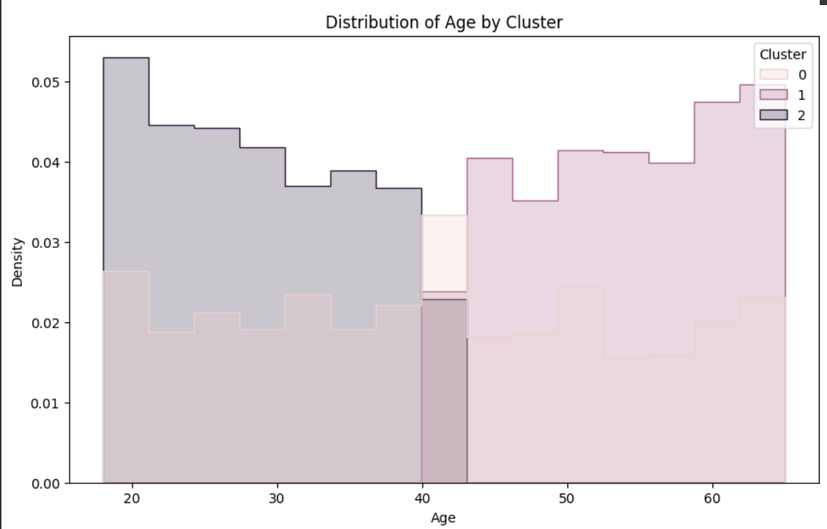

*Figure 45: Distribution of Age by Cluster*

This histogram shows the distribution of 'Age' across the three clusters. It reveals the age composition of each cluster, helping you identify if any cluster is skewed towards younger or older customers.

* **Box Plot of Monthly Income by Cluster**

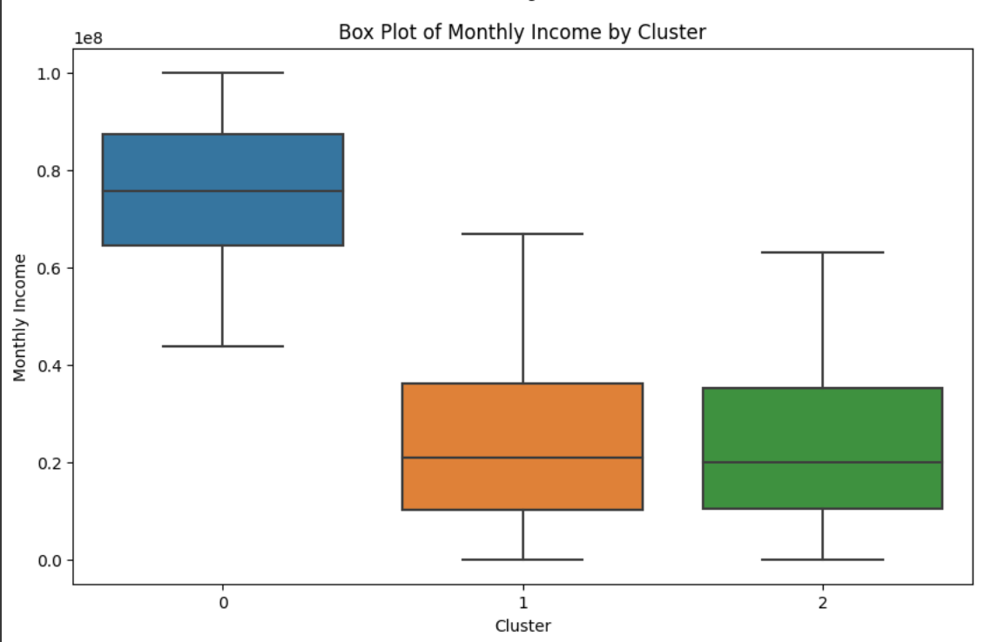

*Figure 46: Box Plot of Monthly Income by Cluster*

This box plot shows the five-number summary (minimum, first quartile, median, third quartile, maximum) of 'Monthly Income' for each cluster. It can also reveal outliers. For instance, if you see that the median line (inside the box) of one cluster is higher than the others, it indicates that this cluster generally has a higher monthly income.

* **Box Plot of Accumulated Assets by Cluster**

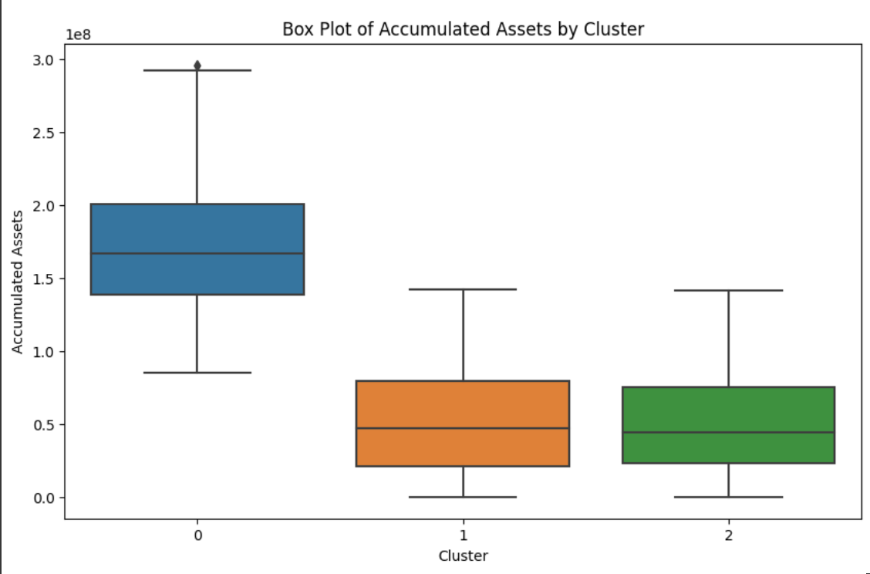

*Figure 47: Box Plot of Accumulated Assets by Cluster*

Similar to the 'Monthly Income' box plot, this shows the five-number summary for 'Accumulated Assets'. You can compare the wealth levels of each cluster.

* **Box Plot of Age by Cluster**

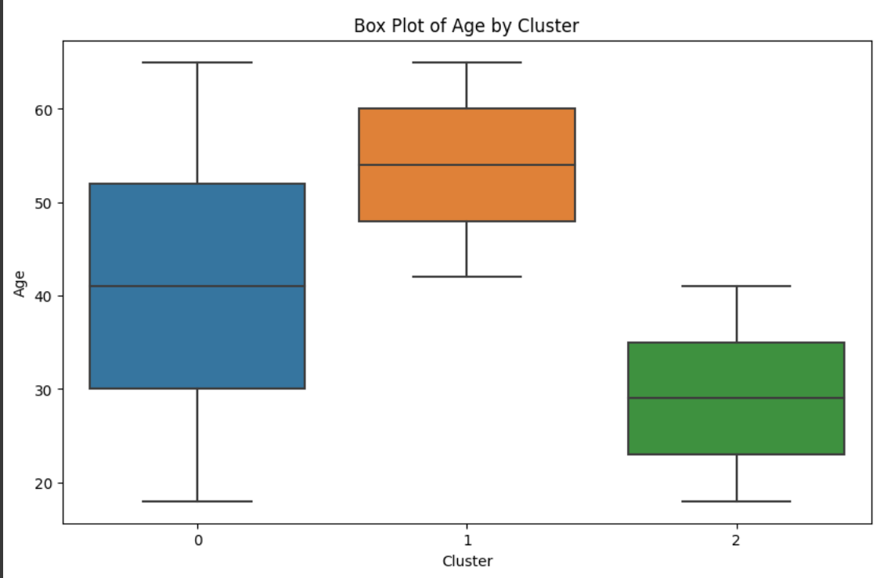

*Figure 48: Box Plot of Age by Cluster*

This box plot shows the five-number summary for 'Age' across clusters, giving you an idea of the age range and median age within each cluster.

* **Pair Plot**

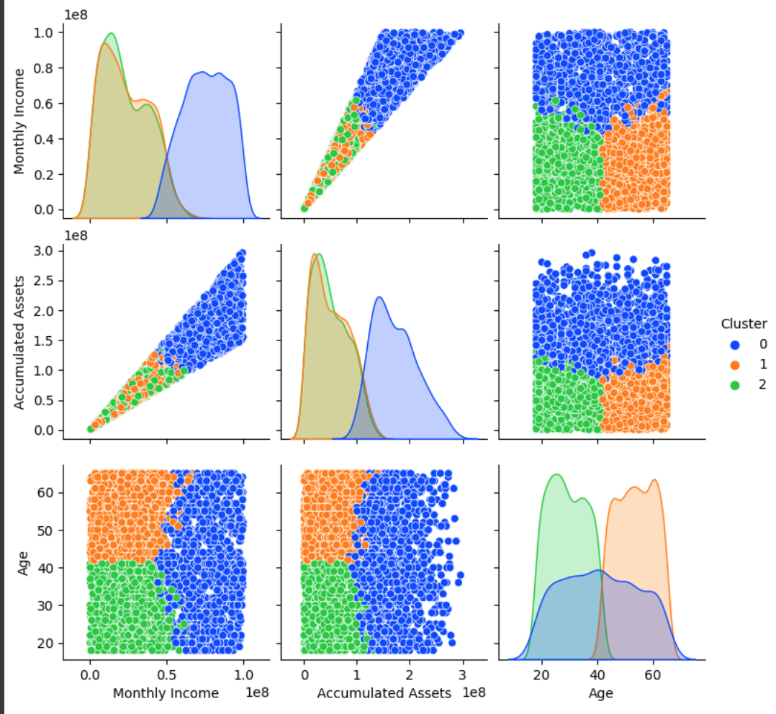

*Figure 49: Pair Plot*

The pair plot includes scatter plots that show the relationship between pairs of features (Monthly Income vs. Accumulated Assets, Monthly Income vs. Age, Accumulated Assets vs. Age) colored by cluster, along with histograms on the diagonal showing the distribution of each feature within each cluster. This comprehensive visualization helps you understand how the clusters differ not just in terms of single features, but also in terms of their relationships.

Overall, these graphs help illustrate the characteristics of each customer segment, allowing you to tailor marketing strategies, product development, and customer service initiatives to different segments based on their unique profiles.**

* **Box Plot of Accumulated Assets by Investment Goals and Risk Tolerance**

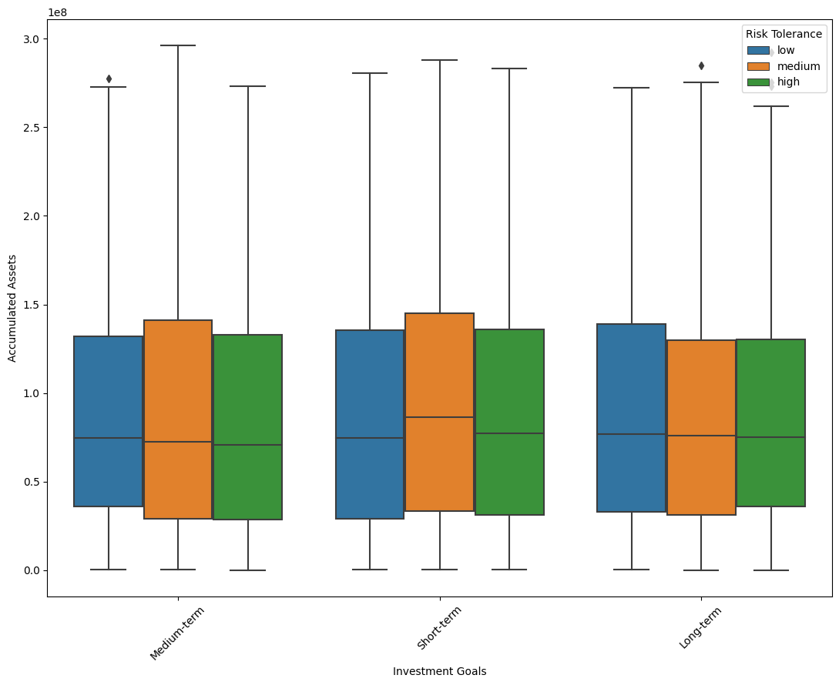

*Figure 50: Box Plot of Accumulated Assets by Investment Goals and Risk Tolerance*

This box plot displays the distribution of 'Accumulated Assets' across different 'Investment Goals' ('Medium-term', 'Short-term', and 'Long-term'), further divided by 'Risk Tolerance' ('low', 'medium', 'high').

* Observations:
  + The median value of 'Accumulated Assets' seems relatively consistent across different investment goals, which suggests that investment horizon might not significantly impact the level of assets customers have.
  + There is a noticeable spread (interquartile range) in each category, indicating variability within each investment goal and risk tolerance group.
  + The presence of outliers (as indicated by the diamonds) suggests that there are customers with significantly higher accumulated assets than the average within each group.
  + There is no clear trend that indicates a higher 'Risk Tolerance' correlates to higher 'Accumulated Assets' across different investment goals.
  + **Box Plot of Monthly Income by Investment Goals and Risk Tolerance***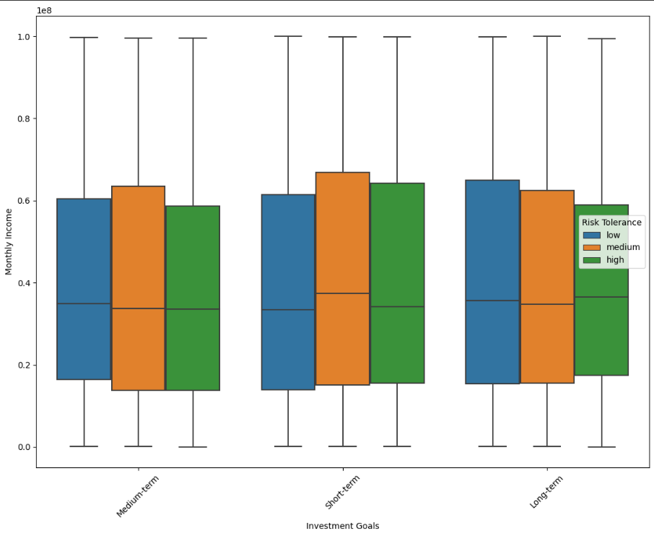Figure 51: Box Plot of Monthly Income by Investment Goals and Risk Tolerance*

This box plot shows 'Monthly Income' across the same 'Investment Goals' and 'Risk Tolerance' categories.

* Observations:
  + Similar to 'Accumulated Assets', the median monthly income appears to be fairly consistent across the investment goals, suggesting that the income level is not strongly correlated with the type of investment goal a customer has.
  + Variability within each category is also evident here, with a wide range in the 'Short-term' and 'Long-term' investment goals.
  + The 'Risk Tolerance' does not seem to have a strong influence on the 'Monthly Income' within the categories of investment goals.

### **3.7.1 Key finding of Customer Segmentation**

In this part, we successfully divided our customers into three distinct groups using a method called K-Means clustering, focusing on their monthly income, total assets, and age. This grouping helps us understand our customers better, which is important for creating effective marketing strategies and developing products that they really need. We made sure that all the financial information was fairly used by standardizing the data. This approach helped us find the ideal number of customer groups. Our findings are not only helpful for targeting our marketing efforts more accurately but also for improving customer satisfaction and growing our business.

Going forward, it's important to keep updating our customer groups to match changing trends and behaviors. This way, we can stay relevant and meet our customers' needs effectively. In short, this analysis is a big step towards focusing more on what our customers need and want, using data to guide our business decisions.

## **3.8 Recommendations**

### **3.8.1 What do client receive when they use ours services?**

Our financial services offer a holistic and comprehensive approach to investing, guiding clients every step of the way toward making informed investment decisions. Initially, we provide a macroeconomic analysis that equips investors with the knowledge to understand the broader economic conditions favorable for stock investments. This foundational understanding helps in timing the market and aligning investment decisions with macroeconomic trends.

Following the macroeconomic overview, we delve into industry sector analysis, giving investors insight into which sectors are outperforming or underperforming against the overall market. This analysis is critical in identifying sectors with strong growth potential or those with inherent risks, allowing for a targeted investment strategy.

Armed with knowledge of the economic context and industry dynamics, clients are then introduced to our comprehensive stock selection strategy. This strategy is a blend of fundamental and technical analysis designed to pinpoint stocks with the highest potential for growth. Our methodology is rigorous, incorporating various financial metrics and market indicators to assess the intrinsic value and momentum of stocks.

For the execution phase, clients have access to our trading bot, which provides specific buy and sell signals. These signals are generated through sophisticated algorithms that analyze market data in real-time, offering timely and actionable trading opportunities based on the current market conditions and predefined investment strategies.

Lastly, we offer portfolio construction services using Modern Portfolio Theory (MPT) principles, tailored to individual client profiles. For instance, a client with a $25,000 capital and a high risk tolerance would receive a recommendation for a portfolio of five high-risk stocks. The specific weights of these stocks are precisely calculated, as demonstrated earlier, to optimize the portfolio's risk-return profile according to the client's risk appetite and investment goals. This personalized portfolio not only considers the capital size but also strategically allocates it across selected stocks to maximize returns while managing risk efficiently.

In essence, our service package is designed to provide a start-to-finish investment solution, from macroeconomic context setting and sectoral analysis to individual stock selection and automated trading signals, all culminating in a bespoke, optimized portfolio construction that resonates with the client's financial aspirations and risk preferences.

## **3.9 Future works**

Looking to the future, our analytical framework and methodologies present numerous opportunities for refinement and expansion to enhance investment strategies further. Continuous improvement of our macroeconomic analysis is critical, incorporating real-time data feeds and advanced predictive models to assess the economic conditions with greater precision and foresight. Enhancing our industry sector analysis is also imperative, potentially by integrating alternative data sources and machine learning techniques to discern emerging sectoral trends and disruptions that may not be evident through traditional analysis.

In terms of our comprehensive stock selection strategy, we plan to explore the integration of additional fundamental indicators that may provide deeper insights into a company's long-term viability, such as environmental, social, and governance (ESG) factors, which are becoming increasingly relevant in today's investment landscape. Technically, the application of more sophisticated algorithms and the inclusion of high-frequency trading data could refine the precision of our buy and sell signals, offering a more granular view of market movements.

Our trading bot, an integral part of the strategy, will benefit from ongoing optimization. This includes the implementation of adaptive algorithms capable of learning from past performance and adjusting to new market conditions, thereby enhancing its responsiveness and accuracy. Furthermore, expanding the bot's functionality to include a wider range of technical indicators and risk management tools, such as stop-loss orders and derivative overlays, could provide more nuanced trading strategies and better risk-adjusted returns.

Portfolio allocation using Modern Portfolio Theory (MPT) will also be an area of continuous development. Exploring more dynamic asset allocation models that can adapt to changing market conditions, as well as incorporating real options theory for better management of the uncertainty and the ability to capitalize on market volatility, are potential areas of improvement. Additionally, the application of Monte Carlo simulations and stress testing scenarios can provide deeper insights into the potential risk factors affecting portfolio performance under various market conditions.

In essence, the future work will involve a concerted effort to integrate cutting-edge technologies and emerging financial theories to build upon the solid foundation we have established. This will not only enhance the robustness and agility of our investment strategies but also ensure that our clients are well-positioned to navigate the complexities of the ever-evolving financial markets.

# **References**

* Times of India (2023) ‘Why college students must learn about trading and investment?’, Times of India, accessed 1 December 2023, https://timesofindia.indiatimes.com/business/india-business/why-college-students-must-learn-about-trading-and-investment/articleshow/92243006.cms.
* Investopedia (2022) ‘Financial Literacy Gaps Across Generations’, Investopedia, accessed 1 December 2023, https://www.investopedia.com/financial-literacy-gaps-across-generations-5204490.
* IJRPR (2023) ‘A Study on Stock Market Awareness and Participation among the …’, IJRPR, accessed 1 December 2023, https://www.ijrpr.com/ijrpradmin/upload/IJRPR_60c12e4e8ac16.pdf.
* CNBC (2021) ‘How to avoid impulsive emotional investing decisions’, CNBC, accessed 1 December 2023, https://www.cnbc.com/2021/11/30/how-to-avoid-impulsive-emotional-investing-decisions.html.
* MagnifyMoney (2023) ‘66% of Investors Regret Emotional Investing’, MagnifyMoney, accessed 1 December 2023, https://www.magnifymoney.com/blog/news/emotional-investing-survey/.
* Forbes (2021) ‘The Diminishing Benefits Of Too Much Stock Diversification’, Forbes, accessed 1 December 2023, https://www.forbes.com/sites/robisbitts2/2021/04/21/the-diminishing-benefits-of-too-much-stock-diversification/.
* Tamplin, T. (2023). Top-Down Stock Analysis. Retrieved from https://www.financestrategists.com/wealth-management/fundamental-vs-technical-analysis/top-down-stock-analysis/
* Hanna, A. J. (2018). Top-down and bottom-up approaches in stock market prediction: A comprehensive study. International Review of Financial Analysis, 55, 93-110.
* van Rensburg, J. J., & van Vuuren, G. (2020). Evaluating investment decisions based on the business cycle: A South African sector approach. Cogent Economics & Finance, 8(1), 1852729.
* Blake, J., Fourie, S., & Goldman, M. M. (2019). The relationship between sports sponsorships and corporate financial returns in South Africa. International Journal of Sports Marketing and Sponsorship, 20(1), 109-125.<https://dx.doi.org/10.1108/IJSMS-12-2016-0088>.
* 陳有宏. (2010). 台股上市、櫃高獲利、轉機與成長型投資組合V.S.整體市場與開放式基金績效評估. Tamkang University.<https://dx.doi.org/10.6846/TKU.2010.01024>.
* Li, Z., Deng, G. and Che, H.-C., 2021. Patent-Based Predictive EPS on Increasing Investment Performance of China Stock Market. In: 2021 International Conference on Power, Electronics and Computer Applications (ICPECA).IEEE, pp.1-5. <https://dx.doi.org/10.1109/ICPECA51329.2021.9362701>
* Agrawal, T., Sehgal, S. and Vasishth, V., 2020. Firm Attributes, Corporate Fundamentals and Investment Strategies: An Empirical Study for Indian Stock Market. Vision, 24(2), pp.160-175. <https://dx.doi.org/10.1177/0258042X20927995>
* Efuntade, O.O. and Efuntade, A.O., 2022. Assessing Literatures on the Dependence of Stock Market Development on Upstream Oil Royalty Revenue and Systematic Risk Factors: Highlighting the Relevance of Dutch Disease Theory and Capital Asset Pricing Model. International Journal of Social Science and Management Research, 8(3), pp.1-30. <https://dx.doi.org/10.56201/ijssmr.v8.no3.2022.pg1.30>
* Zhou, W., Chen, J., Lu, S. and Chen, N., 2021. Variable investment strategies for Chinese listed military enterprises: an empirical study based on double-market network analysis. Applied Economics,53(29), pp.3385-3398. <https://dx.doi.org/10.1080/00036846.2021.1907282>
* Aduroh, M.S. and Paramu, H., 2021. Determinants of Firm Value and the Role of Good Corporate Governance as a Moderating Variable: Empirical Evidence from Indonesian Public Companies. International Journal of Creative and Innovative Research in All Studies, 3(11), pp.1. [IJCIRAS1732.pdf](http://www.ijciras.com/PublishedPaper/IJCIRAS1732.pdf)
* Bai, C.-E., Liu, Q., Lu, J., Song, F.M. and Zhang, J., 2003. Corporate Governance and Market Valuation in China. Faculty of Business and Economics, The University of Hong Kong. [Microsoft Word - Bai-2new.doc (core.ac.uk)](https://core.ac.uk/download/pdf/37914616.pdf)
* Raju, R. và Agarwalla, S.K., 2021. Equity Portfolio Diversification: How Many Stocks Are Enough? Evidence From India. <https://ssrn.com/abstract=3790117>
* Fragkiskos, A., 2014. What is Portfolio Diversification?. <https://ssrn.com/abstract=2331475>
* Sodini, P. and Viceira, L.M. (2020) The Value of Diversification ap7_annual_report-ps_and_lv-2020-01-29.pdf
* Muller, H. (n.d.) ‘Modern portfolio theory: Some main results’, University of Zurich, 1 (1), pp. 1-16. DOI: <https://doi.org/10.1017/S051503610000859X>
* Elton, E. J., & Gruber, M. J. (1998). Modern Portfolio Theory, 1950 to Date. New York University (NYU) Department of Finance. NYU Working Paper No. FIN-98-026. [Modern Portfolio Theory, 1950 to Date by Edwin J. Elton, Martin J. Gruber :: SSRN](https://papers.ssrn.com/sol3/papers.cfm?abstract_id=1297051)
* Pan, H. (2019). Intelligent Portfolio Theory – A New Paradigm of Invest-in-Trading.DOI: [10.1109/ICPHYS.2019.8780231](https://doi.org/10.1109/ICPHYS.2019.8780231)
* Tasche, D., & Zentrum Mathematik (2001) . Modern Portfolio Theory with Homogeneous Risk Measures. chrome-extension://efaidnbmnnnibpcajpcglclefindmkaj/https://citeseerx.ist.psu.edu/document?repid=rep1&type=pdf&doi=69c28772379359af3dd95bc7716ac1b7059c14ee
* Curtis, G. (2004). Modern Portfolio Theory and Behavioral Finance.DOI10.3905/jwm.2004.434562
* Snarska, M., & Krzych, J. (2006). Automatic Trading Agent. RMT based Portfolio Theory and Portfolio Selection.<https://arxiv.org/abs/physics/0608293>
* Grujić, M., Mekinjić, B., & Vujičić-Stefanović, D. Testing of portfolio optimization through investments in stock market indices and Bitcoin.DOI: 10.5937/EKOPRE2106318G
* Zhang, Y., Zhang, H., & Ma, Y. (2022). A Study of Optimal Portfolio of Gold and Bitcoin Based on Risk and Return.DOI: <https://doi.org/10.54691/bcpbm.v26i.1822>
* Zulfahmi, A. R., & Sishadiyati, S. (2023). Differences in the Effect of Monetary Policy and Fiscal Policy on Inflation in Indonesia During COVID-19 and Russia-Ukraine Geopolitical Tensions.<https://dx.doi.org/10.47191/jefms/v6-i12-02>
* Queyranne, M., Baksa, D., Abdulkarim, A., & Bazinas, V. (2021). Morocco’s Monetary Policy Transmission in the Wake of the COVID-19 Pandemic.<https://dx.doi.org/10.5089/9781589067264.001>
* Rao, D., & Kumar, R. (2023). An Assessment of Unconventional Monetary Policy During COVID-19 Pandemic in India.<https://dx.doi.org/10.1177/09726527231163207>

# **Appendix**

## **Appendix 1: Trading bot backtesting result on SSI**

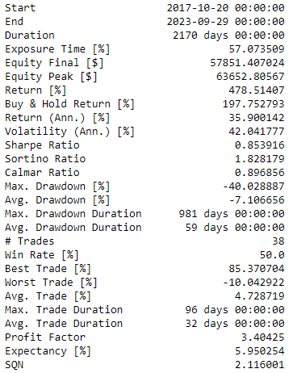

## **Appendix 2: Trading bot backtesting result on VND**

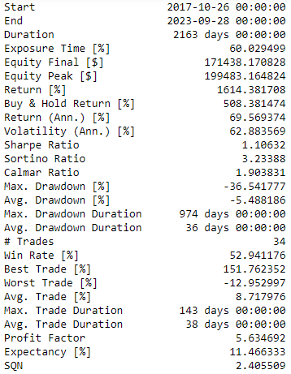

## **Appendix 3: Trading bot backtesting result on HPG**

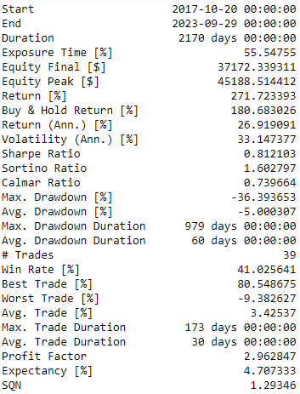

## **Appendix 4: Trading bot backtesting result on MWG**

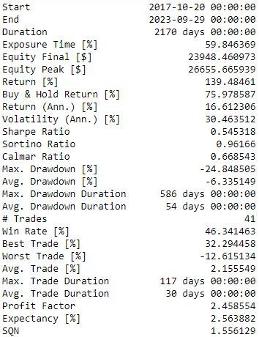

1. "The Benefits of Containerization and What It Means for You - IBM Blog." 6 Feb. 2019, <https://www.ibm.com/blog/the-benefits-of-containerization-and-what-it-means-for-you/>. Accessed 14 Dec. 2023.
2. "Top 31 Kubernetes Statistics You Should Know in 2023-24 - Humalect." 1 Aug. 2023, <https://humalect.com/blog/kubernetes-statistics>. Accessed 14 Dec. 2023.
3. "Apache Kafka." <https://kafka.apache.org/>. Accessed 14 Dec. 2023.
4. "Apache Flink® — Stateful Computations over Data Streams ...." <https://flink.apache.org/>. Accessed 14 Dec. 2023.
5. "Apache Airflow." <https://airflow.apache.org/>. Accessed 14 Dec. 2023.
6. "Timescale: PostgreSQL ++ for time series and events." <https://www.timescale.com/>. Accessed 17 Dec. 2023.
7. "BentoML: Build, Ship, Scale AI Applications." <https://www.bentoml.com/>. Accessed 17 Dec. 2023.
8. "Inspect network activity | DevTools - Chrome for Developers." 8 Feb. 2019, <https://developer.chrome.com/docs/devtools/network>. Accessed 17 Dec. 2023.
9. "What is API Testing? A Guide to Testing APIs - Postman." <https://www.postman.com/api-platform/api-testing/>. Accessed 17 Dec. 2023.
10. "DAGs — Airflow Documentation." <https://airflow.apache.org/docs/apache-airflow/stable/core-concepts/dags.html>. Accessed 17 Dec. 2023.
11. "SSI iBoard." <https://iboard.ssi.com.vn/>. Accessed 17 Dec. 2023.
12. "Schema Registry Overview | Confluent Documentation." <https://docs.confluent.io/platform/current/schema-registry/index.html>. Accessed 17 Dec. 2023.
13. "Data Contracts 101 - How They Work, Why They're Important." 8 Dec. 2022, <https://www.montecarlodata.com/blog-data-contracts-explained/>. Accessed 17 Dec. 2023.
14. "Windows | Apache Flink." <https://nightlies.apache.org/flink/flink-docs-release-1.18/docs/dev/datastream/operators/windows/>. Accessed 17 Dec. 2023.
15. "Streaming 101: The world beyond batch - O'Reilly." 5 Aug. 2015, <https://www.oreilly.com/radar/the-world-beyond-batch-streaming-101/>. Accessed 19 Dec. 2023.
16. "Streaming 101: The world beyond batch - O'Reilly." 5 Aug. 2015, <https://www.oreilly.com/radar/the-world-beyond-batch-streaming-101/>. Accessed 19 Dec. 2023.
17. "Vanishing gradient problem - Wikipedia." <https://en.wikipedia.org/wiki/Vanishing_gradient_problem>. Accessed 17 Dec. 2023.
18. "Backpropagation - Wikipedia." <https://en.wikipedia.org/wiki/Backpropagation>. Accessed 17 Dec. 2023.
19. "Recurrent Neural Networks (RNN) - The Vanishing Gradient Problem." <https://www.superdatascience.com/blogs/recurrent-neural-networks-rnn-the-vanishing-gradient-problem>. *Figure 10: Architecture of LSTM Network*
20. "Understanding of LSTM Networks - GeeksforGeeks." 5 Jun. 2023, <https://www.geeksforgeeks.org/understanding-of-lstm-networks/>. Accessed 17 Dec. 2023.
21. "What You Should Know About Production Readiness: A Guide - Port." 19 Dec. 2022, <https://www.getport.io/blog/production-readiness>. Accessed 19 Dec. 2023.
22. "SOLID - Wikipedia." <https://en.wikipedia.org/wiki/SOLID>. Accessed 25 Dec. 2023.
23. "PEP 8 – Style Guide for Python Code." 9 Dec. 2023, <https://peps.python.org/pep-0008/>. Accessed 25 Dec. 2023.
24. "KEDA Concepts." <https://keda.sh/docs/2.12/concepts/>. Accessed 19 Dec. 2023.
25. "Pod Lifecycle | Kubernetes." 6 Oct. 2023, <https://kubernetes.io/docs/concepts/workloads/pods/pod-lifecycle/>. Accessed 25 Dec. 2023.
26. "When to use GRU over LSTM? - Data Science Stack Exchange." 17 Oct. 2016, <https://datascience.stackexchange.com/questions/14581/when-to-use-gru-over-lstm>. Accessed 25 Dec. 2023.
27. "When to use GRU over LSTM? - Data Science Stack Exchange." 17 Oct. 2016, <https://datascience.stackexchange.com/questions/14581/when-to-use-gru-over-lstm>. Accessed 25 Dec. 2023.
28. "When to use GRU over LSTM? - Data Science Stack Exchange." 17 Oct. 2016, <https://datascience.stackexchange.com/questions/14581/when-to-use-gru-over-lstm>. Accessed 25 Dec. 2023.